Exogenous Variables in Time Series Forecasting During Economic Volatility: A Cross-Sector and Cross-Crisis Evaluation

Orla Kavanagh

A Thesis Submitted in Partial Fulfilment
of the requirements for the
Degree of
Master of Science in Data Analytics



September 2025

Supervisor: Dr Maqsood Hussain Shah

CCT College Dublin

Assessment Cover Page

Module Title: | Master of Science in Data Analytics
Assessment Title: | Capstone Project
Lecturer Name: | Supervisor: Dr Maqsood Hussain Shah
Student Full Name: | Orla Kavanagh
Student Number: | sba24195
Assessment Due Date: | 07/09/2025
Date of Submission: | 06/09/2025

Declaration

By submitting this assessment, I confirm that I have read the CCT policy on Academic Misconduct and understand the implications of submitting work that is not my own or does not appropriately reference material taken from a third party or other source. I declare it to be my own work and that all material from third parties has been appropriately referenced. I further confirm that this work has not previously been submitted for assessment by myself or someone else in CCT College Dublin or any other higher education institution.

Abstract
Periods of economic volatility make time series forecasting especially difficult, but they also provide a chance to see whether external information can improve accuracy. This thesis examines the role of exogenous variables during two disruptions: the COVID-19 pandemic and the 2025 U.S. tariff shock. Using data from two firms in contrasting sectors, Dell (technology) and Boeing (aerospace/manufacturing), it tests whether adding candidate exogenous indicators improves forecasts from ARIMA, SARIMA, and LSTM models in these uncertain times.
The results show that exogenous variables can add value, but their usefulness is highly dependent on context. For Dell, commodity and supply chain indicators improved forecasts during COVID-19, while Boeing’s predictions were more responsive to sectoral and macroeconomic indices. These effects, however, did not carry across settings: in many cases baseline models performed as well or better, and variables that worked during COVID-19 often lost their predictive power in 2025. Generally, LSTM models with exogenous variables tended to do better at longer horizons, while ARIMA family models performed better at shorter horizons. Taken together, these findings highlight both the potential and the limits of exogenous inputs, showing that their contribution depends on sectoral dynamics, the nature of the disruption, and the forecast horizon.
By comparing ARIMA/SARIMA models (as representatives of traditional statistical approaches) with LSTMs (as a representative deep learning approach) under fixed configurations, this thesis provides a realistic assessment of how exogenous information can be incorporated under resource constraints. The results contribute to discussions on forecasting with external signals and point to a practical lesson for forecasters: model sophistication by itself does not guarantee better performance. In practice, this means careful variable choice, ongoing testing, and awareness of context.

Acknowledgements
I would like to thank my lecturer, David McQuaid, and my supervisor, Dr. Maqsood Hussnain, for their support and guidance. I am also grateful to my friends and colleagues for enduring my many complaints along the way. To my children, thank you for your patience, and to my parents, thank you for helping me keep all my plates spinning.
Contents
1. Introduction 1
1.1. Background 1
1.2. Problem Statement 1
1.3. Research Motivation 1
1.4. Research Questions 1
1.5. Research Objectives 2
1.6. Contribution of the Study 2
1.7. Ethics and Legal Regulatory Considerations 2
1.8. Structure of the Thesis 3
2. Literature Review 3
2.1. Introduction 3
2.2. Forecasting Approaches and the Role of Exogenous Variables 4
2.3. Selecting and Using Exogenous Variables 5
2.4. Forecasting During Volatility 5
2.5. Comparing Models across Conditions 6
2.6. Sector-Specific Considerations 8
2.7. Gaps in the Literature 8
2.8. Conclusion 9
3. Methodology 9
3.1. Research Design 9
3.2. Project Management and Design 11
3.2.1. Business Understanding 11
3.2.2. Data Understanding 11
3.2.3. Data Preparation 11
3.2.4. Modelling 11
3.2.5. Evaluation 12
3.2.6. Deployment (Research Context) 12
3.3. Company and Period Selection 12
3.4. Data Sources and Preprocessing 12
3.5. Variable Selection Strategy 14
3.6. Modelling approach 16
3.6.1. ARIMA and SARIMA models 16
3.6.2. LSTM Models 17
3.6.3. Integration of Exogenous Variables 18
3.7. Forecast Horizons (applied across models) 18
3.8. Evaluation Strategy 18
3.8.1. Error Metrics 18
3.8.2. Data splitting strategy 19
3.9. Computational Environment and Tools 19
4. Results and Evaluation 20
4.1. Exploratory Data Analysis (EDA) 20
4.1.1. Initial correlation analysis 21
4.2. Preparation of Data for ARIMA family models 22
4.2.1. Stationarity Testing 22
4.2.2. Granger Causality Tests 23
4.2.3. Comparison of Correlation Heatmap Results and Granger Causality Test Outcomes 25
4.3. Model Selection for ARIMA/SARIMA 26
4.3.1. Boeing – COVID-19 27
4.3.2. Boeing – 2025 Tariffs 30
4.3.3. Dell – COVID-19 32
4.3.4. Dell – 2025 34
4.4. LSTM Baseline Architecture Selection 36
4.5. Model performance comparison (O1 + O2) 38
4.5.1. Statistical vs Deep Learning approaches (baseline) 38
4.5.2. Traditional vs Enhanced models (ARIMA vs ARIMAX / SARIMA vs SARIMAX) 39
4.5.3. LSTMs with and without exogenous variables (individual inputs) 43
4.5.4. Mixed LSTMs: grouped inputs and “best of” blends (O1 + O3) 46
4.5.5. Interpretability vs Performance 48
4.6. Period-wise analysis (O2 + O4) 48
4.7. Sector-wise analysis (O3) 51
4.7.1. Dell (Tech) 51
4.7.2. Boeing (Manufacturing/Aerospace) 51
4.7.3. Summary table of best models 52
5. Discussion 53
5.1. Key Findings and Interpretation 53
5.2. Relation to Literature 54
5.3. Sector-Specific Insights 55
5.4. Practical Implications 55
5.5. Limitations 56
5.6. Future Work 56
6. Conclusion 57
References 58
Appendix 61
Appendix A – Datasets and Code 61
Appendix A.1 Google Drive link 61
Appendix A.2 Statement on AI Usage 61
Appendix B – Ethics full detail 62
Appendix B.1 Legal/ Regulatory Considerations 62
Appendix B.2 Ethics and Data Protection 62
Appendix B.3 License and Permissions 63
Appendix C – LSTM Hyperparameter Search Space 63
Appendix D – Results detail and additional plots 64

List of Tables
Table 0.1: Table of Acronyms & Abbreviations vii
Table 2.1 Wang and Vo (2025): Empirical results. ARIMAX and GALSTM provided highest accuracy 4
Table 2.2 Banaś and Utnik-Banaś (2021) results 7
Table 2.3 Pandit et al (2023) Forecasting accuracies of the time series models under study 7
Table 3.1 Exogenous variables used for Boeing (BA) with tickers, relevance, and category classification. 13
Table 3.2 Exogenous variables used for Dell (DELL) with tickers, relevance, and category classification. 14
Table 3.3 Correlation changes for selected exogenous variables with Boeing stock (COVID-19 vs 2025) 15
Table 4.1 Correlation heatmaps of exogenous variables and stock prices for Boeing and Dell during COVID-19 and the 2025 tariffs. 21
Table 4.2 Results of Augmented Dickey-Fuller (ADF) tests for Boeing and Dell exogenous variables across both periods, before and after first differencing. 22
Table 4.3 Granger causality test results (on stationary data) for Boeing and Dell exogenous variables across both disruption periods. 23
Table 4.4 Comparison of correlation and Granger test outcomes for Boeing and Dell across both disruption periods. 26
Table 4.5 Baseline LSTM setup used in all experiments 37
Table 4.6 Baseline model MAPE comparison by horizon for Boeing and Dell. 38
Table 4.7 Forecast accuracy (MAPE) of grouped-input LSTMs compared with the baseline at Horizon 1 for Boeing and Dell across both periods. 46
Table 4.8 Best-performing models across companies, disruption periods, and forecast horizons. 52

List of Figures
Figure 3.1: Research methodology. The process includes data collection, preprocessing, model training, and evaluation. Train/test splits were applied consistently (80/20 date-wise), with the exception of LSTM hyperparameter tuning, which used a random split 10
Figure 4.1 Stock plots for DELL and exogenous variables for COVID-19 (EDA) 20
Figure 4.2: Stock plots for Boeing and exogenous variables for COVID-19 (EDA) 20
Figure 4.3: CL=F for Dell during 2025 tariffs. 24
Figure 4.4: CL=F (Dell, COVID-19): Granger suggested lag=1, but lag plot indicated lag≈8 was more appropriate. 24
Figure 4.5: Granger causality plot for ITA (Boeing, 2025). 24
Figure 4.6: Granger causality plot for XLI (Boeing, 2025). 24
Figure 4.7: Granger causality plot for ^VIX, the most promising variable for Boeing (2025). 24
Figure 4.8: Example from Boeing (COVID-19) showing rationale for “sensible” lag choice. 25
Figure 4.9: PACF plot for Boeing during COVID-19 27
Figure 4.10: ACF plot for Boeing during COVID-19 27
Figure 4.11: Seasonal-trend Decomposition for Boeing during COVID-19 27
Figure 4.12: Auto ARIMA with seasonality off ( Boeing, COVID-19) 28
Figure 4.13: Auto-ARIMA with seasonality on (Boeing, COVID-19). 29
Figure 4.14: Excerpt of seasonal grid search supporting SARIMA(0,1,2)(1,0,1,30) (Boeing, COVID-19). 29
Figure 4.15: PACF plot for Boeing during 2025 30
Figure 4.16: ACF plot for Boeing during 2025. 30
Figure 4.17: STL decomposition for Boeing 2025 30
Figure 4.18: Auto-ARIMA for Boeing 2025 with seasonality on 31
Figure 4.19: Auto-ARIMA for Boeing 2025 with seasonality off 31
Figure 4.20: Excerpt of grid search results supporting SARIMA(1,1,1)(1,0,0,30) (Boeing, 2025). 31
Figure 4.21: STL decomposition for Dell during COVID-19. 32
Figure 4.22: PACF plot for Dell during COVID-19. 32
Figure 4.23: ACF plot for Dell during COVID-19. 32
Figure 4.24: Auto-ARIMA output with seasonality disabled (Dell, COVID-19). 33
Figure 4.25: Auto-ARIMA identifying a seasonal component (Dell, COVID-19). 34
Figure 4.26: STL decomposition for Dell during the 2025 tariffs. 35
Figure 4.27: Auto-ARIMA output with seasonality disabled (Dell, 2025). 35
Figure 4.28: Seasonal candidate from grid search (Dell, 2025). 36
Figure 4.29: : Accuracy plots of ARIMA vs SARIMA for Boeing during COVID-19 (Horizon 3) to illustrate similar accuracy across traditional models 39
Figure 4.30: Forecast accuracy (MAPE) of top ARIMA and SARIMA models for Boeing during the COVID-19 period (Horizon 1). Sectoral exogenous variables (e.g., ITA, XLI) offered little improvement, with baseline ARIMA models performing similarly. 39
Figure 4.31: Boeing, COVID-19 (Horizon 1). Accuracy plots showing little difference between models. Model: ARIMA(0,1,2) 40
Figure 4.32: Forecast accuracy (MAPE) of top ARIMA and SARIMA models for Dell during the COVID-19 period (Horizon 1). SARIMAX with CL=F showed slight improvement over the baseline; other exogenous variables offered no gain 40
Figure 4.33: Forecast accuracy (MAPE) of top ARIMA and SARIMA models for Boeing during the COVID-19 period (Horizon 3). Seasonal SARIMAX with sectoral indices (e.g., ITA, XLI) consistently outperformed baseline models. 41
Figure 4.34: Forecast accuracy (MAPE) of top ARIMA and SARIMA models for Dell during the COVID-19 period (Horizon 3). SARIMAX with CL=F (crude oil) produced the clearest gains over the baseline. 41
Figure 4.35: Accuracy plot showing slight improvement on SARIMA with CL=F for Dell during COVID-19. 42
Figure 4.36: Forecast accuracy (MAPE) of top ARIMA and SARIMA models for Boeing during the COVID-19 period (Horizon 7). ARIMAX with ^TNX delivered the best results, despite ^TNX showing a negative contemporaneous correlation. 42
Figure 4.37: Forecast accuracy (MAPE) of top ARIMA and SARIMA models for Dell during the 2025 tariff disruption (Horizon 7). SARIMAX with ^VIX achieved the lowest error, despite ^VIX being negatively correlated in contemporaneous terms. 43
Figure 4.38: MAPE delta plots for Boeing, Horizon 1: LSTM with single exogenous inputs compared to the baseline. 44
Figure 4.39: MAPE delta plots for Dell, Horizon 1: LSTM with single exogenous inputs compared to the baseline. 44
Figure 4.40: MAPE delta plots for Boeing, Horizon 3: LSTM with single exogenous inputs compared to the baseline. 44
Figure 4.41: MAPE delta plots for Dell, Horizon 3: LSTM with single exogenous inputs compared to the baseline. 45
Figure 4.42: MAPE delta plots for Boeing, Horizon 7: LSTM with single exogenous inputs compared to the baseline 45
Figure 4.43: MAPE delta plots for Dell, Horizon 7: LSTM with single exogenous inputs compared to the baseline. 45
Figure 4.44: Forecast accuracy (MAPE) of grouped LSTM inputs for Boeing during 2025 tariffs (Horizon 3). All models underperformed the baseline. 47
Figure 4.45: Forecast accuracy (MAPE) of grouped LSTM inputs for Dell during 2025 tariffs (Horizon 3). The best-of-each-category blend was the top performer, slightly better than the baseline. 47
Figure 4.46: Forecast accuracy (MAPE) of grouped LSTM inputs for Boeing during 2025 tariffs (Horizon 7). The best-of-each-category blend slightly outperformed the baseline, the only exogenous input to do so. 47
Figure 4.47: Forecast accuracy (MAPE) of grouped LSTM inputs for Dell during COVID-19 (Horizon 7). Supply-chain inputs delivered modest gains, while the best-of blend matched the baseline. 48
Figure 4.48: Dell – Average ranking (lower is better) of the best-performing model variants across horizons during COVID-19 (left) and the 2025 tariff disruption (right, shaded). Supply chain indicators such as CL=F and HG=F ranked highest during COVID-19, but their advantage diminished in 2025. 49
Figure 4.49: Boeing – Average ranking (lower is better) of the best-performing model variants across horizons during COVID-19 (left) and the 2025 tariff disruption (right, shaded). Sectoral indices such as XLI, IYT, and JETS consistently outperformed other variables, with XLI retaining short-horizon value across both periods. 50

List of Acronyms & Abbreviations
Table 0.1: Table of Acronyms & Abbreviations
Acronym / Abbreviation | Explanation
ACF | Autocorrelation Function
ADF | Augmented Dickey–Fuller test
ARIMA | AutoRegressive Integrated Moving Average
ARIMAX | ARIMA with Exogenous Variables
BA | Boeing (stock ticker)
CCI | Construction Confidence Index
COVID-19 | Coronavirus Disease 2019
CRISP-DM | Cross-Industry Standard Process for Data Mining
DELL | Dell Technologies (stock ticker)
EDA | Exploratory Data Analysis
ETF | Exchange-Traded Fund
GALSTM | Genetic Algorithm–optimised LSTM
GDP | Gross Domestic Product
GDPR | General Data Protection Regulation
GRU | Gated Recurrent Unit
H1 | 1 day Horizon
HP | Hewlett Packard
ITA | iShares U.S. Aerospace & Defense ETF
JETS | U.S. Global Jets ETF
LSTM | Long Short-Term Memory (neural network)
MAE | Mean Absolute Error
MAPE | Mean Absolute Percentage Error
MSE | Mean Squared Error
O1 | Objective 1
PACF | Partial Autocorrelation Function
R&D | Research and Development
RMSE | Root Mean Squared Error
SARIMA | Seasonal ARIMA
SARIMAX | Seasonal ARIMA with Exogenous Variables
SMH | VanEck Semiconductor ETF
STL | Seasonal-Trend decomposition using LOESS
TNX | 10-Year Treasury Yield (ticker ^TNX)
VIX | CBOE Volatility Index (ticker ^VIX)
XLI | Industrial Sector ETF
XLK | Technology Sector ETF
XLY | Consumer Discretionary ETF
yfinance | Yahoo Finance API

1. Introduction

Background
Forecasting in volatile markets is challenging because global shocks can break established economic patterns. Events such as the COVID-19 pandemic and the 2025 U.S. tariff disruptions caused abrupt shifts, reducing the reliability of standard forecasting models. Time series approaches such as ARIMA and SARIMA are widely used for their transparency and effectiveness in stable settings, but since they rely mainly on historical trends, they struggle when confronted with sudden external shocks.
These limitations have led to greater interest in incorporating exogenous variables. External factors such as macroeconomic data, commodity prices, or supply chain indicators can capture influences on firm performance, making forecasts more relevant and potentially more accurate during periods of disruption. However, issues remain about how such variables should be selected, whether they perform consistently across sectors, and whether lessons from one disruption can be applied to another.

Problem Statement
Although numerous studies have shown that exogenous variables can increase forecast accuracy, their usefulness is not guaranteed. Some studies show improvements only in certain settings, while others highlight risks such as overfitting or low generalisability. In many cases, researchers use broad indicators rather than context-specific ones like tariffs, trade data, or supply chain measures (Castilho, 2020; Wang and Vo, 2025). Deep learning models, such as LSTMs, have advantages in capturing non-linear interactions and long-term dependencies, but they require large, high-quality datasets, which are not always available during short-lived disruptions. This raises an important question: which exogenous variables, if any, improve forecasts in volatile environments? And can variables that are beneficial in one disruption, such as COVID-19, also be effective in another, such as the 2025 tariff shock?

Research Motivation
The motivation for this research stems from both academic and practical needs. From an academic perspective, most existing studies either rely on generic exogenous inputs (for example broad macroeconomic indicators) or focus too narrowly on a single disruption such as COVID-19. Less attention has been given to carefully chosen, sector-relevant variables, or to testing whether findings transfer across different types of crises. From a practical perspective, firms navigating volatility need forecasting tools that are accurate but also realistic in terms of data availability and interpretability.

Research Questions
This thesis is guided by the following research questions:
- Can carefully selected exogenous variables improve forecast accuracy during economic shocks?
- Which types of exogenous variables, if any, provide the most consistent value across sectors?
- How does model performance vary between different types of disruption (for example, a pandemic compared with a trade shock)?
- Can exogenous variables that are effective in one disruption retain their predictive value in another?

Research Objectives
To address these questions, the study pursues four objectives:
- O1: To test whether adding carefully chosen exogenous variables, such as macroeconomic and supply chain indicators, improves the accuracy of baseline forecasting models (ARIMA, SARIMA and LSTM) during periods of volatility, compared with versions of the models that rely only on endogenous data.
- O2: To compare the performance of baseline models with their exogenous-augmented counterparts (ARIMAX, SARIMAX and LSTM) across two major economic shocks: the COVID-19 pandemic and the 2025 tariff disruptions, using consistent configurations to ensure fair comparison.
- O3: To examine which categories of exogenous variables (for example commodity prices or trade indices) add the most forecasting value, and whether their impact differs across sectors.
- O4: To explore whether exogenous variables that improve forecasts in one volatile period (for example COVID-19) retain predictive value in another (for example the 2025 tariffs).

Contribution of the Study
This research contributes to both academic literature and forecasting practice in three ways. First, it compares statistical and deep learning models in volatile contexts, assessing the advantages and limitations of adding exogenous variables. Second, it looks at sector-specific dynamics by contrasting results for Dell (technology) and Boeing (aerospace/manufacturing). Third, it explores whether findings from one disruption can transfer to another, building understanding of cross-crisis forecasting.
In practical terms, the study offers guidance on when exogenous inputs are most useful, the trade-offs between simpler and more complex models, and the importance of aligning variable choice with the type of disruption being analysed.

Ethics and Legal Regulatory Considerations
This research uses only open-source, non-personal data, specifically historical stock prices and economic indicators obtained via the Yahoo Finance API. As no personal or sensitive data are involved, the General Data Protection Regulation (GDPR) does not directly apply. Nonetheless, the project follows core GDPR principles such as fairness, transparency, and data minimisation to ensure good practice in data handling.
Ethical considerations centre on the potential application of machine learning and forecasting methods. While models such as ARIMA, SARIMAX, and LSTM are applied here for academic research, they could, in principle, be adapted for financial or strategic decision-making. For this reason, the project aligns with the EU Ethics and Data Protection Guidelines for Research, paying particular attention to model transparency, explainability, and the proportionality of data use.
Because the project does not involve high-risk applications, the EU AI Act does not apply directly. Nonetheless, its emphasis on human oversight and transparency provides a useful reference point.
Further detail on how this research aligns with GDPR principles, the EU Ethics Guidelines, and the AI Act, as well as licensing and permissions, is provided in Appendix B.

Structure of the Thesis
The remainder of this thesis is organised as follows. Chapter 2 reviews the literature on time series forecasting, the use of exogenous variables, and forecasting under conditions of volatility. Chapter 3 describes the research methodology, including data sources, model configurations and evaluation criteria. Chapter 4 presents the results of the forecasting experiments. Chapter 5 discusses the key findings, sectoral insights, practical implications, and limitations, and outlines directions for future research. Chapter 6 concludes by summarising the main contributions, practical implications, and reflections.

Literature Review

Introduction
Time series forecasting is widely applied across sectors such as agriculture, healthcare, energy and finance, where it supports decision-making by predicting future outcomes from historical trends. However, during periods of economic volatility, such as the COVID-19 pandemic or the 2025 United States tariff disruption, forecasting becomes considerably more difficult. Structural breaks, sudden shocks and heightened uncertainty reduce model reliability and challenge the assumption that past patterns are a sound guide to the future.
Traditional approaches, including Autoregressive Integrated Moving Average (ARIMA) and its seasonal variant (SARIMA), perform well in stable environments where these assumptions hold. However, they often falter during disruptions, as they rely only on past values of the target variable and assume underlying stability. Extensions such as ARIMAX and SARIMAX attempt to address these limitations by incorporating exogenous variables, such as macroeconomic indicators, commodity prices, or sector indices which provide additional predictive context.
More recently, deep learning methods, particularly Long Short-Term Memory (LSTM) networks, have been applied to similar challenges. LSTMs can capture complex, non-linear dependencies and, like ARIMAX-type models, can be adapted to include exogenous variables. This makes them potentially more resilient during volatile periods, although they carry higher computational demands and concerns about interpretability.
This review therefore examines how incorporating exogenous variables affects forecasting accuracy in both statistical and deep learning models, with a particular focus on their performance during major economic disruptions. The aim is to establish the conditions under which additional inputs improve predictive accuracy and to assess whether such benefits transfer across different sectors and episodes of volatility.

Forecasting Approaches and the Role of Exogenous Variables
Traditional time series models such as ARIMA and SARIMA remain popular because they are straightforward to implement and can capture linear patterns and seasonality. These models perform well once the data has been made stationary, drawing only on historical values to generate forecasts (Box, Jenkins, and Gwilym M. Jenkins, 1970; Zhang, 2003; Gao et al., 2024). However, they often fall short during unexpected disruptions, such as trade disputes or pandemics, because of their univariate nature and reliance solely on past values of the target variable (Ahmed et al., 2010; Makridakis, Spiliotis and Assimakopoulos, 2018).
To address these limitations, extended models such as ARIMAX and SARIMAX are often used. These allow exogenous variables to be incorporated, including external factors such as macroeconomic indicators, commodity prices, or sector indices that influence the target series. Including such inputs makes forecasts more adaptable and context-aware, particularly during economic disruptions or public health crises. For example, Wang and Vo, (2025) showed that ARIMAX, when combined with carefully selected “dual important indicators,” achieved the highest accuracy in the Vietnamese market, outperforming both traditional and machine learning alternatives. Emerging methods such as Prophet and XGBoost have also gained attention for their ability to incorporate exogenous variables while keeping model complexity relatively low. Their straightforward implementation and solid performance during irregular or data-scarce periods make them appealing in volatile contexts. (Wang and Vo, 2025). Other studies (Suhartono, Lee and Prastyo, 2015; ALKALI, 2019; Castilho, 2020) also note that these models can offer stronger interpretability, particularly in scenario analysis.
Table 2.1 Wang and Vo (2025): Empirical results. ARIMAX and GALSTM provided highest accuracy
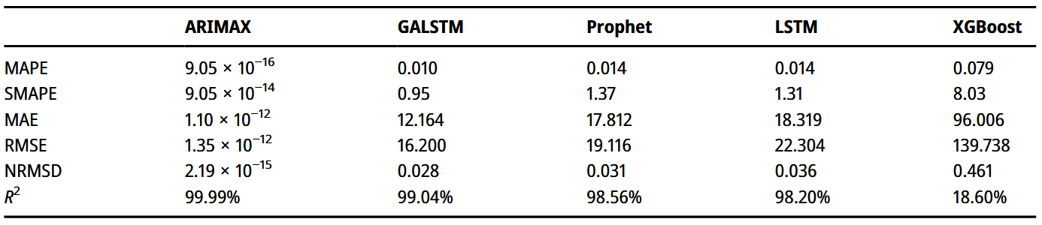
A further limitation of traditional univariate models is their inability to account for latent confounders, meaning external variables that influence both the predictors and the outcome. When such confounders are left out, forecasts may be affected by hidden bias, especially during volatile periods when external shocks trigger rapid changes across several market indicators at once. Including exogenous variables can help reduce this risk by explicitly modelling these relationships.
However, incorporating exogenous variables also presents challenges. Choosing inputs that are relevant, timely, and genuinely predictive requires domain knowledge and careful validation to avoid overfitting (Castilho, 2020). Tuning ARIMA models is already complex, and adding external variables increases their sensitivity to input quality.
Long Short-Term Memory (LSTM) networks were developed to address the limitations of standard RNNs, and they excel at capturing long-term, non-linear dependencies (Hochreiter and Schmidhuber, 1997). Their design includes memory cells and gates that manage information over time, which makes them effective in volatile contexts (Gao et al., 2024). LSTMs have shown particular promise in hybrid configurations, such as Genetic Algorithm-optimised LSTM (GALSTM) (Wang and Vo, 2025).
Despite their strengths, LSTMs are resource-intensive and lack interpretability, which can be drawback in fields such as finance (Makridakis, Spiliotis and Assimakopoulos, 2018). Their performance is sensitive to data quantity and quality, and their “black box” nature is often at odds with the need for transparency in financial decision-making. Nonetheless, they represent a valuable complement to traditional models, particularly for capturing complex and non-linear behaviours.

Selecting and Using Exogenous Variables
Exogenous variables can significantly improve model performance during volatile periods, but selecting the right ones is crucial. Banaś and Utnik-Banaś, (2021) improved timber price forecasts by incorporating lagged variables that were statistically significant. Similarly, ARX-based models draw not only on statistical correlation but also on interpretability, making them useful in applied fields such as finance or production (Guo and Lin, 2018).
Common selection methods include correlation analysis, Granger causality, and domain-driven techniques. For example, Banaś and Utnik-Banaś (2021) showed that the Construction Confidence Index (CCI), when tested with a lag structure, added predictive power to SARIMAX models. Wang and Vo (2025) recommend “dual important indicators,” variables with both historical and forward-looking value. In some settings, these have proven more effective than deep learning alternatives.
However, using exogenous inputs is not without risks. Multicollinearity can obscure interpretation and make models unstable. If variables cannot be forecast themselves or are not available in real time, their inclusion may reduce performance (Banaś and Utnik-Banaś, 2021). In addition, correlation does not imply causation, so inputs must be checked carefully to avoid misleading results (Dai, Zhu and Kang, 2021; Ma and Yan, 2022).
Examples of practical exogenous variables include macroeconomic indicators such as inflation, interest rates, GDP growth, and unemployment; trade measures such as tariffs, import and export volumes, and trade balance indices; supply chain data such as freight rates, delivery times, and inventory levels; and market sentiment measures such as volatility indices, consumer confidence surveys, and sector-specific sentiment indicators. Their relevance is often sector-specific: steel and aluminium prices can strongly influence manufacturing forecasts, seasonal labour trends and consumer sentiment may be critical in retail and fashion, while semiconductor supply metrics and R&D spending are more relevant in technology.
Matching the choice of exogenous variables to the industry context improves the chances of capturing meaningful external influences. Latent confounders are unobserved factors that can be addressed in advanced frameworks to reduce hidden bias (Gao et al., 2024). Domain-specific variables, such as irrigation area in agriculture, can significantly improve accuracy when combined with hybrid models (Pandit et al., 2023).

Forecasting During Volatility
Volatile periods such as the COVID-19 pandemic and the 2025 US trade tensions create unique forecasting challenges. Structural breaks, sudden changes, and non-stationarity reduce the effectiveness of traditional models (Baek, Mohanty and Glambosky, 2020). The severity and timing of shocks vary by sector, calling for flexible and sector-aware forecasting approaches.
The pandemic affected industries differently: tourism and hospitality were hit harder than utilities or food production. Rising case numbers, media coverage, and lockdowns triggered spikes in volatility (Baek, Mohanty and Glambosky, 2020). These disruptions underline the need for models that can respond to industry-specific patterns.
During COVID-19, volatility was driven not only by direct demand shocks but also by factors such as rapidly changing government restrictions, media cycles, and shifts in consumer behaviour. For example, airline and hospitality demand collapsed almost overnight following lockdown announcements, while home improvement and technology sectors saw sharp gains as consumers adapted to remote work. These sector-specific impacts demonstrate why exogenous variables tied to the root causes of disruption, such as mobility data, policy stringency indices, or infection rates, can be crucial in improving model responsiveness.
Chaudhary, Bakhshi and Gupta, (2020) used GARCH models with a COVID-19 dummy variable to capture increased conditional variance. Their findings revealed mean-reverting behaviour, showing that while shocks may temporarily disrupt patterns, market correction mechanisms persist.
Traditional models’ static assumptions make them vulnerable to failure during abrupt events. In contrast, Wang and Vo (2025) showed that dynamic models incorporating exogenous features outperformed baseline approaches in forecasting next-day returns during disruption.
Improving forecasting frameworks for volatile periods may involve:
- incorporating real-time or high-frequency data
- using rolling or expanding window evaluations
- combining traditional and deep learning models to balance interpretability and adaptability.

Comparing Models across Conditions
Model performance varies depending on the data, context, and volatility. Comparative studies provide insights into when and why exogenous variables matter.
Banaś and Utnik-Banaś (2021) found that SARIMAX outperformed ARIMA and SARIMA when forecasting timber prices over long horizons, particularly due to CCI’s ability to reflect wider market sentiment. While short-term results across models were similar, SARIMAX retained accuracy better over time.
Table 2.2 Banaś and Utnik-Banaś (2021) results
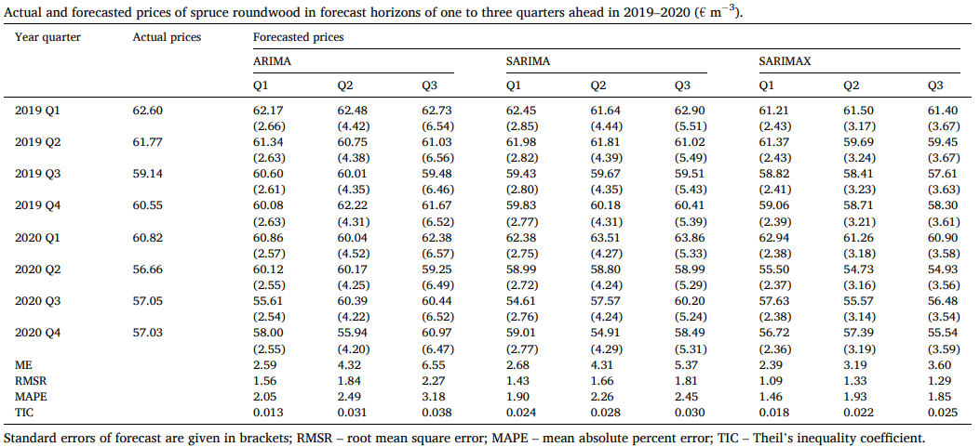
Pandit et al. (2023) showed ARIMAX and hybrid ARIMAX-LSTM outperformed ARIMA in agricultural forecasting, especially when domain-specific exogenous inputs were included. However, added complexity requires more robust variable selection and validation (Wang and Vo, 2025).
Table 2.3 Pandit et al (2023) Forecasting accuracies of the time series models under study
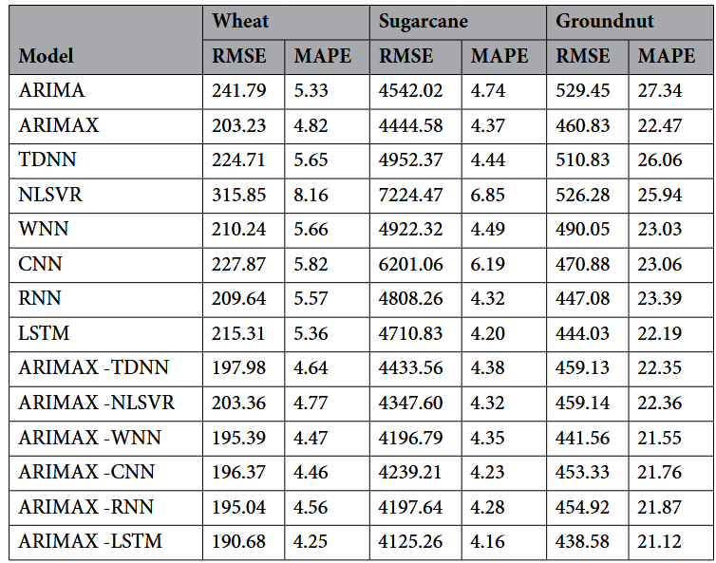
Exogenous inputs have been shown to work best when variables are timely and reflective of underlying conditions. Lagged indicators, macroeconomic variables, and sentiment data are common inclusions. However, their predictive value depends on sector, context, and forecast horizon (Chiu et al., 2019; Wang and Vo, 2025).
ARIMA models remain effective in stable settings and are easier to interpret, whereas LSTMs can outperform in non-linear, high-volatility conditions. For small datasets, ARIMA may even surpass LSTM (Yamak, Yujian and Gadosey, 2020). Conversely, LSTM with attention mechanisms performs better in fast-changing, sentiment-driven environments (Joosery and Deepa, 2019).
Evaluation techniques such as rolling-window testing are crucial for identifying how well models adapt during disruption. Rolling and expanding window evaluations help assess model adaptability by simulating real-world forecasting where only past data is available. This approach reduces the risk of lookahead bias and allows for performance monitoring over multiple, shifting training and test splits. Such methods are particularly useful when testing models across pre-, mid- and post-shock periods (Makridakis, Spiliotis and Assimakopoulos, 2018).

Sector-Specific Considerations
Different sectors respond to volatility in different ways. For example, retail and technology stocks are often influenced by short-term sentiment and media cycles, while energy and manufacturing tend to be more exposed to supply chain shocks.
Joosery and Deepa (2019) reported that LSTM worked best with high-frequency data in volatile sectors such as technology, whereas ARIMA was more reliable in sectors with slower-moving trends. Yamak, Yujian and Gadosey (2020) likewise noted that ARIMA outperformed LSTM when forecasting Bitcoin prices, mainly due to short data samples and the absence of exogenous inputs. This reinforces earlier observations about LSTM’s dependence on large, high-quality datasets: in settings with limited or noisy data, simpler models like ARIMA may not only be more robust but also more interpretable.
These results underline the need for sector-sensitive modelling. Input variables should reflect the external factors most relevant to each industry. For instance, fashion may depend on seasonal trends and labour disruptions, food production may be shaped by climate conditions and logistics data, and technology sectors may be more affected by research and development spending or semiconductor supply chain constraints.

Gaps in the Literature
Although significant progress has been made, important gaps remain in how forecasting models handle volatility and exogenous inputs.
- Exogenous features are often chosen based on convenience or generic technical indicators rather than context-specific, sector-relevant variables such as tariffs, freight costs or consumer sentiment (Castilho, 2020; Dai, Zhu and Kang, 2021; Ma and Yan, 2022; Wang and Vo, 2025).
- There is a shortage of cross-sector and cross-market studies to test whether findings can be generalised. Much of the existing literature focuses on single sectors or case studies, such as timber (Banaś and Utnik-Banaś, 2021), agriculture (Pandit et al., 2023) or specific stock markets (Wang and Vo, 2025).
- While the COVID-19 period has been widely analysed, fewer studies test whether strategies effective in that context retain predictive value during new disruptions such as the 2025 United States trade issues. Wang and Vo (2025) highlight that rapidly evolving market dynamics make adaptable and generalisable forecasting frameworks more important than ever.
Together, these gaps point to the need for further comparative research on statistical and deep learning models, systematic evaluation of variable selection methods, and analysis of whether findings can be transferred across both sectors and different types of disruption.

Conclusion
This review has examined the role of exogenous variables in time series forecasting during periods of volatility. Traditional models such as ARIMA and SARIMA are valued for their simplicity and interpretability, but their performance weakens when structural breaks occur. Extensions like ARIMAX and SARIMAX can improve accuracy by incorporating relevant external factors.
Deep learning models such as LSTM capture complex, non-linear dynamics but face challenges of interpretability and implementation. Hybrid models, such as ARIMAX-LSTM, offer a potential balance between these strengths and weaknesses.
Careful selection of exogenous variables, supported by both domain knowledge and statistical testing, remains crucial. Sector-specific behaviour also shapes forecasting outcomes, but this is still underexplored in much of the literature.
This thesis contributes to addressing these issues by comparing models across sectors and evaluating how exogenous variables affect performance during volatility. It focuses on three key questions:
- Which exogenous variables meaningfully improve accuracy?
- In what contexts and sectors are they most effective?
- How can forecasting systems remain robust during unpredictable events?
The overall aim is to explore how exogenous variables can be used strategically to strengthen time series forecasting in volatile markets shaped by major external shocks.

Methodology

Research Design
This study takes an experimental, quantitative approach to test how the inclusion of exogenous variables affects forecasting accuracy during periods of economic volatility. Baseline models, using only past stock prices, are compared against models that also include external predictors. This design makes it possible to isolate and evaluate the effect of exogenous inputs. Figure 3.1 shows the overall process, which consists of data collection, preprocessing, model training, and evaluation. Models were trained and tested using an 80/20 date-based split, except during LSTM hyperparameter tuning where a random split was applied.
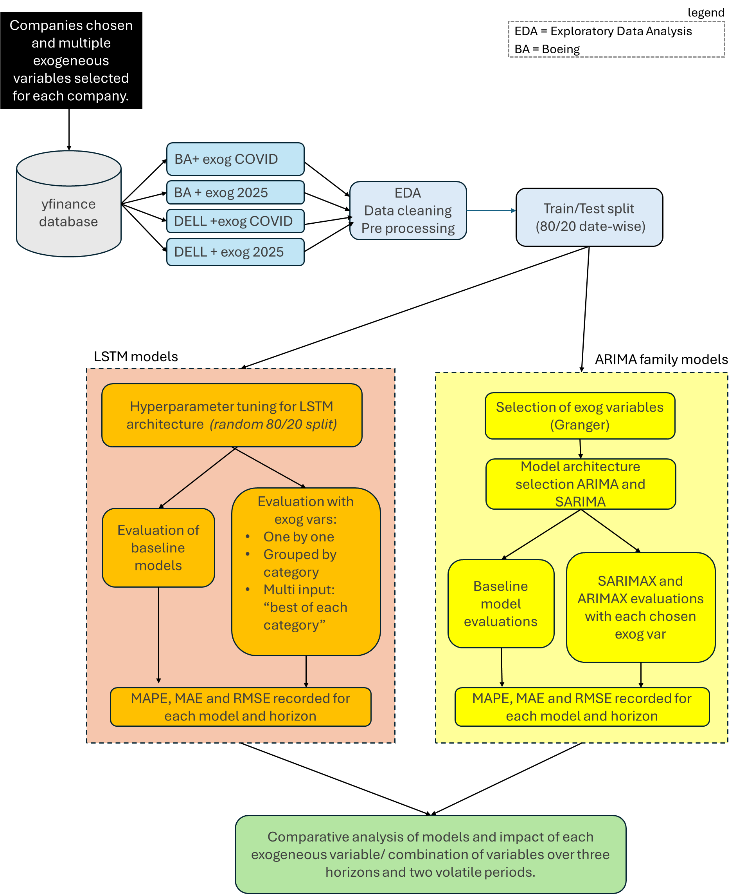
Figure 3.1: Research methodology. The process includes data collection, preprocessing, model training, and evaluation. Train/test splits were applied consistently (80/20 date-wise), with the exception of LSTM hyperparameter tuning, which used a random split
This comparative design reflects real-world forecasting conditions: it benchmarks baseline models against exogenous-augmented versions, making it possible to quantify the added value of external predictors under volatility.
Two periods of volatility were selected:
- COVID-19 (Q1 2020 – Q1 2021)
- the 2025 United States tariff disruption (Q1 – Q3 2025)
This setup also allowed testing whether model–variable combinations that performed well in one disruption remained effective in another (Objective 4).
All experiments were implemented in Python, mainly in Jupyter Notebook. This environment supported iterative development, visualisation of results, and integration of notes with code, helping to ensure reproducibility. Open-source libraries (statsmodels, scikit-learn, TensorFlow, and pmdarima) provided the flexibility to apply both statistical and deep learning methods under consistent conditions.

Project Management and Design
The research followed the CRISP-DM (Cross-Industry Standard Process for Data Mining) framework, which provides a structured approach for managing data-driven projects. Although developed for industry use, its six phases fit well with the design and execution of this thesis.
    - Business Understanding
This stage clarified the research problem and objectives. The central challenge was forecasting stock prices during volatile periods (COVID-19 and the 2025 tariffs) and testing whether exogenous variables, such as macroeconomic and supply chain indicators, could improve model performance. Four research objectives (O1 – O4) were defined to guide the study, covering both methodological comparisons (ARIMA/SARIMA versus LSTM, with and without exogenous inputs) and applied insights (sector-specific and cross-crisis behaviour).
    - Data Understanding
This stage involved identifying, sourcing, and exploring the datasets. The endogenous series consisted of daily stock prices for Dell and Boeing. Candidate exogenous variables included macroeconomic indicators, sector indices, and commodity prices. Initial exploration involved plotting time series, generating correlation heatmaps, and conducting Granger causality tests to assess potential predictive value. The COVID-19 period provided around two years of daily data, while the 2025 tariff disruption covered six months, a limitation discussed later in the thesis.

Data Preparation
Data were cleaned, aligned by trading days, and transformed where required. For ARIMA-family models, non-stationary series were differenced. For LSTMs, scaling and windowing were applied to create input sequences. Exogenous candidates were screened using correlation and causality tests to reduce noise and improve interpretability. The final prepared datasets included both endogenous and selected exogenous variables for each company and period.

Modelling
Two groups of models were implemented: statistical (ARIMA, SARIMA, ARIMAX, SARIMAX) and machine learning (LSTM). Baseline versions used only endogenous data, while augmented versions also included exogenous inputs. LSTM hyperparameters were tuned with Keras Tuner, and the best configuration was then fixed and reused across all experiments. This approach balanced practical constraints with the need for fair comparison, ensuring that the marginal effect of exogenous inputs was assessed consistently.

Evaluation
Models were evaluated using three error metrics (MAE, RMSE, and MAPE) across three forecast horizons (1, 3, and 7 days). Comparisons between baseline and exogenous-augmented models addressed O1 and O2, while analysis of variable categories informed O3 (sector-specific effects) and O4 (cross-crisis transferability). Both numerical metrics and visual tools, such as error plots and heatmaps, were used to interpret performance.

Deployment (Research Context)
In CRISP-DM, this stage usually refers to operationalising a model. In this thesis, it is taken to mean the communication of findings. Results are synthesised into a discussion of model performance, trade-offs, and practical implications. Limitations and future research directions are also identified to ensure transparency and support follow-up work.

Company and Period Selection
Two publicly traded companies were selected using purposive sampling, each representing a different economic sector:
- Boeing (BA) - Manufacturing/Aerospace
- Dell Technologies (DELL) - Information Technology
The intention was to investigate whether different types of exogenous variables would prove more useful for different sectors (Objective 3). This choice allowed for cross-sector analysis while still keeping the project manageable.
Each company was modelled separately for both volatility periods, resulting in four complete experimental setups:
- Boeing – COVID-19
- Boeing – 2025 tariffs
- Dell – COVID-19
- Dell – 2025 tariffs
This structure reduced the risk of bias towards a single industry or time frame, while also providing a framework to test how far results could be generalised. Although the study focuses on two sectors, the same methodology could be extended to others, such as healthcare or retail, to explore sector-specific forecasting in more depth.

Data Sources and Preprocessing
Daily closing stock prices for Boeing and Dell were collected from Yahoo Finance using the yfinance API. Candidate exogenous variables were identified with the assistance of ChatGPT, checked for availability on Yahoo Finance and assessed for relevance. Ideally, these variables would be selected by domain experts with detailed knowledge of the firms and their markets. In this project, ChatGPT was used as a practical starting point, and the list was then refined through a reasonableness check by the researcher.
Both stock and exogenous series were collected programmatically through yfinance. Initial downloads were carried out in Google Colab because queries from Jupyter Notebook often triggered connection timeout and “too many reads” errors. Using Colab ensured that complete datasets could be retrieved without interruptions. Once collected, the datasets were aligned to business days and matched to each company’s trading calendar.
Preprocessing was performed locally. Missing values were handled, and all series were aligned consistently to trading days. Because the aim of this thesis was to examine volatility, unusual peaks, flat periods, or outliers identified during exploratory analysis were retained rather than smoothed out. Apart from dealing with NaN values, no additional filtering was applied, as removing volatility-related behaviour would have undermined the research objectives.
The yfinance API was selected because it provides programmatic access to both equity prices and a broad set of market and commodity indicators. Its integration with pandas DataFrames streamlined preprocessing and reduced the risk of dataset mismatches. Pandas and NumPy were used for data manipulation and computation due to their efficiency with time series and compatibility with modelling libraries. Using a single API and a consistent preprocessing framework supported reproducibility.
The exogenous variables chosen for Boeing are listed in Table 3.1, while those for Dell are shown in Table 3.2.
Table 3.1 Exogenous variables used for Boeing (BA) with tickers, relevance, and category classification.
# | Variable | Ticker | Relevance | Category
1 | Steel ETF | SLX | Reflects input cost sensitivity, as Boeing uses large volumes of steel in production | Commodity
2 | Crude Oil Futures | CL=F | Influences airline operating costs, which affect aircraft demand | Commodity
3 | US Dollar Index | DX-Y.NYB | A stronger dollar reduces Boeing’s international competitiveness and order values | Macroeconomic
4 | Airline ETF | JETS | Captures the financial health of airlines, Boeing’s primary customers | Sectoral
5 | Aerospace & Defence ETF | ITA | Represents industry sentiment and performance of peers | Sectoral
6 | CBOE Volatility Index | ^VIX | Tracks overall market uncertainty, which can delay investment decisions | Macroeconomic
7 | 10-Year Treasury Yield | ^TNX | Reflects borrowing costs that influence financing of aircraft orders | Macroeconomic
8 | Industrial Sector ETF | XLI | Proxy for wider US manufacturing activity and demand | Sectoral
9 | Transportation ETF | IYT | Indicates logistics activity and freight demand, linked to aerospace supply chains | Supply Chain

Table 3.2 Exogenous variables used for Dell (DELL) with tickers, relevance, and category classification.
# | Variable | Ticker | Relevance | Category
1 | Semiconductor ETF | SMH | Captures supply and pricing trends in semiconductors, a critical input for hardware | Sectoral
2 | NASDAQ Composite | ^IXIC | Represents overall tech market sentiment and investor confidence | Sectoral
3 | Tech Sector ETF | XLK | Tracks performance of Dell’s peer group in the technology sector | Sectoral
4 | Copper Futures | HG=F | Input cost for electronics and components such as wiring and cabling | Commodity
5 | Crude Oil Futures | CL=F | Affects logistics and transport costs for shipping hardware | Commodity
6 | US Dollar Index | DX-Y.NYB | Influences Dell’s international sales through exchange rate effects | Macroeconomic
7 | 10-Year Treasury Yield | ^TNX | Proxy for interest rates, affecting enterprise IT investment | Macroeconomic
8 | CBOE Volatility Index | ^VIX | Captures uncertainty in financial markets that can dampen tech investment | Macroeconomic
9 | Consumer Discretionary ETF | XLY | Indicates consumer demand trends for PCs and personal technology | Sectoral
10 | Industrial Sector ETF | XLI | Reflects wider business cycle conditions relevant to B2B demand | Sectoral
11 | Transportation ETF | IYT | Tracks supply chain and freight conditions affecting hardware delivery | Supply Chain

Variable Selection Strategy
Boeing’s data was analysed first. Missing values were handled by dropping the first two missing cells (if present) and then applying forward-fill followed by back-fill for remaining gaps, so that dates aligned fully with the target series. This alignment was important for SARIMAX, which requires complete exogenous inputs on all target dates.
As part of exploratory data analysis, each variable was plotted and a correlation heatmap was used to examine relationships with the target stock and with each other. Correlation strengths shifted between the COVID-19 (2020–21) and 2025 tariff periods, indicating changing economic linkages. An illustrative example for Boeing is presented in Table 3.3.
Table 3.3 Correlation changes for selected exogenous variables with Boeing stock (COVID-19 vs 2025)
Variable | Correlation with BA  COVID-19 | Correlation with BA  2025 | Change
SLX (Steel ETF) | 0.49 | 0.72 | Slight increase
CL=F (Crude Oil) | 0.70 | –0.17 | Significant decrease
ITA (Aerospace ETF) | 0.97 | 0.91 | Slight decrease
XLI (Industrial ETF) | 0.57 | 0.88 | Increase
^TNX (10Y Yield) | 0.84 | 0.24 | Significant decrease
^VIX (Volatility Index) | –0.59 | –0.58 | No change
DX-Y.NYB (USD Index) | –0.08 | –0.46 | Decrease
IYT (Transport ETF) | 0.43 | 0.30 | Slight decrease
JETS (Airline ETF) | 0.95 | 0.19 | Significant decrease

Stationarity was assessed using the Augmented Dickey–Fuller (ADF) test. Non-stationary series were differenced once and re-tested; none required second differencing.
Predictive usefulness for SARIMA/SARIMAX was then evaluated using Granger causality on the stationary series. Variables that met conventional significance thresholds were retained. Where very few passed at 0.05, the maximum lag was increased and, where necessary, the threshold was relaxed to approximately 0.10 so that a meaningful set of candidates could be carried forward across companies and periods. Lag plots were reviewed alongside the test statistics to guide sensible lag choices when the automated output indicated very short lags that were inconsistent with the observed structure. In a small number of cases, variables that fell short of the strict threshold were kept for testing to preserve comparability and to ensure SARIMAX models had exogenous inputs to evaluate, with selection informed by the lag-plot evidence.
For LSTM models, no pre-filtering based on stationarity or Granger significance was applied. This was deliberate: neural networks can capture non-linear dependencies that may not appear in linear tests, and Objectives 1 and 3 required that potentially useful signals were not excluded at the screening stage.
Differencing sometimes reduced the apparent raw correlations between exogenous variables and the target series, which underlines the limitations of relying on undifferenced correlations alone for variable selection.
Finally, each retained variable and grouped categories were tested at the three forecast horizons (1, 3, and 7 days). Results were compared with baselines without exogenous inputs so that any gains or losses could be linked directly to the inclusion of these variables across companies and disruption periods. The same variable sets were then carried forward into the COVID-19 and 2025 tariff experiments, allowing a direct test of whether findings from one disruption generalised to another (Objective 4)

Modelling approach
To assess the effect of exogenous variables under realistic time and computing constraints, the modelling process was organised in two stages. First, a baseline model was trained and tuned using only endogenous variables for each forecasting method (ARIMA/SARIMA and LSTM). Second, the tuned configurations were carried forward as the basis for all exogenous-variable experiments. At this stage, individual variables, grouped categories, and best-performing sets were introduced and the models re-estimated.
This sequential design was adopted for two main reasons. The project ran within a twelve-week window, using personal hardware rather than high-performance computing. Fully re-tuning every model for every new exogenous-variable configuration would not have been practical within this timeframe. Keeping the underlying architecture and hyperparameters constant allowed for a clearer comparison, since differences in performance could be linked directly to the presence or absence of exogenous inputs rather than to changes in model specification.

ARIMA and SARIMA models
The aim of this stage was to ensure that ARIMA-type models were well configured, so that any performance differences observed later could be attributed to the presence (or absence) of exogenous variables rather than to poor baseline selection.
Model specification began with an inspection of Autocorrelation Function (ACF) and Partial Autocorrelation Function (PACF) plots for each company’s stock series. These plots helped identify autocorrelation and partial lags, guiding the choice of autoregressive (p) and moving average (q) parameters. Seasonal-Trend decomposition using LOESS (STL) was also applied to detect repeating seasonal patterns and longer-term trends. Where seasonality was evident, both seasonal and non-seasonal variants were considered, resulting in ARIMA, SARIMA, ARIMAX and SARIMAX models being tested.
To complement this manual diagnostic process, the auto_arima function from pmdarima was used as an automated parameter search tool. Where its suggested models conflicted with the ACF/PACF and STL diagnostics, manual alternatives and small grid searches were carried out to confirm whether seasonal terms should be included. This hybrid approach balanced the efficiency of automation with the domain-specific insight gained from statistical diagnostics.
Rather than committing to a single “best” specification at this stage, multiple candidate ARIMA and SARIMA models were retained for each company–period combination. This ensured that exogenous-variable experiments were not overly dependent on a single baseline and that comparisons reflected both seasonal and non-seasonal structures.
All candidate models, both automated and manually specified, were evaluated using a rolling-origin forecast strategy, where models were retrained as new observations became available. This ensured that performance metrics reflected realistic deployment conditions. Exogenous variables were then incorporated into ARIMAX and SARIMAX models one at a time for each forecast horizon (1, 3, and 7 days ahead). In addition, results were also summarised by variable category (macroeconomic, sectoral, commodity/supply chain) to see whether any consistent patterns of usefulness appeared across groups.
The detailed process of baseline selection, including diagnostics and candidate models for each company and period, is presented in Section 4.3.

LSTM Models
To evaluate forecasting performance at different lead times, this study used a direct forecast strategy: separate models were trained to predict stock prices at 1-day (short-term), 3-day (medium-term), and 7-day (long-term) horizons. This approach was chosen for its clarity, reduced complexity, and alignment with the aim of isolating the effect of exogenous inputs across different horizons. While multi-output forecasting could have produced several steps ahead in a single model, the direct approach gave cleaner, horizon-specific comparisons.
Architecture selection processes
The LSTM architecture was shaped by a mix of manual testing and systematic tuning. Initial exploratory trials compared design features such as activation functions, dropout layers, and network depth. For instance, a simple model with a Dense output, ReLU activation, Adam optimiser and MSE loss was tested, alongside variants using dropout, early stopping, and alternative activations such as tanh. A deeper two-layer ReLU model was also attempted but did not perform as well, so simpler structures were preferred.
Hyperparameter tuning was carried out using Keras Tuner with RandomSearch. The tuned parameters were then reused for all models, with each company, period and horizon retrained from scratch on its dataset. This ensured a consistent architecture across experiments, so that differences in performance could be attributed to the addition of exogenous variables rather than to changes in model design. The full hyperparameter search space used in tuning is provided in Appendix C, and the details of the final tuned LSTM architecture are reported in Section 4.4.
Activation and optimiser choices
The final architecture reflected both exploratory findings and tuning results:
- ReLU was efficient and reduced vanishing gradient problems, although tanh often gave smoother results for stock price data.
- Leaky ReLU was also tested, as it can avoid fully zeroing gradients.
- Sigmoid and Softmax were excluded from hidden layers as they saturate too easily and are not suited to continuous regression tasks.
- Adam and RMSprop were the main optimisers used, as their adaptive learning rates perform well on noisy financial time series. SGD was excluded because of slower convergence and heavier tuning demands.

Integration of Exogenous Variables
The baseline LSTM architecture was first trained without exogenous inputs to establish benchmarks for each forecast horizon. Exogenous variables were then incorporated in three stages:
- Single-variable tests: Each variable was added individually, with metrics compared against the baseline at 1-, 3-, and 7-day horizons (Objectives 3 and 4).
- Grouped-variable tests: Variables were grouped into macroeconomic, sectoral, and commodity/supply chain categories and tested as multi-input models to assess category-level impact.
- Best-of-category tests: The best-performing variable from each category (by MAPE) was combined into a single multi-input model to test whether a blended approach produced the stronger forecasts.
All models were evaluated across multiple random seeds (see Section 3.9). A consistent LSTM architecture was used throughout, so that differences in performance could be linked to the inclusion of exogenous inputs rather than to changes in model design. It is acknowledged, however, that tuning specifically for each variable or category might have altered relative rankings, which is highlighted as an area for future work.
All models were therefore set up to test the contribution of exogenous variables under consistent conditions. The next step was to define the forecast horizons used for evaluation.

Forecast Horizons (applied across models)
Forecast horizons were defined consistently across both ARIMA-family and LSTM models to make results directly comparable. Each model was evaluated across three horizons:
- Short-term (1 day ahead): immediate predictions.
- Medium-term (3 days ahead): short-range forecasts where patterns may evolve beyond the next day.
- Long-term (7 days ahead): tests whether predictive value is sustained further into the future.
Using multiple horizons helped reveal how accuracy changes over time and prevented conclusions from being drawn from a single frame of reference. For instance, if only 1-day forecasts were considered, baseline ARIMA models might have appeared sufficient, understating the added value of exogenous inputs. Evaluating short, medium, and longer horizons gave a more balanced picture of effectiveness, while also reflecting the common pattern that accuracy declines as uncertainty accumulates over longer periods.

Evaluation Strategy

Error Metrics
Model performance was assessed using three complementary error metrics:
- Root Mean Squared Error (RMSE): penalises larger errors more heavily, making it useful for identifying models that occasionally make substantial mistakes.
- Mean Absolute Error (MAE): provides a straightforward, scale-dependent measure of average error and is less sensitive to outliers than RMSE.
- Mean Absolute Percentage Error (MAPE): expresses error as a percentage, making results easy to interpret and directly comparable across companies, periods and price scales.
During hyperparameter tuning, Mean Squared Error (MSE) was used as the loss function, with validation loss guiding the Keras Tuner search. For evaluation and comparison, however, MAPE was chosen as the primary metric because of its interpretability and scale-independence, which are particularly important when comparing forecasts across different companies and disruption periods. RMSE and MAE were also reported to provide a fuller picture of performance and to avoid drawing conclusions from a single measure.

Data splitting strategy
To make evaluation realistic, models were trained on earlier segments of each disruption period and tested on later segments, simulating how forecasts would be used in practice.
For ARIMA, SARIMA, ARIMAX and SARIMAX models, this was implemented as a straightforward time-based holdout: models were fitted on the first 80% of observations and tested on the most recent 20%.
For LSTM models, two approaches were taken. During the hyperparameter search with Keras Tuner (see Section 3.6.2), an 80/20 random split was used so that the tuner could sample across the full dataset and identify a configuration robust to different conditions. For the final experiments, however, an 80/20 time-based split was applied, with the last segment of each series reserved for testing. This prevented look-ahead bias and ensured that reported performance reflected realistic forecasting conditions.

Computational Environment and Tools
The majority of computations were performed on a Lenovo ThinkPad T480s (Intel Core i5-8350U @ 1.70 GHz, 16 GB RAM, Windows 10). Additional runs were conducted on an HP Elite x2 G8 (Intel Core i5 11th Gen, Windows 11 Pro) to reduce total experiment time. Three of the four main notebooks were executed on the Lenovo, while the Dell 2025 tariff-period run was performed on the HP in parallel. GitHub was used to synchronise code and outputs between machines, ensuring consistency and traceability.
Model development and experimentation were carried out primarily in Jupyter Notebook. This environment supported interactive execution, inline visualisation, and stepwise debugging, all of which were essential for iterative forecasting experiments. It also allowed methodological explanations, code, and outputs to be integrated in a single, reproducible document.
For deep learning experiments, Keras/TensorFlow was used for its ease of prototyping, large community support, and compatibility with hyperparameter optimisation tools such as Keras Tuner. For statistical forecasting models, statsmodels was employed for ARIMA/SARIMA, as it provides transparent diagnostics (residuals, ACF/PACF, detailed summaries). Pmdarima’s auto_arima function helped automate initial parameter searches, while scikit-learn supported preprocessing and metric calculation. All experiments were run in Python 3.9 with the following key libraries: pandas, numpy, yfinance, statsmodels, scikit-learn, pmdarima, keras, and tensorflow.
To ensure comparability, a single LSTM architecture (tuned using Keras Tuner) was applied consistently across all exogenous-variable sets. The model was retrained from scratch for each experiment, but the underlying architecture and hyperparameters remained the same. This meant that any observed differences in performance could be attributed to the inclusion of exogenous variables rather than variations in model design. While re-tuning for each setup might have delivered marginal gains, it would have undermined the consistency needed for fair comparison.
Random seeds were introduced in later runs to improve reproducibility, particularly for LSTM models where stochastic weight initialisation and random splits can lead to variation. Early experiments had no seed set, and the “best per category” variable sometimes shifted between runs. This highlighted two points: (1) reproducibility required explicit seed control, and (2) many of the apparent differences between variables were more ‘much of a muchness’ than a clear performance gap. For final experiments, the random seed was fixed at 22 to ensure replicability.

Results and Evaluation

Exploratory Data Analysis (EDA)
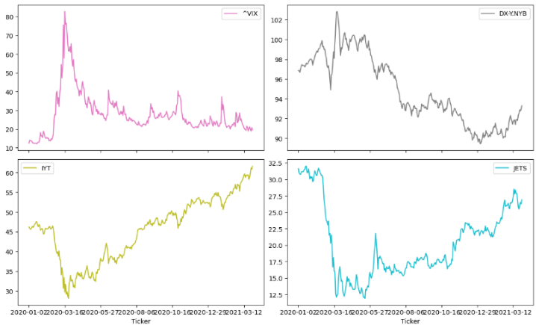
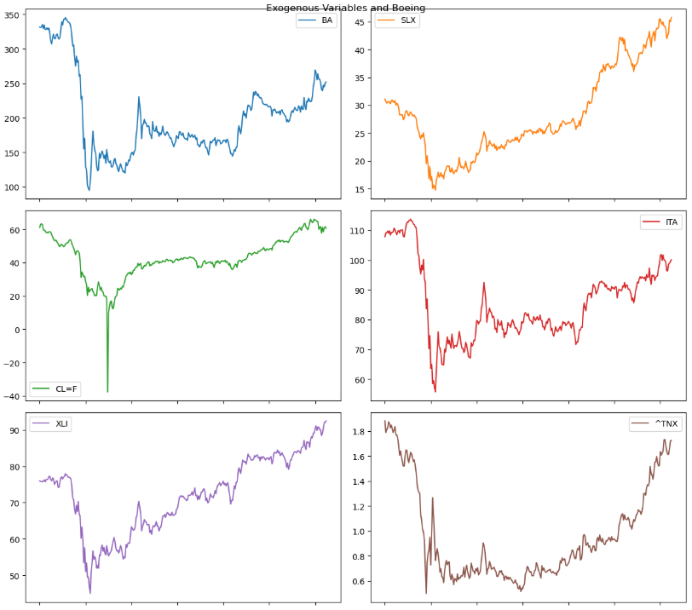
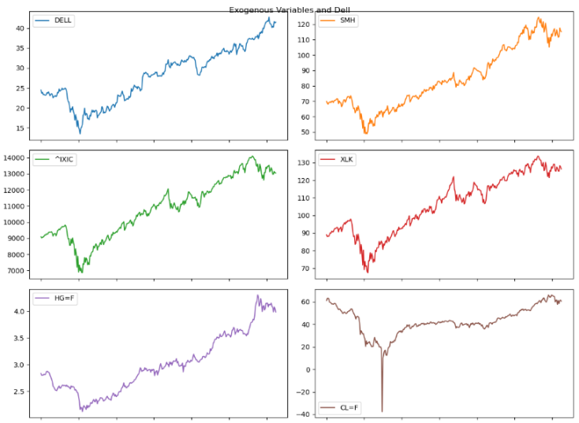
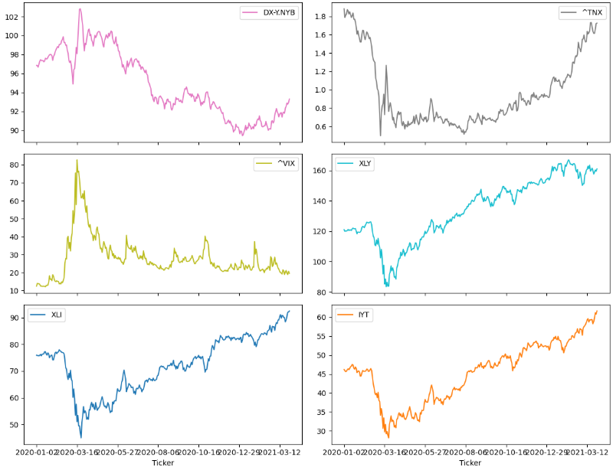
To begin with each company and their respective exogenous variables’ stock data were plotted together, using a multiplot, to check for any obvious gaps in the datasets or similar trends during the period. There were no significant issues with missing data, as expected given the use of yfinance. Generally, the exogenous variables plot suggested correlations with the main company series, both positive and negative. This was reflected in the lag-0 correlation heatmaps. These findings indicated that the selected exogenous variables were appropriate for further evaluation in this project. To explore this further, the next step was to quantify these relationships through correlation analysis.
Figure 4.1 Stock plots for DELL and exogenous variables for COVID-19 (EDA)

Figure 4.2: Stock plots for Boeing and exogenous variables for COVID-19 (EDA)

Initial correlation analysis
The table below shows the correlation heat maps between each candidate exogenous variable and the target company’s stock price, for both volatility periods (COVID-19 and the 2025 tariff disruption). Warm colours indicate positive correlations, while cool colours indicate negative correlations.
Table 4.1 Correlation heatmaps of exogenous variables and stock prices for Boeing and Dell during COVID-19 and the 2025 tariffs.
 | Boeing | Dell
COVID | 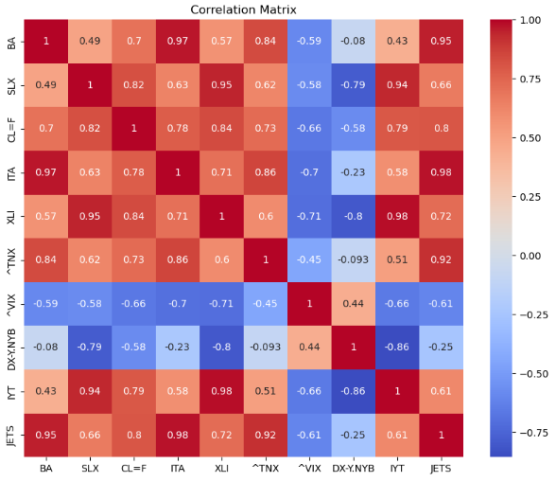 | 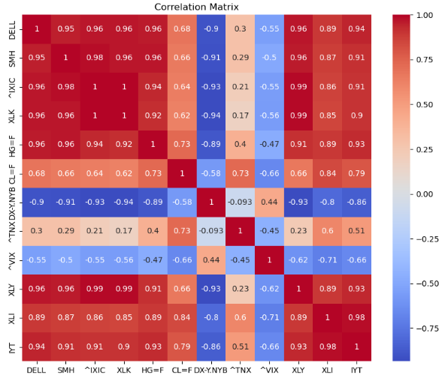
2025 | 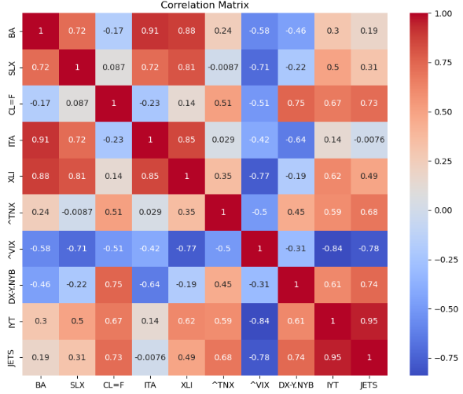 | 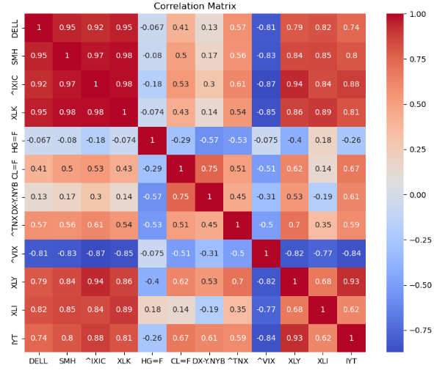
Boeing:
- COVID-19: Sectoral indices such as ^TNX, ITA, and JETS exhibited the strongest positive correlations with Boeing’s closing price (r ≈ 0.84 to 0.97). CL=F also showed a moderate positive correlation, while SLX (Steel ETF) and IYT displayed a weaker positive relationship (r ≈ 0.49 to 0.43). Conversely, volatility indices (^VIX) were negatively correlated and DX-Y.NYB (U.S. dollar index) showed little to no correlation.
- 2025 tariffs: Overall correlation strengths shifted. ITA, XLI, and SLX remained strongly positive with Boeing (r ≈ 0.72 to 0.91), while JETS and IYT weakened considerably. CL=F turned slightly negative (r ≈ -0.17), and macro indicators such as ^VIX and DX-Y.NYB stayed moderately negative. ^TNX was only weakly positive.
Dell:
- COVID-19: Sectoral indices such as SMH, XLK, and XLY exhibited very strong positive correlations with Dell’s price(r ≈ 9.4 to 9.6), while CL=F showed a moderate positive relationship. HG=F was also strongly aligned. In contrast, macroeconomic indicators were mixed: ^TNX was weakly positive, ^VIX was weakly negative, and DX-Y.NYB displayed a strong negative correlation (r ≈ -0.9).
- 2025 tariffs: The correlation structure changed markedly. Sectoral indicators (e.g., SMH, XLI) retained strong positive correlations, while HG=F weakened to near zero. CL=F remained moderately positive. ^VIX became strongly negative, and macroeconomic indicators such as ^TNX turned moderately positive.
Overall, the correlation patterns were shaped by both sector and period. For Dell, commodity and supply chain indicators mattered during COVID-19 but lost much of their strength by 2025 (HG=F dropped to near zero while CL=F remained only moderately positive), while for Boeing, sectoral indices stayed consistently relevant. These shifts suggested that variable usefulness might not carry over from one disruption to another (Objective 4), which is why later sections include period-specific model evaluations. Still, correlation by itself cannot confirm predictive value.
To assess whether these variables could be effectively incorporated into ARIMA-type models, stationarity testing was required as a first step.

Preparation of Data for ARIMA family models

Stationarity Testing
EDA plots and correlation heatmaps alone were not sufficient to decide which exogenous variables to include in the ARIMA family models. To assess suitability more rigorously, the Granger causality test was applied. However, before running this test, all series had to be checked for stationarity.
Stationarity was evaluated using the Augmented Dickey-Fuller (ADF) test. Because SARIMA-type models require stationary series for both the dependent and exogenous variables, variables were considered appropriate if they could be made stationary without excessive differencing.
Table 4.2 reports the ADF test results for each company and period, before and after first differencing. All variables became stationary after at most one round of differencing, meaning that none had to be discarded at this stage. Accordingly, all candidate variables were retained for the subsequent Granger causality analysis. This allowed the Granger causality tests to be applied consistently across companies and periods.
Table 4.2 Results of Augmented Dickey-Fuller (ADF) tests for Boeing and Dell exogenous variables across both periods, before and after first differencing.
 | Boeing |  | Dell
 | Before differencing | After one difference | Before differencing | After one difference
COVID | 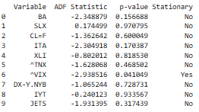 | 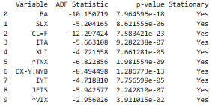 | 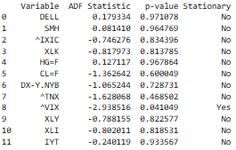 | 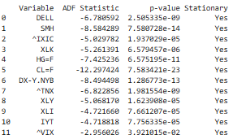
2025 | 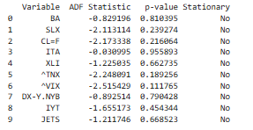 | 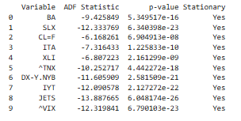 | 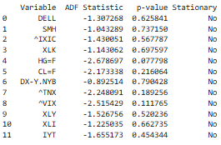 | 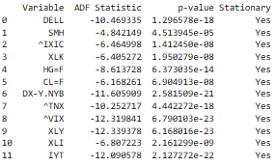

Granger Causality Tests
Granger causality tests were used to identify exogenous variables with predictive value for the target stock price under linear assumptions. This step was particularly important because ARIMA family models respond best to exogenous variables with linear relationships. Only variables that passed the Granger tests were included in the SARIMA-type models. In contrast, LSTM models can capture non-linear dependencies more effectively, so all candidate variables were evaluated in that framework.
The tests were conducted on stationary data, following any required differencing. Where the series was already stationary, no further differencing was applied. Notably, some of the correlations observed in the initial heatmaps weakened or disappeared once stationarity was imposed. To ensure enough variables could be retained for a meaningful comparison across companies and periods, the maximum lag parameter was increased. In a few cases, the significance threshold was relaxed from 0.05 to ≈0.1. (See Figure 4.3. Although CL=F did not pass the Granger threshold, it was retained for testing to ensure comparability)
Lag plots were reviewed alongside the Granger test statistics to help identify sensible lag lengths. This avoided cases where the test suggested very short lags (e.g., 1) that were inconsistent with the visual lag structure. A balance was struck between selecting lags long enough to capture meaningful dependencies (>1) but not so long that excessive data loss occurred. The resulting Granger outputs were then compared against the earlier correlation findings to examine how the two methods aligned and diverged.
Table 4.3 Granger causality test results (on stationary data) for Boeing and Dell exogenous variables across both disruption periods.
 | Boeing | Dell
COVID | 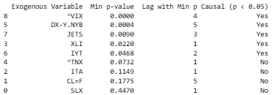 | 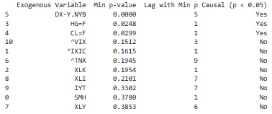
2025 | 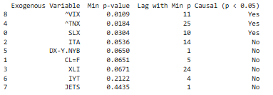 | 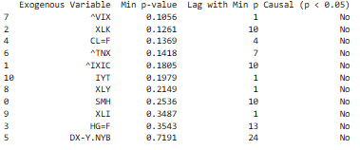

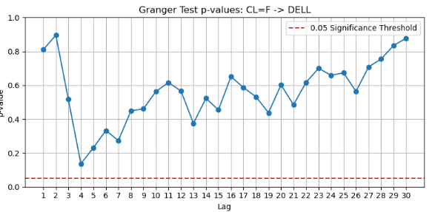
Figure 4.3: CL=F for Dell during 2025 tariffs.
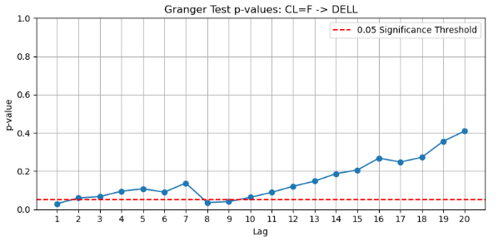
Figure 4.4: CL=F (Dell, COVID-19): Granger suggested lag=1, but lag plot indicated lag≈8 was more appropriate.
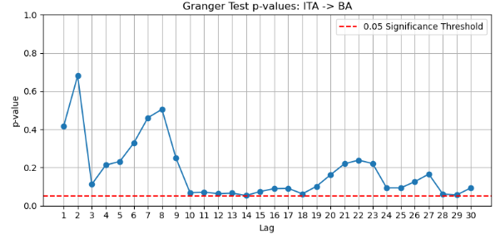
Figure 4.5: Granger causality plot for ITA (Boeing, 2025).
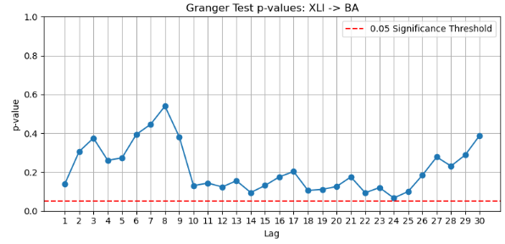
Figure 4.6: Granger causality plot for XLI (Boeing, 2025).
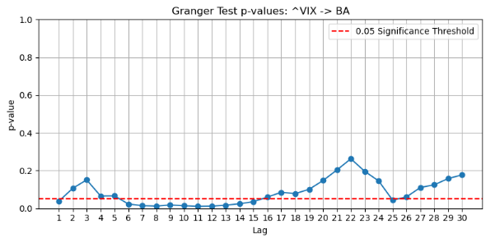
Figure 4.7: Granger causality plot for ^VIX, the most promising variable for Boeing (2025).
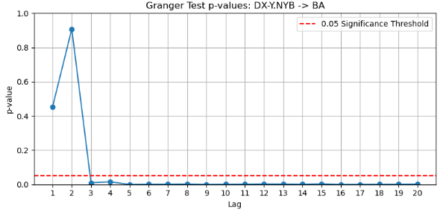
Figure 4.8: Example from Boeing (COVID-19) showing rationale for “sensible” lag choice.

Comparison of Correlation Heatmap Results and Granger Causality Test Outcomes
The correlation heat maps gave an initial indication of which exogenous variables moved in tandem with each company’s stock price. However, once the series were differenced to ensure stationarity, the Granger causality tests produced a narrower and sometimes unexpected set of variables for ARIMAX/SARIMAX modelling. In several cases, variables with strong contemporaneous correlations did not demonstrate predictive lagged effects, while others with weaker or even negative correlations were retained.
Boeing, COVID-19:
The heat maps highlighted ITA and JETS as very strongly correlated with Boeing’s price, yet ITA was dropped by the Granger test. CL=F also showed a moderate positive correlation but was excluded. In contrast, weaker or even negative correlations such as ^VIX and DX-Y.NYB were retained, along with ^TNX, JETS, XLI, and IYT. This shows that while correlation captures same-day co-movement, Granger tests whether lagged values help prediction.
Boeing, 2025 tariffs:
Despite strong lag-0 correlations for ITA, XLI, and SLX, the Granger test added weight to weaker or negative variables such as ^VIX, ^TNX, and CL=F, while JETS and IYT were excluded. The inclusion of CL=F, despite its near-zero contemporaneous correlation, highlights how lagged effects may capture predictive dynamics that raw correlations miss.
Dell, COVID-19:
For Dell, correlation patterns were dominated by sector and commodity variables. SMH, XLI, and HG=F all showed very strong positive correlations, with CL=F moderately positive, while macro indicators such as ^VIX and DX-Y.NYB were negative. The Granger shortlist carried forward DX-Y.NYB, HG=F, and CL=F, while strongly correlated sector indices like SMH and XLI were excluded. In this case, correlation and Granger outcomes aligned more closely than for Boeing, but still showed key differences.
Dell, 2025 tariffs:
In this case, SMH and XLI showed strong positive correlations, while CL=F was only moderately positive and ^VIX strongly negative. Granger testing, however, kept ^VIX but excluded SMH, and CL=F was carried forward for comparability despite not passing the strict Granger threshold. This was unexpected: one of the strongest correlations (SMH) was dropped, while weaker or even negative correlations were kept, likely reflecting lagged predictive effects rather than direct co-movement.
Overall, the comparison between correlation heatmaps and Granger results showed that strong correlation did not guarantee a variable would be retained, while weak or negative correlations did not necessarily exclude one. For example, ITA in Boeing’s COVID-19 period and SMH in Dell’s 2025 period both had very strong correlations but were dropped by the Granger test. Conversely, variables such as ^VIX (negative in both cases) and ^TNX (weak in 2025) were retained, reflecting their lagged predictive influence. The choice of lag length proved particularly important: several variables only passed once the maximum lag was extended to around 30 days, consistent with the idea that macroeconomic and supply chain effects take longer to feed through. The degree of alignment between correlation and Granger results also varied by context: Dell during COVID-19 showed closer alignment than Boeing or Dell in 2025, but important mismatches still remained. This filtering step substantially reduced the pool of candidate variables for SARIMA-type models, with the retained set reflecting lagged predictive power rather than contemporaneous correlation. For completeness, all variables, whether or not they passed Granger, were still carried forward for LSTM testing to allow for the capture of potential non-linear relationships.
Table 4.4 Comparison of correlation and Granger test outcomes for Boeing and Dell across both disruption periods.
Company & Period | Variables Strong in Correlation Heat Map | Variables Retained After Granger Test | Key Notes
Boeing: COVID-19 | ITA, JETS (very strong); ^TNX strong; CL=F, XLI moderate; ^VIX negative | ^VIX, ^TNX, DX-Y.NYB, JETS, XLI, IYT | ITA and CL=F dropped despite strong lag-0 correlations. ^VIX and DX-Y.NYB retained despite weak/negative correlations.
Boeing: 2025 | ITA, XLI very strong; SLX strong; JETS, IYT, ^TNX weak; CL=F slightly negative; ^VIX, DX-Y.NYB negative | ^VIX, ^TNX, SLX, ITA, XLI, CL=F | JETS and IYT excluded despite some contemporaneous correlation. CL=F retained despite weak negative correlation, suggesting lagged effects.
Dell: COVID-19 | SMH, XLI, HG=F very strong; CL=F moderate; ^VIX and DX-Y.NYB negative | DX-Y.NYB, HG=F, CL=F | Strongly correlated sector indices (e.g., SMH, XLI) were excluded, while commodities and DX-Y.NYB were retained. Shows closer alignment than Boeing, but key mismatches remained.
Dell: 2025 | SMH, XLI very strong; XLK, ^XIC strong; CL=F moderate; ^VIX strongly negative | ^VIX, ^TNX, CL=F* | SMH and XLI excluded despite very strong correlations. ^VIX included.  * CL=F retained for comparability despite not passing the strict Granger threshold.

With this filtered set of exogenous variables in place, the next step was to select appropriate ARIMA/SARIMA model architectures for evaluation.

Model Selection for ARIMA/SARIMA
Across all company–period combinations, the initial plan was to identify a single best-performing ARIMA/SARIMA baseline per context and then carry this forward into all exogenous-variable trials. However, there was uncertainty about how different model structures might interact with exogenous inputs. Narrowing the choice too early risked committing to a suboptimal baseline. To mitigate this, multiple candidate models were retained in each case, ensuring that exogenous-variable evaluations were not overly dependent on a single configuration. These candidates were chosen using a consistent procedure: inspection of ACF/PACF plots, STL decomposition to assess trend and seasonality, Auto ARIMA for automated parameter selection, and grid search where seasonality was suspected, but not supported, by Auto ARIMA. Both seasonal and non-seasonal variants were included where justified by the diagnostics.
    - Boeing – COVID-19
For Boeing’s COVID-19 period (Q1 2020 - Q1 2021), ACF and PACF plots indicated moderate short-lag autocorrelation and partial autocorrelation, with patterns most consistent with low-order ARMA processes. The PACF suggested an MA(2) structure might be appropriate, while the ACF pointed to low autoregressive terms.
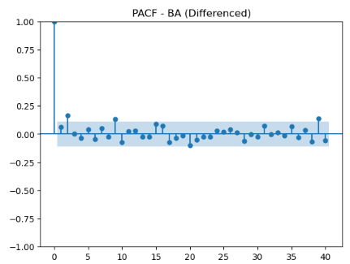
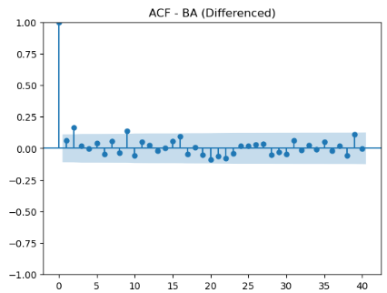
Figure 4.9: PACF plot for Boeing during COVID-19
Figure 4.10: ACF plot for Boeing during COVID-19
Seasonal-trend decomposition revealed a weak but visible cyclical component, broadly consistent with a weekly trading rhythm (5-7 business days). The amplitude of this seasonal component was small compared to the trend and irregular components, suggesting only modest potential benefit from seasonal adjustment.
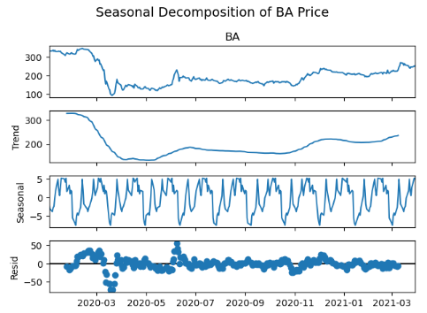
Figure 4.11: Seasonal-trend Decomposition for Boeing during COVID-19
Auto ARIMA, when run with seasonality disabled, selected an ARIMA(0, 1, 2) model based on the lowest in-sample AIC. With seasonality enabled, Auto ARIMA did not identify any improvement from adding a seasonal component. However, a grid search with seasonality enabled selected SARIMA(0, 1, 2)(1, 0, 1, 30) as the best candidate by AIC among the tested seasonal configurations. This contradicted the approximate weekly cycle suggested by STL decomposition, but weekly lags (5-7) tested in the grid search produced weaker AIC values than the 30-day option. For that reason, the 30-day specification was retained, though the potential for overfitting to monthly reporting/trading patterns is acknowledged.
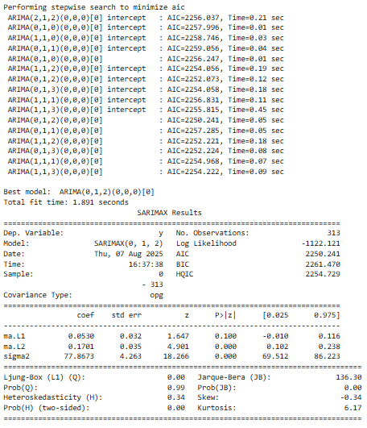
Figure 4.12: Auto ARIMA with seasonality off ( Boeing, COVID-19)
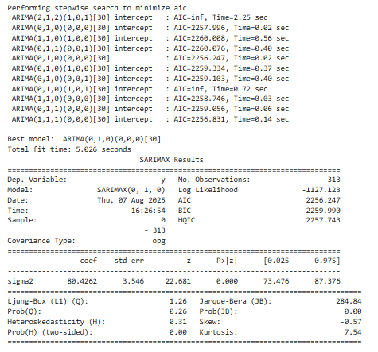
Figure 4.13: Auto-ARIMA with seasonality on (Boeing, COVID-19).
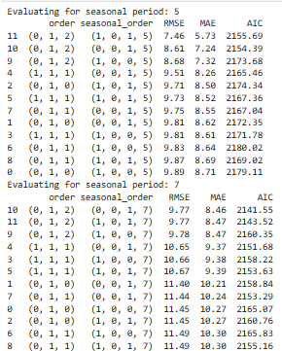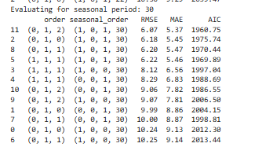
Figure 4.14: Excerpt of seasonal grid search supporting SARIMA(0,1,2)(1,0,1,30) (Boeing, COVID-19).
To ensure that exogenous-variable evaluations were not overly dependent on a single baseline, four configurations were taken forward:
- ARIMA(0, 1, 2) – Auto ARIMA’s non-seasonal choice, strong across 3- and 7-day horizons, and with a stable MA structure suited to absorbing shocks from exogenous inputs.
- SARIMA(0, 1, 2)(1, 0, 1, 30) – Best seasonal option from grid search.
- ARIMA(0,1,1) and ARIMA(1,1,0) – variants to test whether modest AR or MA terms improved robustness.
This multi-model approach allowed exogenous variables to be tested across both seasonal and non-seasonal structures, reducing the risk that results were biased by reliance on a single, possibly unsuitable, baseline.
The same model-selection procedure was then applied to the remaining firm–period combinations to ensure comparability across contexts.

Boeing – 2025 Tariffs
or Boeing’s 2025 tariff period (Q1–Q3 2025), the ACF and PACF plots again pointed towards low-order ARIMA processes, though with clearer evidence of possible seasonality. STL decomposition revealed a repeating component with an approximate monthly frequency (~30 business days), reinforcing the case for testing SARIMA variants.
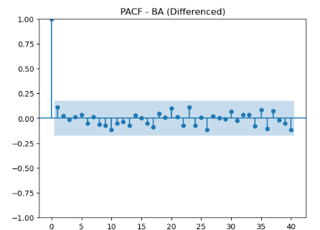
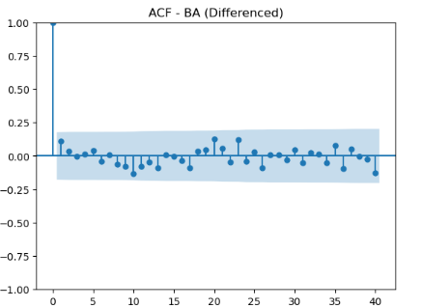
Figure 4.15: PACF plot for Boeing during 2025
Figure 4.16: ACF plot for Boeing during 2025.
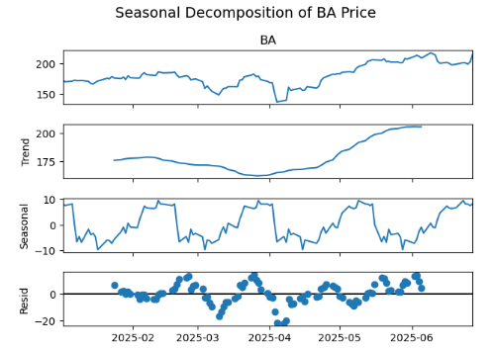
Figure 4.17: STL decomposition for Boeing 2025
When Auto ARIMA was run without seasonality, it recommended ARIMA(0, 1, 0) as the best in-sample fit. With seasonality enabled, Auto ARIMA did not identify a suitable model. However, a grid search across seasonal orders highlighted SARIMA(1, 1, 1)(1, 0, 0, 30) as the strongest candidate (RMSE = 5.19, MAE = 3.08, AIC = 518.66).
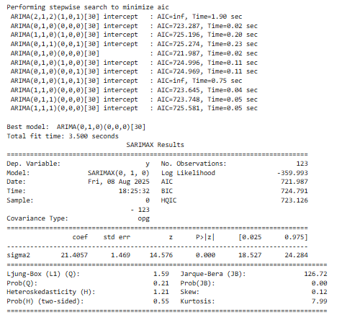
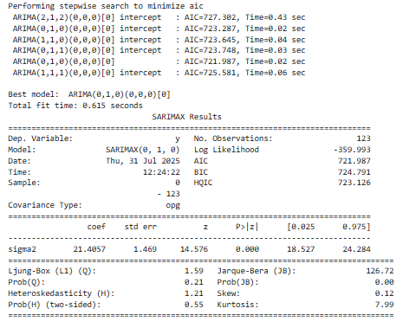
Figure 4.18: Auto-ARIMA for Boeing 2025 with seasonality on
Figure 4.19: Auto-ARIMA for Boeing 2025 with seasonality off
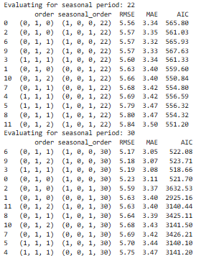
Figure 4.20: Excerpt of grid search results supporting SARIMA(1,1,1)(1,0,0,30) (Boeing, 2025).
To provide a balanced set of baselines, the following configurations were carried forward:
- ARIMA(0, 1, 0): Auto ARIMA’s minimal baseline.
- ARIMA(1, 1, 1): A standard benchmark in financial time series, also supported by ACF/PACF.
- ARIMA(1, 1, 0) and ARIMA(0, 1, 1): Variants testing isolated AR or MA effects.
- SARIMA(1, 1, 1)(1, 0, 0, 30): Best seasonal model from the grid search.
Taken together, these results for Boeing demonstrated that while Auto ARIMA often defaulted to minimal baselines, additional seasonal candidates could still emerge through grid search.

Dell – COVID-19
The next stage applied the same diagnostic and selection process to Dell, beginning with the COVID-19 period (Q1 2020 – Q1 2021). STL decomposition revealed a strong upward trend alongside a consistent cyclical pattern, most likely reflecting weekly trading activity (5–7 business days). As expected, the Augmented Dickey–Fuller (ADF) test confirmed non-stationarity, justifying the use of first differencing.
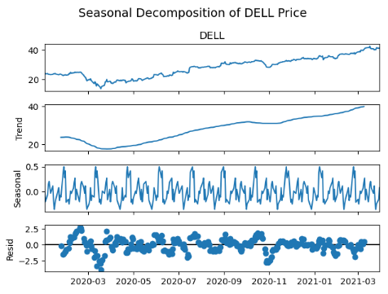
Figure 4.21: STL decomposition for Dell during COVID-19.
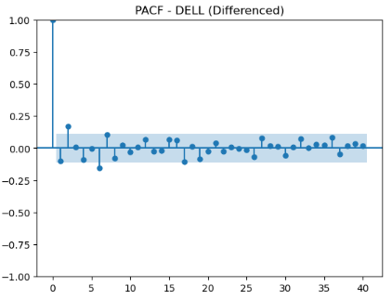
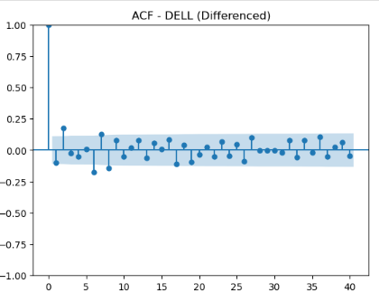
Figure 4.22: PACF plot for Dell during COVID-19.
Figure 4.23: ACF plot for Dell during COVID-19.
Inspection of ACF and PACF plots suggested that low-order AR and MA terms would be sufficient, with plausible candidates including ARIMA(1, 1, 1) and ARIMA(1, 1, 0).
Auto ARIMA identified ARIMA(0, 1, 2) as the optimal non-seasonal model. Unlike Boeing, it also detected seasonality, with SARIMA(0, 1, 2)(1, 0, 0, 7) emerging as a viable candidate consistent with the weekly cycle identified in the STL decomposition.
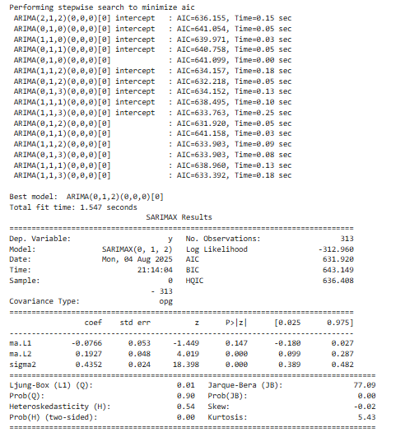
Figure 4.24: Auto-ARIMA output with seasonality disabled (Dell, COVID-19).
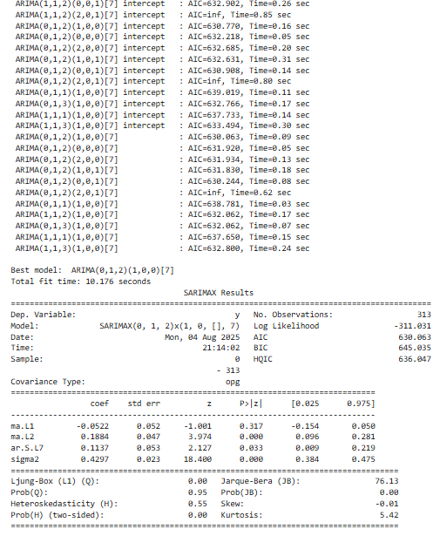
Figure 4.25: Auto-ARIMA identifying a seasonal component (Dell, COVID-19).
Based on these results, three models were carried forward:
- ARIMA(0, 1, 2): Auto ARIMA’s preferred non-seasonal structure.
- ARIMA(1, 1, 1): A conventional benchmark for stock price series.
- SARIMA(0, 1, 2)(1, 0, 0, 7): Capturing the weekly seasonality supported by both decomposition and auto-selection.

Dell – 2025
For Dell’s 2025 tariff-disruption period, the dataset covered ~125 business days (Jan to June 2025). STL decomposition showed a steady decline early in the period followed by partial recovery, confirming the need for differencing. The seasonal component was less pronounced than in the COVID-19 period, but signs of cyclical behaviour around 20–25 business days were apparent.
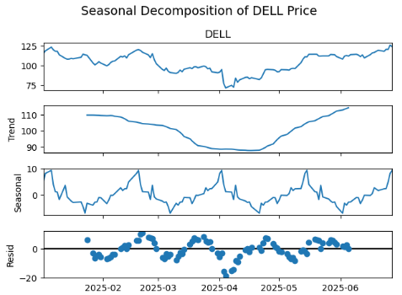
Figure 4.26: STL decomposition for Dell during the 2025 tariffs.
Auto ARIMA selected ARIMA(0, 1, 0) as the best non-seasonal fit, implying minimal autoregressive or moving-average structure. As with Boeing, Auto ARIMA did not detect a seasonal model, but a grid search identified SARIMA(1, 1, 1)(1, 0, 0, 21) as the best seasonal candidate, consistent with the observed approximate monthly pattern.
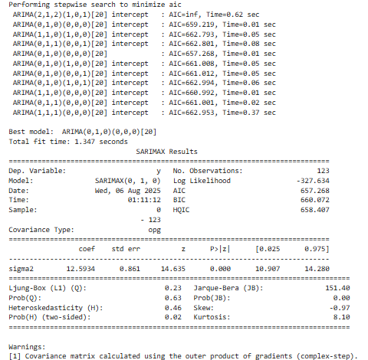

Figure 4.27: Auto-ARIMA output with seasonality disabled (Dell, 2025).
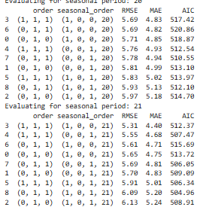
Figure 4.28: Seasonal candidate from grid search (Dell, 2025).
Based on these diagnostics, the following models were carried forward:
- ARIMA(0, 1, 0): Auto ARIMA’s minimal baseline.
- ARIMA(1, 1, 1): Standard benchmark informed by ACF/PACF.
- ARIMA(1, 1, 0) and ARIMA(0, 1, 1): To isolate AR or MA effects individually.
- SARIMA(1, 1, 1)(1, 0, 0, 21): Seasonal candidate from grid search.
As in other cases, carrying multiple models forward helped reduce the risk of over-reliance on a single baseline and ensured that exogenous-variable testing was not biased by model choice.
Across the four company–period combinations, the diagnostics generally pointed towards low-order ARIMA structures as suitable baselines, with seasonal variants only proving useful in certain cases. Boeing during COVID-19 and Dell in both periods showed some evidence of cyclical behaviour, but the strength of this seasonality varied. In some instances, it was only apparent through manual grid searches rather than automatic detection. Auto ARIMA often suggested very simple models such as ARIMA(0, 1, 0) or ARIMA(0, 1, 2), which underlined the value of combining automated selection with visual inspection and targeted grid searches. For this reason, several candidate models were carried forward in each case, covering both seasonal and non-seasonal structures. This reduced the risk that the evaluation of exogenous variables would be biased by relying on a single baseline All models were evaluated consistently over 1-day, 3-day, and 7-day horizons to allow comparison across companies and disruption periods. The next step was to introduce exogenous variables into these baselines and assess their impact on forecasting accuracy.
The following section sets out the baseline architecture used for the LSTMs, before turning to the evaluation of exogenous variables across both model families.

LSTM Baseline Architecture Selection
All LSTM experiments in this study used the same tuned baseline architecture, selected with Keras Tuner and retrained from scratch for each company and period. This ensured that performance differences reflected the effect of exogenous variables rather than changes in model design.
The baseline configuration consisted of a single LSTM layer with 64 units and a tanh activation, followed by a dropout layer (rate = 0.4) for regularisation, and a final dense output layer with linear activation. The model therefore produced a single scalar forecast from each input window. Although the tuner search space included options such as a second recurrent layer, alternative activations (e.g., ReLU), and different dropout arrangements, the best-performing configuration did not select these. In total, the chosen model contained around 17k trainable parameters, which increased slightly when additional features were included.
Training was carried out with the Adam optimiser (learning rate ≈ 6.6 × 10⁻³) and mean squared error (MSE) loss, with early stopping based on validation loss (patience = 3, restore best weights). Each run was capped at 20 epochs, although most converged earlier. A fixed random seed was introduced later in the project to improve repeatability.
Table 4.5 Baseline LSTM setup used in all experiments
Element | Details
Input shape | (window_size, features). One feature = stock only; more features when exogenous variables added.
Hidden layer | LSTM, 64 units, tanh activation, return_sequences=False.
Dropout | 0.40 applied after LSTM.
Output | Dense(1), linear activation (single forecast value).
Optimiser | Adam, learning rate ≈ 6.6 × 10⁻³.
Loss | Mean Squared Error (MSE).
Training | Early stopping on validation loss (patience = 3, restore best weights), max 20 epochs.
Parameters | Approx. 17,000 trainable (dropout layers have none).

When exogenous variables were introduced, they were appended as additional features to the input window. For example, with one exogenous series the input shape became (window_size, 2), and with grouped inputs (e.g., sectoral or macroeconomic blocks) the number of features expanded accordingly. Importantly, the network architecture and hyperparameters remained unchanged: only the input dimensionality varied, and the model was retrained in full for each experiment.
In summary, the baseline LSTM used throughout can be described as:
LSTM(64, activation=tanh, return_sequences=False) → Dropout(0.4) → Dense(1, activation=linear); Adam optimiser (lr ≈ 6.6 × 10⁻³), loss = MSE, EarlyStopping (patience=3).

Model performance comparison (O1 + O2)

Statistical vs Deep Learning approaches (baseline)
In Table 4.6 the performances of each of the baseline models for each of the companies and horizons are displayed as grouped bar charts with MAPE as the error metric. The differences between ARIMA-based models and the LSTM baseline can be compared visually over the different periods and horizons. They have been grouped by forecast horizon allows trends in model performance over increasing prediction lengths to be more easily interpreted.
Across both companies, baseline performance varied by forecast horizon and disruption period. At Horizon 1, ARIMA-based models generally performed better than the LSTM baseline. For Dell, forecast errors were higher in the 2025 tariff period than during COVID-19, while Boeing showed the opposite pattern, achieving greater accuracy in 2025. By Horizon 3, ARIMA still held a slight edge for Dell, though the gap narrowed, whereas for Boeing, the fixed LSTM baseline began to outperform ARIMA during the tariff period but not in COVID-19. At Horizon 7, the performance gap between approaches was smaller, with results often quite similar. For Dell, the LSTM baseline did better in 2025 but not in COVID-19, while for Boeing, forecasts were less accurate overall during the pandemic, though the LSTM gave the best results at this longer horizon. Differences between ARIMA and SARIMA were minor across periods, with SARIMA in some Boeing cases performing slightly worse than its ARIMA counterpart.
Overall, the traditional model appears to have performed better than the deep learning model for shorter forecast with LSTMs showing some improvements as it approached the longer, 7-day horizon.
Table 4.6 Baseline model MAPE comparison by horizon for Boeing and Dell.
 | Boeing | Dell
Horizon 1 | 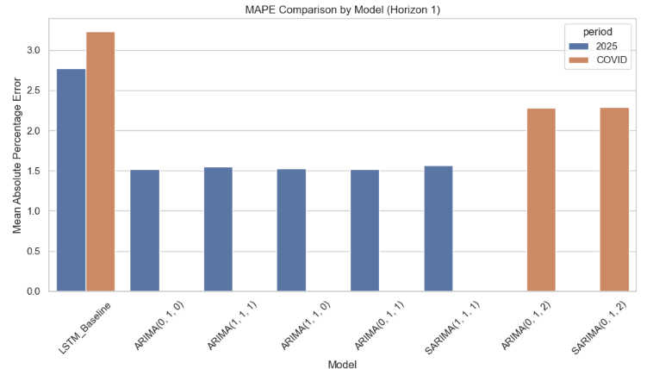 | 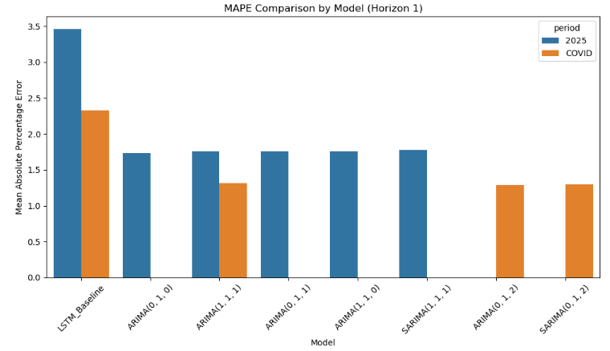
Horizon 3 | 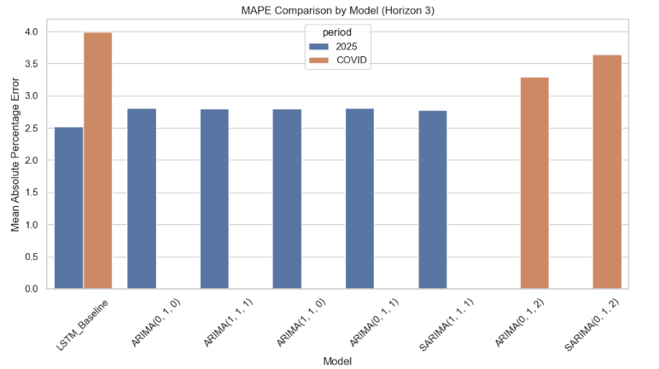 | 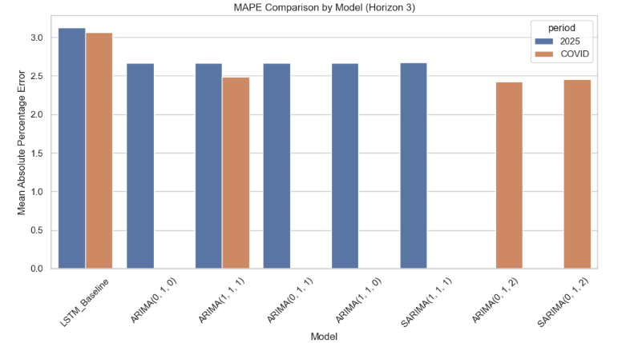
Horizon 7 | 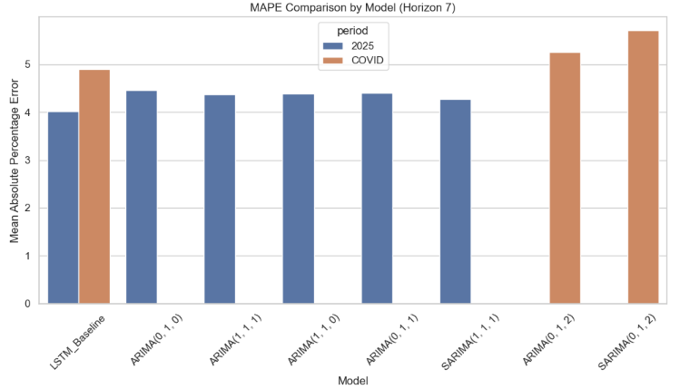 | 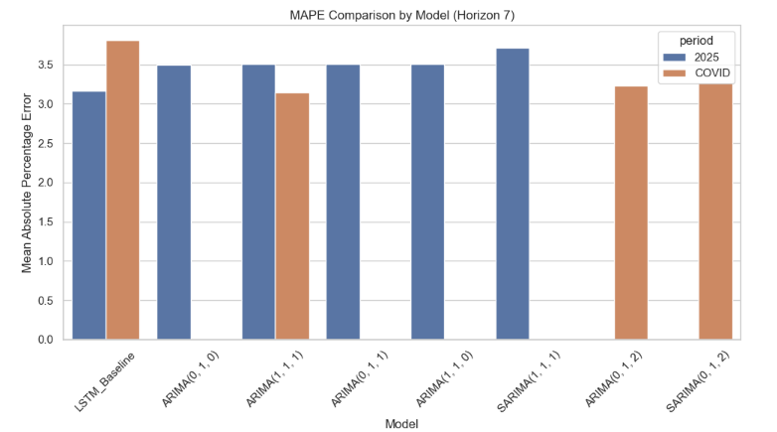

Traditional vs Enhanced models (ARIMA vs ARIMAX / SARIMA vs SARIMAX)
In this section, each ARIMA/SARIMA baseline is compared directly with its corresponding ARIMAX/SARIMAX variant across both companies and periods, at all forecast horizons. This allowed assessment of whether adding exogenous variables consistently improved the performance of the traditional statistical models.
Horizon 1
For Boeing, exogenous variables generally had little impact at the shortest forecast horizon. Most ARIMAX and SARIMAX configurations performed on par with, or slightly worse than, their baselines. The only notable exception was XLI, which provided improvements in both disruption periods across several model variants.

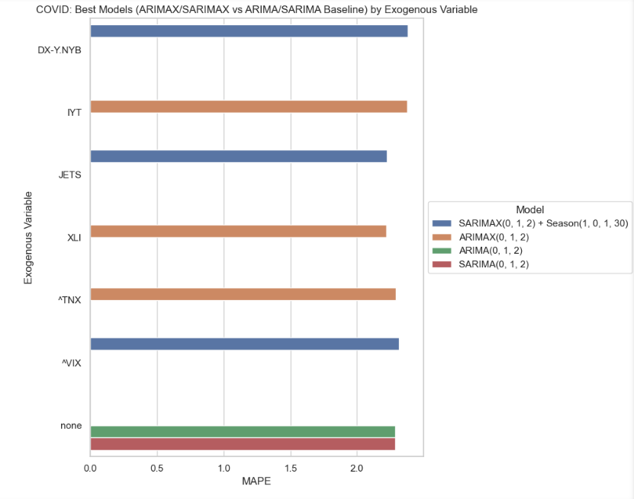
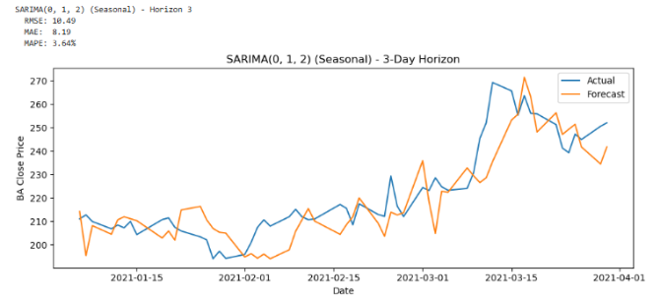
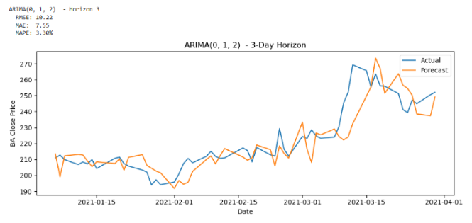
Figure 4.29: : Accuracy plots of ARIMA vs SARIMA for Boeing during COVID-19 (Horizon 3) to illustrate similar accuracy across traditional models

Figure 4.30: Forecast accuracy (MAPE) of top ARIMA and SARIMA models for Boeing during the COVID-19 period (Horizon 1). Sectoral exogenous variables (e.g., ITA, XLI) offered little improvement, with baseline ARIMA models performing similarly.
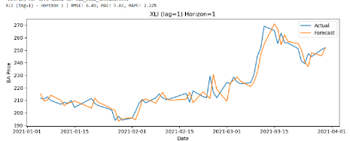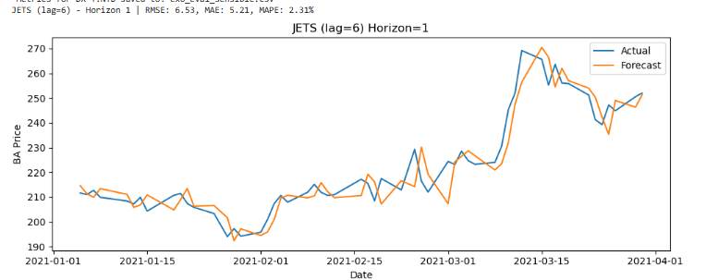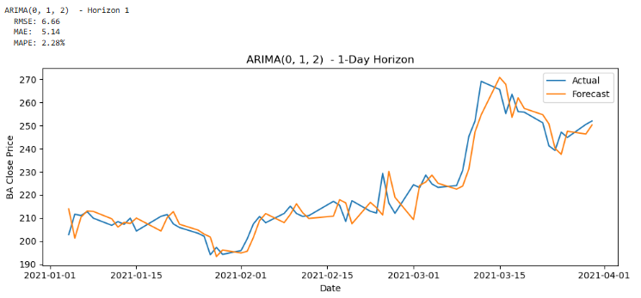
Figure 4.31: Boeing, COVID-19 (Horizon 1). Accuracy plots showing little difference between models. Model: ARIMA(0,1,2)
For Dell, exogenous inputs were similarly unhelpful, with performance typically matching or falling below the baselines. During the COVID-19, the only improvement came from including CL=F in a SARIMAX model. In the 2025 tariff period, marginal gains were observed from ^VIX and ^TNX when they were each added to the ARIMA(0,1,0) configuration, but these effects were not consistent across other models.
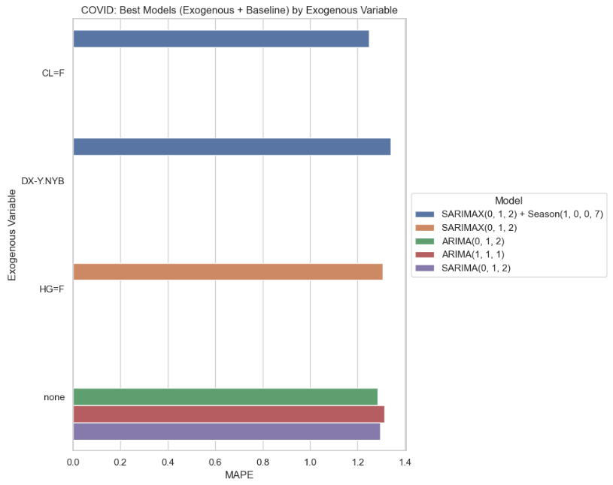
Figure 4.32: Forecast accuracy (MAPE) of top ARIMA and SARIMA models for Dell during the COVID-19 period (Horizon 1). SARIMAX with CL=F showed slight improvement over the baseline; other exogenous variables offered no gain
Horizon 3
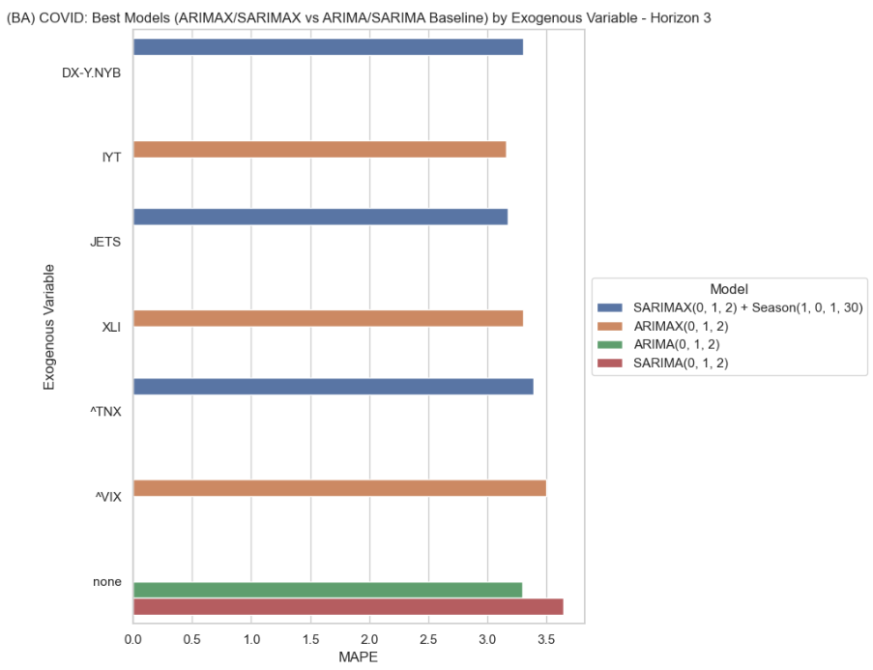
At this medium-term horizon, Boeing result showed a clearer benefit from exogenous inputs during COVID-19 Seasonal models performed better across all tested variables, while in non-seasonal models only IYT added value, which aligns with its predictive signal observed in the Granger causality tests. In the 2025 tariff period, improvements were smaller, limited mainly to ^TNX and ITA. The best-performing configuration in COVID-19 was an ARIMAX model with ITA, while in 2025 the strongest was a SARIMAX(1,1,1)(1,0,0,30) with ^TNX.

Figure 4.33: Forecast accuracy (MAPE) of top ARIMA and SARIMA models for Boeing during the COVID-19 period (Horizon 3). Seasonal SARIMAX with sectoral indices (e.g., ITA, XLI) consistently outperformed baseline models.
For Dell, improvements at Horizon 3 were also limited. During COVID-19, CL=F proved useful when included in seasonal SARIMAX models, but in the 2025 period no exogenous variables improved on the baselines.
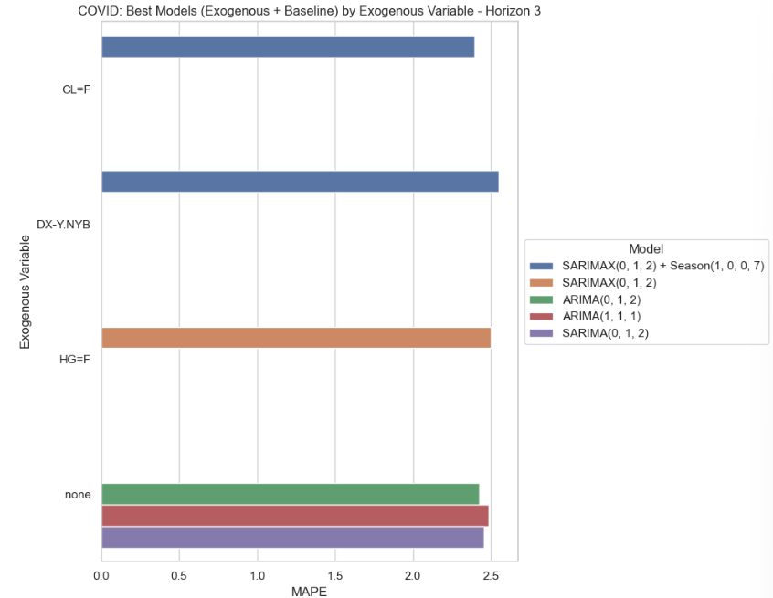
Figure 4.34: Forecast accuracy (MAPE) of top ARIMA and SARIMA models for Dell during the COVID-19 period (Horizon 3). SARIMAX with CL=F (crude oil) produced the clearest gains over the baseline.
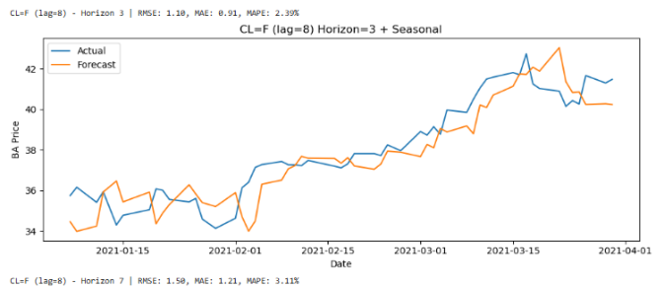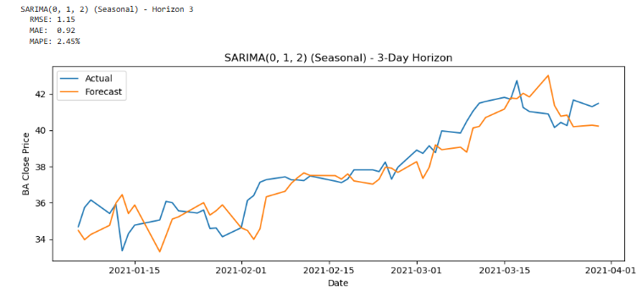
Figure 4.35: Accuracy plot showing slight improvement on SARIMA with CL=F for Dell during COVID-19.
Horizon 7
At the longest horizon, Boeing’s seasonal models were again the most responsive to exogenous variables during COVID-19, with all tested inputs producing at least modest improvements. In non-seasonal models, ^TNX was the only variable to improve accuracy, despite being negatively correlated with Boeing’s stock price at lag-0. In the 2025 tariff period, the influence of exogenous variables was weaker, with mixed gains and losses resulting in broadly similar performance between enhanced and baseline models. The strongest performer during COVID-19 was an ARIMAX(0,1,2) with ^TNX, closely followed by several seasonal SARIMAX variants. In 2025, the SARIMA(1,1,1) baseline gave the best results, although SARIMAX with ITA performed comparably.

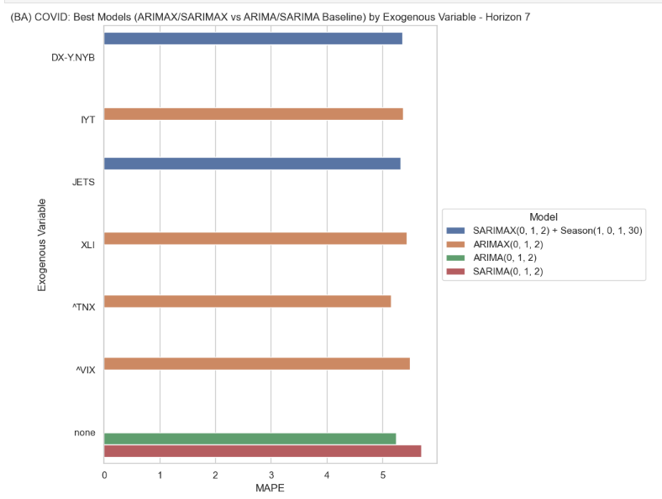
Figure 4.36: Forecast accuracy (MAPE) of top ARIMA and SARIMA models for Boeing during the COVID-19 period (Horizon 7). ARIMAX with ^TNX delivered the best results, despite ^TNX showing a negative contemporaneous correlation.
For Dell, CL=F was again beneficial during COVID-19 when paired with seasonal models. In 2025, however, the best gains came from ^VIX, which was particularly effective in a SARIMAX configuration despite its negative same-day correlation. This echoes the earlier finding from the Granger causality test that negative contemporaneous correlations did not preclude predictive power.
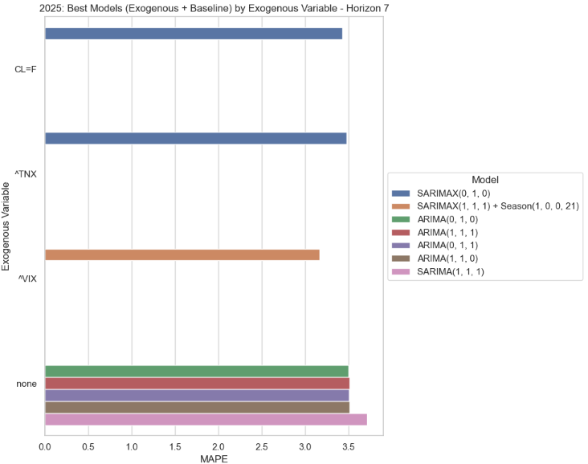
Figure 4.37: Forecast accuracy (MAPE) of top ARIMA and SARIMA models for Dell during the 2025 tariff disruption (Horizon 7). SARIMAX with ^VIX achieved the lowest error, despite ^VIX being negatively correlated in contemporaneous terms.

Summary
Across both companies, the impact of exogenous variables on ARIMA family models depended strongly on forecast horizon, period, and model configuration. The clearest gains came for Boeing during COVID-19, especially in seasonal models, while for Dell the benefits were more isolated, with crude oil (CL=F) and ^VIX emerging as the most effective variables in specific contexts.

LSTMs with and without exogenous variables (individual inputs)

To test whether exogenous inputs improved the deep-learning forecasts, the tuned LSTM baseline (without exogenous variables) was compared against versions of the model that included one variable at a time. Performance was assessed across both disruption periods and all forecast horizons. To make the comparison clear, delta plots of MAPE were used. In these plots, a negative bar indicates that adding an exogenous variable improved accuracy relative to the baseline.

Horizon 1 (short-term)
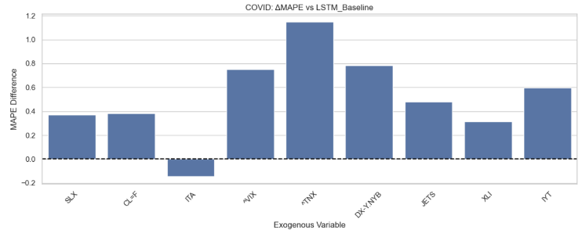
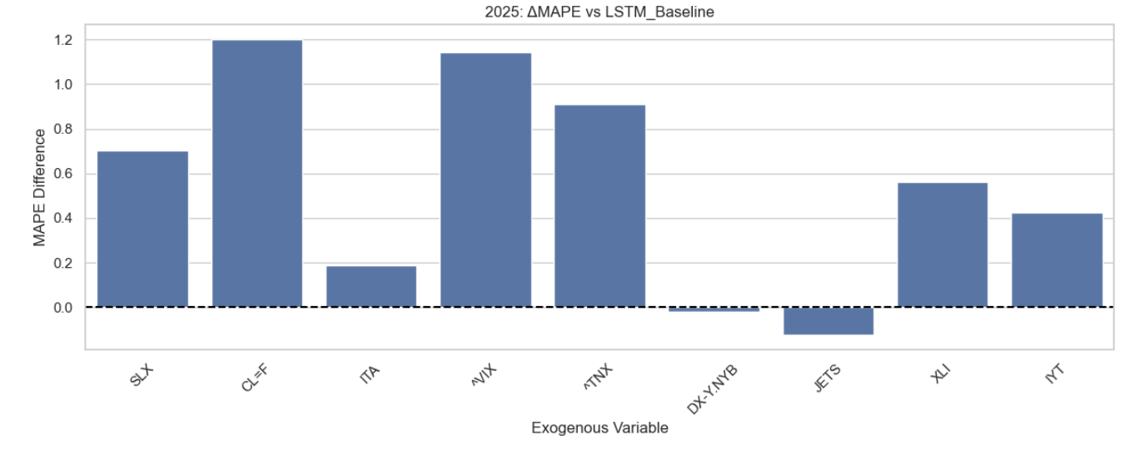
- Boeing: During COVID-19, ITA was the only variable to improve on the baseline; all others reduced accuracy. In 2025, JETS gave a small improvement and DX-Y.NYB performed roughly the same as baseline. Looking across variable types, sectoral indices tended to be the most effective additions in both periods.
Figure 4.38: MAPE delta plots for Boeing, Horizon 1: LSTM with single exogenous inputs compared to the baseline.
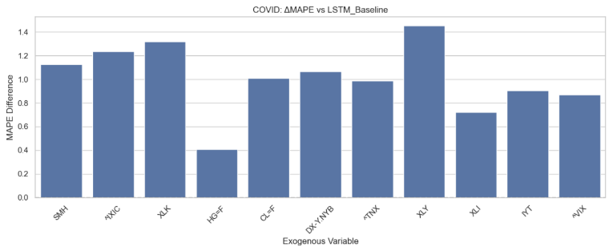
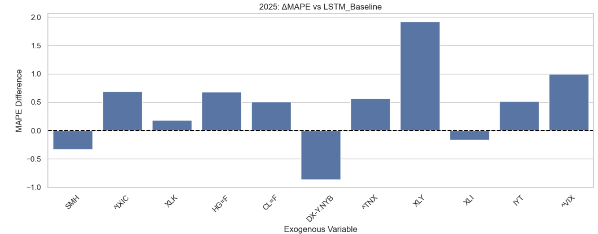
- Dell: In 2025, DX-Y.NYB, SMH and XLI each gave small improvements, while all other variables worsened the forecasts. During COVID-19, none of the exogenous inputs helped, with accuracy falling below the baseline in every case. The leading category shifted across periods: supply-chain variables were most effective in COVID-19, while sectoral indicators led in 2025.
Figure 4.39: MAPE delta plots for Dell, Horizon 1: LSTM with single exogenous inputs compared to the baseline.

Horizon 3 (medium-term)
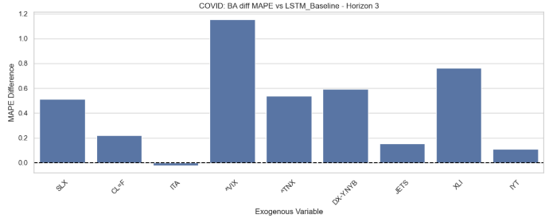
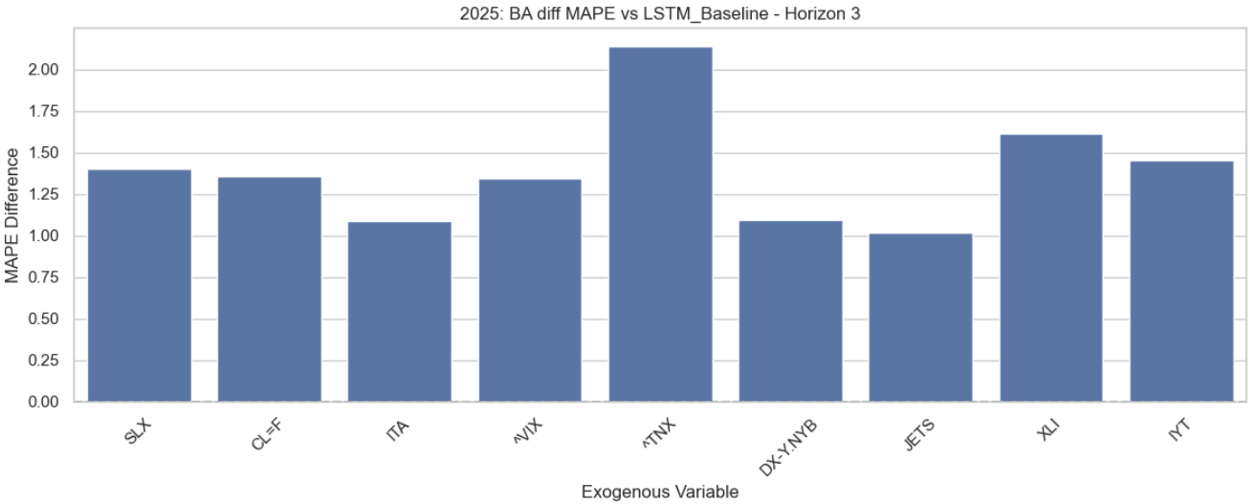
- Boeing: No clear gains were seen at this horizon. ITA and JETS performed about the same as the baseline during COVID-19, but all other variables worsened results. Category ordering was stable across periods: sectoral inputs gave the strongest results, and macroeconomic variables the weakest.
Figure 4.40: MAPE delta plots for Boeing, Horizon 3: LSTM with single exogenous inputs compared to the baseline.
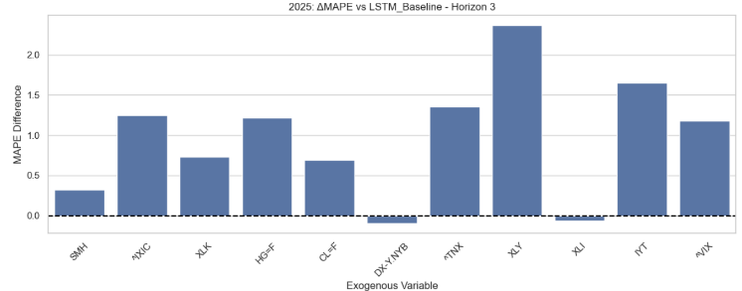
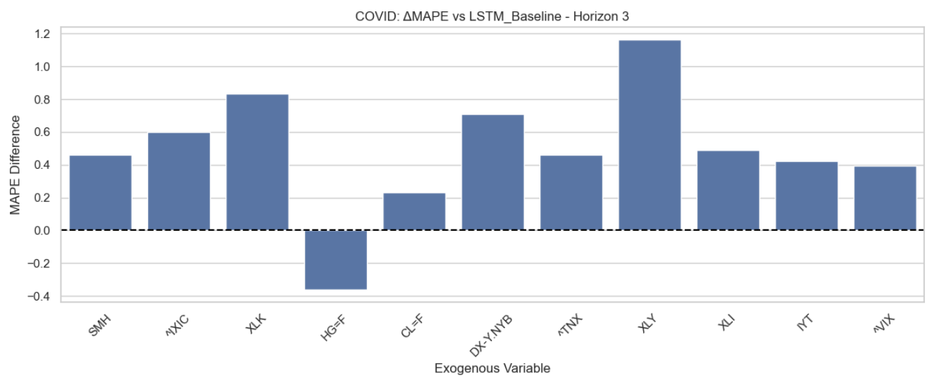
- Dell: HG=F (copper) improved forecasts during COVID-19, but in 2025 only XLI and DX-Y.NYB offered very slight gains, with all others performing worse. Category patterns differed across periods: supply-chain variables were best in COVID-19 but weakest in 2025.
Figure 4.41: MAPE delta plots for Dell, Horizon 3: LSTM with single exogenous inputs compared to the baseline.

Horizon 7 (long-term)
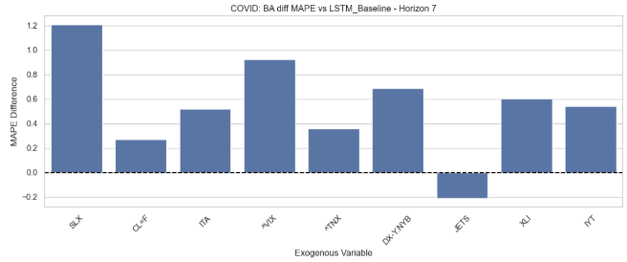
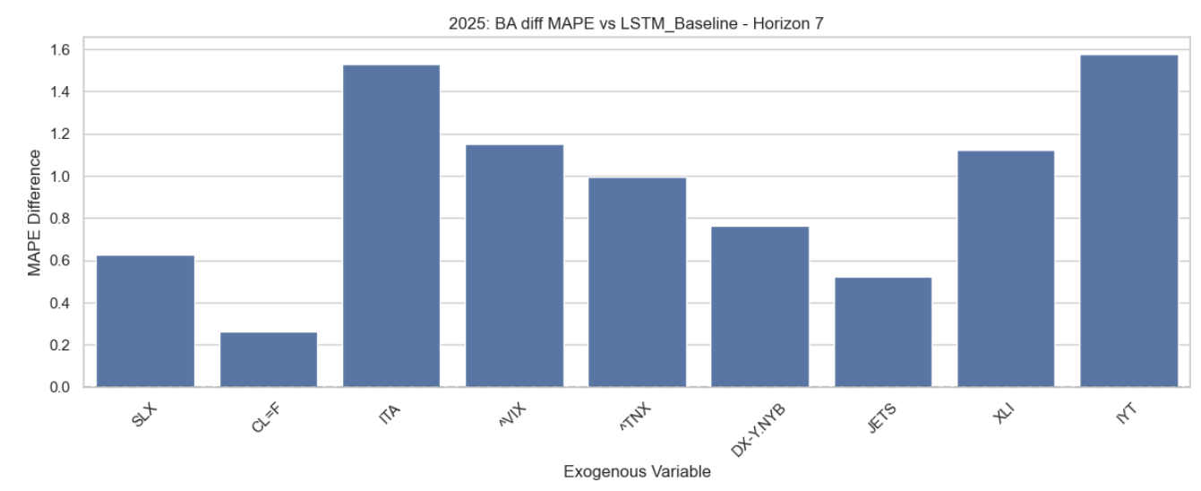
- Boeing: In COVID-19, JETS was the only variable to outperform the baseline (approx. 0.2 MAPE lower); the rest were worse, though in some cases only slightly. In 2025, every variable underperformed the baseline, with CL=F the closest to matching it. Category ordering flipped between periods: sectoral inputs worked best in COVID-19, while commodities were least poor in 2025.
Figure 4.42: MAPE delta plots for Boeing, Horizon 7: LSTM with single exogenous inputs compared to the baseline
- Dell: In COVID-19, HG=F gave the clearest improvement, while DX-Y.NYB performed almost the same as the baseline. In 2025, all variables worsened results, though DX-Y.NYB again came closest to matching baseline performance. Category ordering differed across periods: supply-chain variables led in COVID-19, while sectoral inputs came out on top in 2025, although the differences between categories were small.

Summary
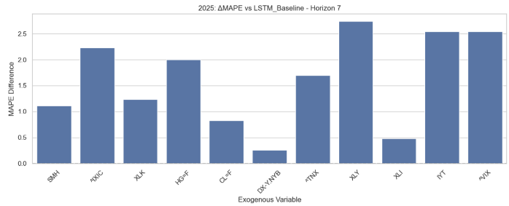
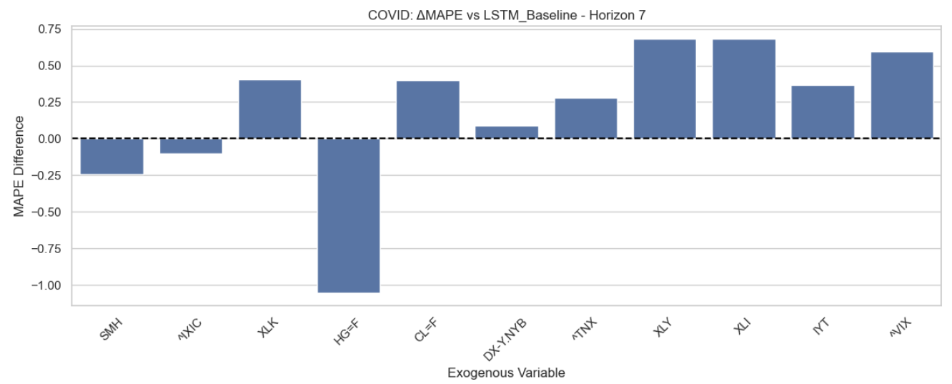
Single exogenous inputs occasionally helped LSTMs, most often at short horizons or during the COVID-19 period. However, the improvements were rare and highly context dependent. In 2025, and particularly at longer horizons, the tuned baseline LSTM was usually as good as or better than any of the exogenous variants (Objectives 1 and 2).
Figure 4.43: MAPE delta plots for Dell, Horizon 7: LSTM with single exogenous inputs compared to the baseline.

Mixed LSTMs: grouped inputs and “best of” blends (O1 + O3)
We next tested multi-input LSTMs using two approaches: (i) grouping variables by category (macroeconomic, sectoral, or commodity/supply-chain), and (ii) combining a “best-of-each-category” blend into a single model.
Horizon 1 (short-term)
For both Boeing and Dell, gains over the baseline were rare with grouped exogenous variables. The only consistent improvement came from the “best-of” blend in 2025, and even then, the effect was slight. By category, Boeing’s results showed sectoral inputs leading during COVID-19, while commodity indicators were strongest in 2025. For Dell, supply chain inputs were most effective during COVID-19, but macroeconomic indicators led in 2025.

Table 4.7 Forecast accuracy (MAPE) of grouped-input LSTMs compared with the baseline at Horizon 1 for Boeing and Dell across both periods.
 | COVID-19 | 2025
Boeing | 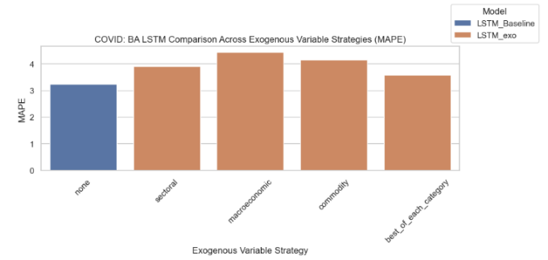 | 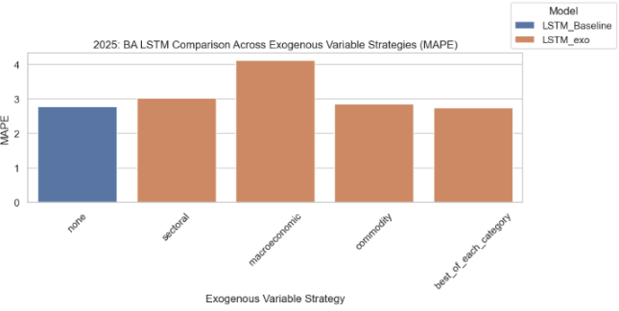
Dell | 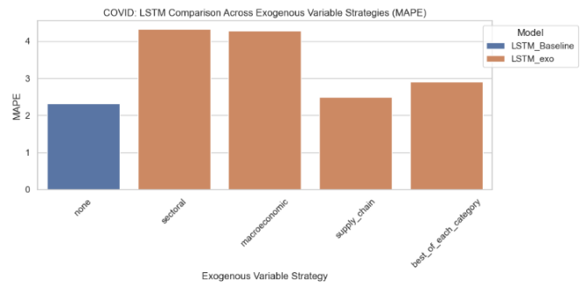 | 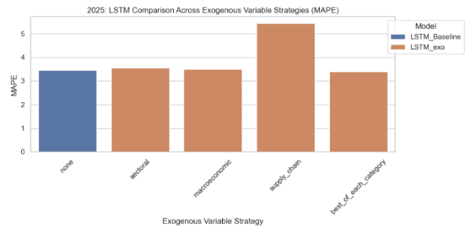
Horizon 3 (medium-term)
For Boeing, none of the grouped models improved on the baseline at Horizon 3. During COVID-19, the different category groups performed at similar levels, while in 2025 the commodity group was slightly ahead, though still worse than the baseline. Dell showed a little more promise: supply-chain inputs during COVID-19 performed just above the baseline, though they were the weakest in 2025. Instead, macroeconomic variables led for Dell in 2025, though they still lagged the baseline. Interestingly, the “best-of” blend was slightly worse than the baseline in COVID-19, but slightly better in 2025, making it Dell’s strongest LSTM for that period.
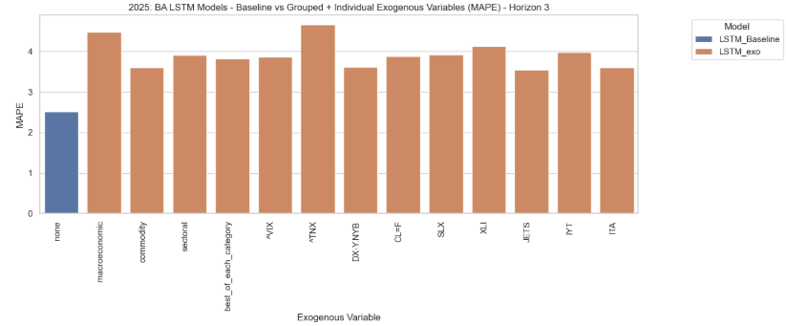
Figure 4.44: Forecast accuracy (MAPE) of grouped LSTM inputs for Boeing during 2025 tariffs (Horizon 3). All models underperformed the baseline.
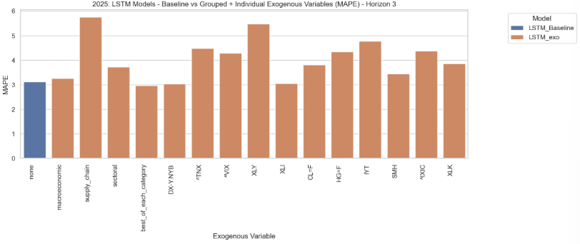
Figure 4.45: Forecast accuracy (MAPE) of grouped LSTM inputs for Dell during 2025 tariffs (Horizon 3). The best-of-each-category blend was the top performer, slightly better than the baseline.
Horizon 7 (long-term)
By Horizon 7, grouped models came closer to the baseline. For Boeing during COVID-19, both the sectoral group and the “best-of” blend essentially matched baseline performance. In 2025, the commodity group led, but the best-of blend was the only configuration to edge above baseline, making it Boeing’s best LSTM for that disruption, though still only marginally better. Dell’s results were less encouraging: no grouped inputs improved on the baseline in 2025, although the “best-of” blend stayed close. During COVID-19, the supply-chain group provided the only improvement, with the blend roughly equal to the baseline.
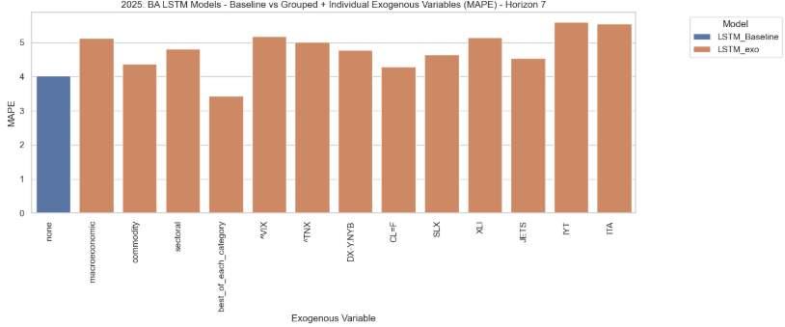
Figure 4.46: Forecast accuracy (MAPE) of grouped LSTM inputs for Boeing during 2025 tariffs (Horizon 7). The best-of-each-category blend slightly outperformed the baseline, the only exogenous input to do so.
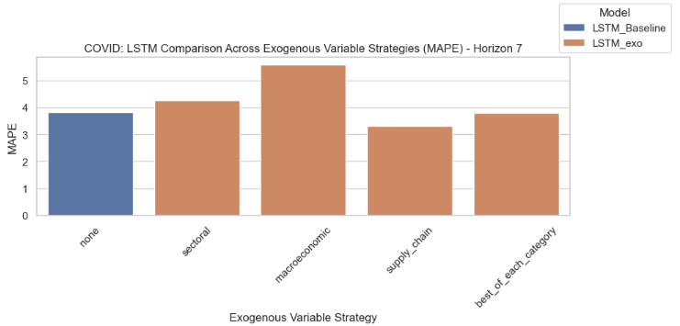
Figure 4.47: Forecast accuracy (MAPE) of grouped LSTM inputs for Dell during COVID-19 (Horizon 7). Supply-chain inputs delivered modest gains, while the best-of blend matched the baseline.
Summary
Grouped multi-input LSTMs rarely produced large gains. The best-of-each-category blend showed occasional promise, particularly for Boeing at longer horizons in 2025, but overall, the benefits were marginal and highly context dependent. Category effectiveness varied by firm and disruption, supporting Objective 3.

Interpretability vs Performance
A clear trade-off in this study was between accuracy and interpretability. The ARIMA family produced transparent results, with coefficients and lags that could be linked back to economic reasoning. This made it possible to see why certain exogenous variables, such as crude oil futures or ^VIX, influenced forecasts and to compare their roles across different periods. By contrast, the LSTM models acted more as black boxes. It was often hard to explain how or why particular inputs improved the forecasts, even when they lowered errors at longer horizons.
Taken together, the findings suggest that while deep learning can be useful in some cases, it comes at the expense of transparency. In practice, this means that the simpler statistical models may still be preferable where interpretability matters, even if their accuracy is not always quite as strong.

Period-wise analysis (O2 + O4)
This section examines whether the usefulness of exogenous variables carried over between disruption periods. Figures 4.48 and 4.49 plot the average ranking (lower is better) of the best-performing model variant from each family (ARIMA, ARIMAX, SARIMA, SARIMAX, LSTM baseline, LSTM with exogenous inputs) across horizons, shown separately for each exogenous variable. Results are reported for the COVID-19 period (left panels) and the 2025 tariff disruption (right panels, shaded).
These plots highlight how the relative effectiveness of exogenous variables differed not only by sector but also by crisis period. For Dell, supply chain indicators such as CL=F (crude oil futures) and HG=F (copper futures) ranked consistently high during COVID-19, particularly at short horizons, but their advantage faded in 2025. For Boeing, sectoral indices such as XLI, IYT, and JETS often outperformed other groups, with XLI in particular showing continued short-horizon value across both disruptions.
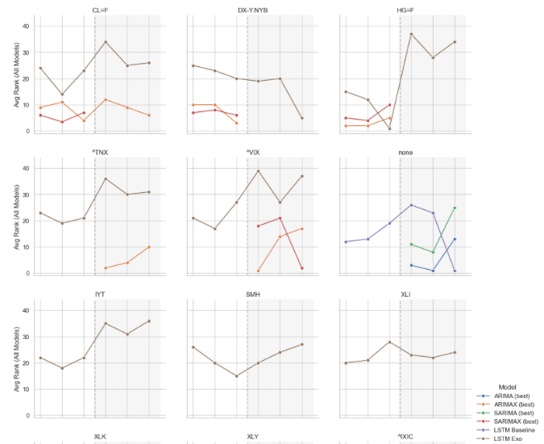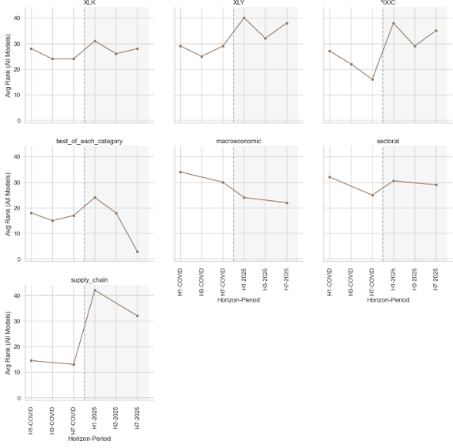
Figure 4.48: Dell – Average ranking (lower is better) of the best-performing model variants across horizons during COVID-19 (left) and the 2025 tariff disruption (right, shaded). Supply chain indicators such as CL=F and HG=F ranked highest during COVID-19, but their advantage diminished in 2025.
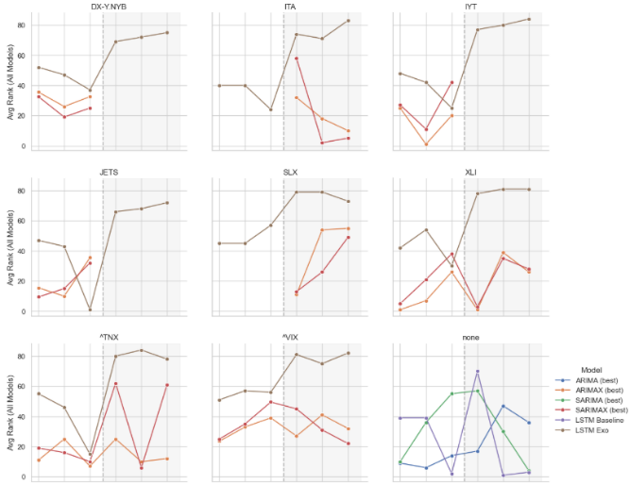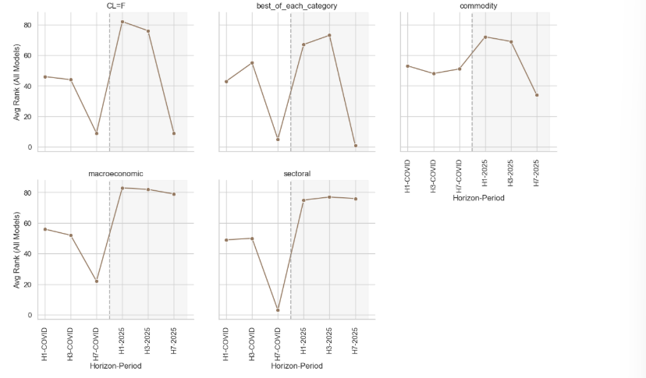
Figure 4.49: Boeing – Average ranking (lower is better) of the best-performing model variants across horizons during COVID-19 (left) and the 2025 tariff disruption (right, shaded). Sectoral indices such as XLI, IYT, and JETS consistently outperformed other variables, with XLI retaining short-horizon value across both periods.
A clear message from these results is that a variable which performs well in one volatile period will not necessarily do so in another. Even within the same company, the ranking of variables across horizons often shifted between COVID-19 and 2025. For example, HG=F was among the best inputs with LSTM at Horizon 7 during COVID-19, yet it was one of the weakest at the same horizon in 2025. This underlines how volatile the relative importance of different variables can be across crises and horizons. Taken together, the period-wise results speak directly to the research objectives. They show that exogenous variables can indeed deliver meaningful gains (O1), particularly at short horizons during COVID-19, where Dell’s supply chain indicators (CL=F, HG=F) and Boeing’s sectoral indices (notably XLI) provided clear improvements. At the same time, these benefits were far from universal (O2). By the 2025 tariff period, and especially at longer horizons, the predictive advantage of exogenous inputs largely disappeared, with the tuned LSTM baseline or its exogenous variants often performing as well as or better than SARIMA-family models. The results also point to strong sectoral differences (O3). Dell’s forecasts were most sensitive to commodity and supply chain variables, reflecting the tech sector’s reliance on raw materials and logistics, whereas Boeing’s accuracy was more influenced by sectoral indices, consistent with its industrial and transportation exposure. Finally, the analysis highlights the limited transferability of variable usefulness across disruptions (O4). While some indicators, such as Boeing’s XLI, retained value across both crises at short horizons, many others, particularly Dell’s supply chain variables, did not. This confirms that the usefulness of exogenous variables is highly context-dependent, shaped by the type of disruption, the sector, and the forecast horizon.

Sector-wise analysis (O3)

Dell (Tech)
The most influential factors for Dell were those linked to supply chains and commodities. During the COVID-19 period, crude oil (CL=F) and copper (HG=F) consistently improved forecasts, particularly at short and medium horizons where SARIMAX models with these inputs outperformed their baselines (Figures 4.34 and 4.41). This pattern was reinforced by the LSTM experiments, where these same inputs occasionally matched or exceeded the tuned baseline, with the strongest effects at Horizon 3 and Horizon 7 (Figures 4.41 and 4.43). This reflects the tech sector’s reliance on raw materials and global logistics during COVID-19.
By contrast, in the 2025 tariff disruption these advantages largely disappeared. The tuned LSTM baseline often matched or outperformed exogenous-augmented variants (Figures 4.39 and 4.43), while SARIMAX results showed no consistent improvement from commodity or supply-chain indicators. Some macro inputs such as ^VIX and ^TNX produced small, short-horizon gains (Figure 4.37), but these were not sustained across horizons or models. Overall, Dell’s results underline that supply-chain variables were highly effective in the COVID-19 context, but their predictive value did not transfer cleanly to 2025.

Boeing (Manufacturing/Aerospace)
Boeing’s results showed a different pattern. Sectoral indices such as XLI, IYT, and JETS were consistently the strongest inputs. During COVID-19, seasonal SARIMAX models incorporating ITA or XLI clearly outperformed baselines at medium horizons (Figure 4.33), while at longer horizons ^TNX provided improvements even though it was negatively correlated contemporaneously with Boeing’s stock price (Figure 4.36). LSTM results confirmed the same sectoral dominance: JETS and ITA were among the few exogenous variables that improved upon the tuned baseline at Horizons 1 and 7 (Figures 4.38 and 4.42).
In the 2025 tariff period, the relative strength of exogenous inputs weakened. At shorter horizons, ITA and XLI still offered modest benefits in some SARIMAX and LSTM configurations (Figures 4.39 and 4.45), but at longer horizons the advantage shifted towards LSTM baselines or grouped “best-of” blends, which occasionally edged ahead of SARIMAX models (Figure 4.46). These findings suggest that Boeing’s forecasts are most sensitive to industrial and transport-related indices, reflecting its manufacturing and aerospace context, but that the relative advantage of these inputs can diminish when market conditions change.

Summary table of best models
Table 4.8 presents the single best-performing model for each company, period, and forecast horizon. The table supports the sectoral contrasts highlighted earlier. For Dell, supply chain indicators such as CL=F and HG=F were decisive during COVID-19, especially at short and medium horizons. By 2025, however, tuned baselines or LSTMs generally performed best, with little added value from exogenous inputs. Boeing, in contrast, showed more consistent benefits from sectoral indices such as XLI, IYT, and JETS across both periods. At longer horizons, LSTM architectures (with or without exogenous inputs) emerged as the best-performing configurations, particularly in 2025.
Table 4.8 Best-performing models across companies, disruption periods, and forecast horizons.
Company | Period | Horizon | Best Model | Exogenous Variable | Category | MAPE
Dell | COVID | H1 | SARIMAX(0,1,2)(1,0,0,7) | CL=F | Supply chain | 1.250
Dell | 2025 | H1 | ARIMA(0,1,0) | — | — | 1.737
Dell | COVID | H3 | SARIMAX(0,1,2)(1,0,0,7) | CL=F | Supply chain | 2.395
Dell | 2025 | H3 | ARIMA(0,1,0) | — | — | 2.664
Dell | COVID | H7 | LSTM_exo | HG=F | Supply chain | 2.753
Dell | 2025 | H7 | LSTM_Baseline | — | — | 3.162
Boeing | COVID | H1 | ARIMAX(0,1,2) | XLI | Sectoral | 2.218
Boeing | 2025 | H1 | ARIMAX(0,1,1) | XLI | Sectoral | 1.493
Boeing | COVID | H3 | ARIMAX(0,1,2) | IYT | Sectoral | 3.160
Boeing | 2025 | H3 | LSTM (baseline) | — | — | 2.517
Boeing | COVID | H7 | LSTM (exogenous) | JETS | Sectoral | 4.685
Boeing | 2025 | H7 | LSTM (exogenous) | best_of_each_category | Mixed | 3.431

Taken together, the summary table highlights the core findings of this chapter: that the impact of exogenous variables was context-dependent, highly sensitive to both sector and disruption, and rarely transferable across periods. The next chapter builds on these findings.

Discussion
This study set out to test whether exogenous variables could improve forecasting during volatile periods, and whether those effects carried across firms, shocks, and model families. The results show that the value of exogenous information is highly dependent on context. For example, crude oil (CL=F) and copper (HG=F) were helpful for Dell during COVID-19, but they lost most of their value in the 2025 tariff disruption. Boeing’s forecasts, on the other hand, gained from sectoral indices such as XLI, ITA and JETS during COVID, yet those same signals weakened or disappeared under tariffs. These contrasts highlight that exogenous predictors rarely transfer cleanly across crises (O4), and that variable choice needs to be carefully tailored to the economic environment being studied.

Key Findings and Interpretation
The results show that the impact of exogenous variables on forecasting is highly context-dependent, varying with the type of disruption, the sector, and the forecast horizon.
Commodity and supply chain indicators consistently improved Dell’s forecasts during COVID-19. Crude oil (CL=F) and copper (HG=F) in particular proved useful, strengthening SARIMAX at shorter horizons and LSTM at H7. These variables also passed predictive tests, supporting the view that supply shocks had a measurable effect on technology manufacturing during this period. However, the same pattern did not hold in the 2025 tariff disruption. In that period, commodity signals lost their predictive value. Only modest and inconsistent improvements came from sectoral indices such as SMH and XLI, and from a single macroeconomic indicator (^VIX at H7), with baselines often matching or outperforming the exogenous-augmented models.
For Boeing (aerospace/manufacturing), forecasts were more closely linked to sectoral and, at times, macroeconomic indicators, though again with important variation across contexts. During COVID-19, indices such as XLI, ITA and JETS provided clear improvements, especially at short horizons, and the 10-year Treasury yield (^TNX) added value at H7 despite its negative contemporaneous correlation. Some short-term benefits from sectoral and macro variables (such as XLI, JETS, and ^TNX) persisted under the 2025 tariffs, but these effects diminished significantly at longer horizons, where baselines often performed as well or better. However, these relationships shifted when tariffs replaced the pandemic as the shock, showing how the relevance of exogenous signals can fade or transform across crises.
Horizon length and model type also influenced the results for both firms. During the COVID-19 period, SARIMAX gained the most from exogenous inputs at short horizons, particularly when seasonal components aligned with the added signals. LSTMs showed occasional gains at longer horizons, such as HG=F for Dell during COVID or JETS for Boeing at H7, but in many cases exogenous-enhanced LSTMs underperformed their baselines. This suggests that the interaction between model type, horizon, and variable choice is critical: exogenous inputs can help, but their benefit is far from universal (O1, O2).
Sectoral distinctions were clear but not absolute (O3). Dell’s forecasts were more sensitive to commodity and supply chain factors, while Boeing’s were more influenced by sectoral and, to a lesser extent, macroeconomic indicators. This underlines that variable relevance is shaped by sector as well as disruption type.
Finally, the fixed LSTM architecture used in all experiments means that the observed improvements represent the marginal benefit of exogenous variables when added to an already-tuned baseline, rather than the maximum possible benefit with full re-tuning. This gives a realistic sense of how practitioners might test new inputs under limited resources, even if it likely understates the best achievable performance (O4).

Relation to Literature
This study contributes to the growing research on exogenous-variable augmentation in time series forecasting, linking its findings to both traditional statistical models and more recent machine learning approaches. For the first objective (O1), earlier work often found that carefully chosen exogenous variables can improve accuracy, especially in domain-specific settings. For instance, Banaś and Utnik-Banaś (2021) showed that SARIMAX with timber market indicators outperformed univariate SARIMA in short-term forecasts. Similarly, Alkali (2019) and Chiu et al. (2019) reported benefits from ARIMAX in real estate and agricultural contexts. Guo and Lin (2018) demonstrated that LSTMs incorporating exogenous features outperformed autoregressive LSTMs in certain settings. While this study partly reflects these findings, with some exogenous variables improving forecasts (particularly in COVID-19 short-horizon cases, such as Dell with commodity prices and Boeing with sectoral indices), it also diverges from the assumption of universal benefit. In a number of scenarios, especially under the 2025 tariff shock, baselines matched or outperformed exogenous-augmented models. This is consistent with warnings from Makridakis et al. (2018) and Castilho (2020) that external regressors can introduce noise when underlying relationships are unstable.
Looking at cross-period performance (O2 and O4), Baek et al. (2020) and Chaudhary et al. (2020) draw attention to the unique volatility dynamics of COVID-19 and caution against assuming transferability across crises. This study supports that point: variables that proved useful during COVID-19 (such as CL=F for Dell or XLI for Boeing) often lost predictive value under the 2025 tariffs. This contrast tempers stronger claims in Dai et al. (2021) and Ma and Yan (2022), who emphasised persistent predictive roles for macro or technical indicators, by showing that such relationships can break down once conditions shift.
On sectoral differences (O3), the literature provides limited consensus on which categories of exogenous inputs are most effective. Pandit et al. (2023) found that climate and crop indices improved agricultural forecasts, while Joosery and Deepa (2019) and Yamak et al. (2020) reported mixed results when financial indicators were added. This study reflects that lack of uniformity. For Dell (technology), commodity and supply chain variables offered clear benefits in some COVID-19 cases, but not in others or in the later tariff period. For Boeing (aerospace/manufacturing), sectoral and macroeconomic indicators sometimes added value, especially at shorter horizons, though their effects varied by context. These findings suggest that variable utility is not fixed: it depends on the disruption, the sector, and may also shift with model type or horizon length.
On methodology, Zhang (2003) and Ahmed et al. (2010) argue that hybrid and re-tuned models often deliver greater gains than single baselines. By contrast, this study fixed LSTM hyperparameters tuned on endogenous data and reused them across experiments, providing a conservative test of exogenous impact. While this likely understates the maximum benefit, it mirrors real-world forecasting conditions, where resources are constrained and re-tuning for each new input set is impractical (Makridakis et al., 2018). From a methodological perspective, the findings support Gao et al.’s (2024) argument that instability and confounding limit the generalisability of exogenous effects.

Sector-Specific Insights
The findings make clear that the usefulness of exogenous variables depends strongly on the sector. For Dell (technology), commodity and supply chain indicators were often the most valuable during the COVID-19 period. Crude oil (CL=F) and copper (HG=F), in particular, improved forecasts across both SARIMAX and LSTM models. This fits with expectations that technology firms, which depend on complex global supply chains, are sensitive to upstream commodity shocks. But the pattern did not carry over into the 2025 tariff period. In that context, those same variables lost much of their predictive value, and occasional short-horizon gains came instead from sectoral indices such as SMH (semiconductors) and XLI (industrials). Even then, the improvements were limited and inconsistent. This shift shows how the relevance of supply chain indicators is time-bound: they were critical during a global disruption, but less so under trade-policy-driven shocks.
For Boeing (aerospace and manufacturing), sectoral indices were more consistently useful than raw commodities. During COVID-19, XLI (industrials), ITA (aerospace and defence), and JETS (airlines) all improved short-horizon forecasts, and in some cases macro-financial variables such as the 10-year Treasury yield (^TNX) added value at longer horizons despite weak contemporaneous correlations. During the 2025 tariff period, the influence of sectoral and macroeconomic indicators was more limited. They still offered benefits at short horizons, but these diminished as the horizon lengthened, with baselines often performing just as well or better. In a few cases, blended “best-of-category” combinations provided some gains, though their impact remained modest compared with COVID-19.
Altogether, these results highlight that variable relevance is shaped both by sector and by the nature of the disruption. For Dell, commodity and supply chain signals mattered most in the pandemic, while for Boeing, sectoral and macroeconomic indicators played the stronger role. At the same time, neither pattern was fixed: once the type of disruption changed, so did the signals that carried predictive value.

Practical Implications
A few points stand out for forecasting practice during volatile periods. First, the results show that model sophistication alone is not enough. The value of exogenous inputs depends on how well they align with the disruption and the sector. Practitioners should prioritise variables that plausibly capture the main transmission channels of the shock, rather than relying on generic indicators.
Second, forecasting short-lived or fast-moving crises poses particular challenges. The 2025 tariff dataset, for instance, covered only six months, which limited the training data available for deep learning models. In settings like this, simpler statistical models or more targeted exogenous inputs may provide more reliable results than complex architectures that require larger datasets.
Finally, the limited transferability of variables across crises shows the need for ongoing monitoring and re-evaluation. A variable that proves highly predictive during one disruption cannot be assumed to work in the next. Forecasting practice should therefore remain adaptive, with variable sets revised as conditions change.

Limitations
Several limitations should be kept in mind when interpreting these findings. First, the study focuses on only two firms (Dell and Boeing) and two disruption periods (COVID-19 and the 2025 tariffs). While these cases provide useful contrasts, the results cannot be assumed to generalise across other firms, sectors, or forms of economic volatility. The two disruptions themselves were also very different in nature: COVID-19 was a global health crisis with wide-ranging supply and demand effects, while the tariff shock was a trade-policy intervention centred on specific industries. The limited transferability of variables across periods may therefore reflect not only volatility itself but also differences in the type of disruption. On top of this, the 2025 dataset covered only six months, which gave far fewer observations than the COVID-19 period. That imbalance likely made training harder, particularly for the LSTM models (which work best with lots of data), and may partly explain why results for 2025 were weaker or less consistent.
Second, there are methodological limitations around model selection and tuning. The optimal configuration for models with exogenous inputs may not be the same as for models without them. Hyperparameters such as learning rate, regularisation, or network depth can all interact with the size and structure of the input space. By fixing LSTM hyperparameters once and applying them across firms and periods, the study likely understates the potential benefits of exogenous variables, particularly in the deep learning models. This trade-off to kept the experiments feasible, so the results should be read as showing incremental gains under fixed settings rather than the maximum achievable with full re-tuning.
Third, the range of exogenous variables was limited. Only a small set of financial, sectoral, and commodity indicators were included, all at daily frequency. In practice, access to exogenous data may be patchier or delayed, which could further reduce their usefulness.
Finally, both modelling approaches carry risks. ARIMA and SARIMA models are sensitive to differencing choices and lag structure, while LSTMs risk overfitting because their parameter complexity can exceed the available sample size. Early stopping and dropout helped to manage these issues, but they still cannot be ruled out.
Overall, these limitations mean the results are best viewed as an initial demonstration of how exogenous variables can influence forecast accuracy during volatility, rather than as a definitive guide to which signals or model types will always deliver improvements.

Future Work
There are a number of directions that could build on this work. The most obvious step would be to widen the scope beyond two firms. Including other sectors such as retail, healthcare, or energy would test whether the sector-specific patterns observed here, for example supply-chain sensitivity in technology or macro/sectoral responsiveness in aerospace, also hold elsewhere.
It would also be useful to compare like with like. This study deliberately looked at two very different shocks, a pandemic and a tariff disruption. That contrast was helpful, but it also makes it harder to separate what is general from what is specific. Future research could examine multiple examples of the same type of disruption (for instance, comparing different trade wars or multiple public health crises) to see whether exogenous variables transfer more effectively under similar conditions.
On the modelling side, this study fixed the LSTM hyperparameters to give a clean test of exogenous impact. With greater computational resources, future work could re-tune architectures for each variable set (rather than fixing hyperparameters across all tests), or test newer approaches such as Transformers or hybrid models that may capture long-range and non-linear effects more effectively.
Finally, richer exogenous data sources could be explored. Real-time data such as sentiment indices, news-based metrics, or high-frequency logistics and commodity measures may capture evolving shocks more effectively than static daily indicators. Testing whether models trained on past disruptions remain useful in real time as new shocks unfold would also provide a clearer sense of operational value.

Conclusion
This thesis set out to test whether exogenous variables could improve time series forecasting during periods of volatility, using two firms (Dell and Boeing) and two disruptions (COVID-19 and the 2025 tariffs). Four objectives guided the analysis: (O1) to see if adding exogenous variables improved accuracy in ARIMA, SARIMA, and LSTM models; (O2) to compare performance across disruptions; (O3) to explore which categories of variables were most useful in different sectors; and (O4) to assess whether variables that worked in one disruption carried over to another.
The results paint a clear but nuanced picture. For O1, exogenous inputs sometimes improved forecasts, mainly when they captured the factors most relevant to each sector. For Dell, commodity and supply chain variables added value during COVID, while Boeing, representing aerospace and wider manufacturing, was more influenced by sectoral and macroeconomic indicators. Yet consistent with O2, these gains certainly did not hold across the board: in many 2025 tariff cases, baseline models matched or outperformed exogenous-augmented versions, showing that additional inputs are not automatically useful.
On O3, sectoral contrasts were clear. Technology forecasts (Dell) responded most to supply chain and commodity signals in the pandemic, while Boeing’s forecasts were more sensitive to sectoral and macroeconomic measures. On O4, transferability across disruptions was limited: variables that helped in COVID often lost value in the tariff period, reflecting both differences in the nature of the shocks and the fact that relationships between indicators and stock movements can be time-bound.
Altogether, the results show that the value of exogenous information lies not in its universal application but in its fit with context: the sector, the type of disruption, and the model design. For practice, this suggests that model sophistication on its own is not enough. What matters is careful variable selection, ongoing testing, and the flexibility to adjust as circumstances change.
There is also a broader lesson. Forecasting under uncertainty is not about relying on a single “best” model, but about developing approaches that are resilient, context-sensitive, and adaptable to shifting conditions. In short, the most effective forecasting during volatile times comes from combining sound models with thoughtful, flexible use of external information.

References
Ahmed, N.K. et al. (2010) “An Empirical Comparison of Machine Learning Models for Time Series Forecasting,” Econometric Reviews, 29(5–6), pp. 594–621. Available at: https://doi.org/10.1080/07474938.2010.481556.
ALKALI, M. (2019) “ASSESSING THE FORECASTING PERFORMANCE OF ARIMA AND ARIMAX MODELS OF RESIDENTIAL PRICES IN ABUJA NIGERIA,” Asia Proceedings of Social Sciences, 4, pp. 4–6. Available at: https://doi.org/10.31580/apss.v4i1.528.
API Documentation | TensorFlow v2.16.1 (no date) TensorFlow. Available at: https://www.tensorflow.org/api_docs (Accessed: September 3, 2025).
Baek, S., Mohanty, S.K. and Glambosky, M. (2020) “COVID-19 and stock market volatility: An industry level analysis,” Finance Research Letters, 37, p. 101748. Available at: https://doi.org/10.1016/j.frl.2020.101748.
Banaś, J. and Utnik-Banaś, K. (2021) “Evaluating a seasonal autoregressive moving average model with an exogenous variable for short-term timber price forecasting,” Forest Policy and Economics, 131, p. 102564. Available at: https://doi.org/10.1016/j.forpol.2021.102564.
Bland, G. (2020) “yfinance Library - A Complete Guide - AlgoTrading101 Blog,” Quantitative Trading Ideas and Guides - AlgoTrading101 Blog, 16 June. Available at: https://algotrading101.com/learn/yfinance-guide/ (Accessed: April 15, 2025).
Box, G.E.P., Jenkins, G.M., and Gwilym M. Jenkins (1970) “Time series analysis, forecasting and control.”
Castilho, C.M. (2020) Time Series Forecasting With Exogenous Factors: Statistical vs. Machine Learning Approaches. masters. Universidade do Porto (Portugal).
Chaudhary, R., Bakhshi, P. and Gupta, H. (2020) “Volatility in International Stock Markets: An Empirical Study during COVID-19,” Journal of Risk and Financial Management, 13(9), p. 208. Available at: https://doi.org/10.3390/jrfm13090208.
Chiu, L.-Y. et al. (2019) “Modelling and Forecasting of Greenhouse Whitefly Incidence Using Time-Series and ARIMAX Analysis,” IFAC-PapersOnLine, 52(30), pp. 196–201. Available at: https://doi.org/10.1016/j.ifacol.2019.12.521.
Core — google-api-core documentation (no date). Available at: https://googleapis.dev/python/google-api-core/latest/index.html (Accessed: September 3, 2025).
Dai, Z., Zhu, H. and Kang, J. (2021) “New technical indicators and stock returns predictability,” International Review of Economics & Finance, 71, pp. 127–142. Available at: https://doi.org/10.1016/j.iref.2020.09.006.
EU AI Act: first regulation on artificial intelligence (2023) Topics | European Parliament. Available at: https://www.europarl.europa.eu/topics/en/article/20230601STO93804/eu-ai-act-first-regulation-on-artificial-intelligence (Accessed: April 19, 2025).
Gao, W. et al. (2024) “Deconfounding Time Series Forecasting.” arXiv. Available at: https://doi.org/10.48550/arXiv.2410.21328.
gc — Garbage Collector interface (no date) Python documentation. Available at: https://docs.python.org/3/library/gc.html (Accessed: September 3, 2025).
Guo, T. and Lin, T. (2018a) “Multi-variable LSTM neural network for autoregressive exogenous model.” arXiv. Available at: https://doi.org/10.48550/arXiv.1806.06384.
Guo, T. and Lin, T. (2018b) “Multi-variable LSTM neural network for autoregressive exogenous model.” arXiv. Available at: https://doi.org/10.48550/arXiv.1806.06384.
Hochreiter, S. and Schmidhuber, J. (1997) “Long short-term memory,” Neural Computation, 9(8), pp. 1735–1780. Available at: https://doi.org/10.1162/neco.1997.9.8.1735.
Joosery, B. and Deepa, G. (2019) Comparative analysis of time-series forecasting algorithms for stock price prediction, p. 6. Available at: https://doi.org/10.1145/3373477.3373699.
Josef Perktold et al. (2024) “statsmodels/statsmodels: Release 0.14.2.” Zenodo. Available at: https://doi.org/10.5281/ZENODO.593847.
Kusumahadi, T.A. and Permana, F.C. (2021) “Impact of COVID-19 on Global Stock Market Volatility,” Journal of Economic Integration, 36(1), pp. 20–45.
Latif, S. et al. (2025) “Integrating Macroeconomic and Technical Indicators into Forecasting the Stock Market: A Data-Driven Approach,” Economies, 13(1), p. 6. Available at: https://doi.org/10.3390/economies13010006.
Ma, C. and Yan, S. (2022) “Deep learning in the Chinese stock market: The role of technical indicators,” Finance Research Letters, 49, p. 103025. Available at: https://doi.org/10.1016/j.frl.2022.103025.
Makridakis, S., Spiliotis, E. and Assimakopoulos, V. (2018) “Statistical and Machine Learning forecasting methods: Concerns and ways forward,” PLOS ONE, 13(3), p. e0194889. Available at: https://doi.org/10.1371/journal.pone.0194889.
Matplotlib documentation — Matplotlib 3.10.6 documentation (no date). Available at: https://matplotlib.org/stable/index.html?utm_source=chatgpt.com (Accessed: September 3, 2025).
NumPy Documentation (no date). Available at: https://numpy.org/doc/ (Accessed: September 3, 2025).
pandas documentation — pandas 2.3.2 documentation (no date). Available at: https://pandas.pydata.org/docs/?utm_source=chatgpt.com (Accessed: September 3, 2025).
Pandit, P. et al. (2023) “Hybrid time series models with exogenous variable for improved yield forecasting of major Rabi crops in India,” Scientific Reports, 13(1), p. 22240. Available at: https://doi.org/10.1038/s41598-023-49544-w.
Phillips, M. (2025) Retail, autos, tech: These are the US industries that could be walloped by tariffs on China, FOXBusiness. Fox Business. Available at: https://www.foxbusiness.com/politics/retail-autos-tech-us-industries-could-walloped-tariffs-china (Accessed: April 15, 2025).
pmdarima: ARIMA estimators for Python — pmdarima 2.0.4 documentation (no date). Available at: https://alkaline-ml.com/pmdarima/ (Accessed: September 3, 2025).
read, J.R. 6 min (2021) The 10 Industries That Have Been Impacted the Most by COVID-19, Yahoo Finance. Available at: https://finance.yahoo.com/news/10-industries-impacted-most-covid-110042511.html (Accessed: April 19, 2025).
scikit-learn: machine learning in Python — scikit-learn 1.7.1 documentation (no date). Available at: https://scikit-learn.org/stable/index.html (Accessed: September 3, 2025).
SciPy documentation — SciPy v1.16.1 Manual (no date). Available at: https://docs.scipy.org/doc/scipy/ (Accessed: September 3, 2025).
Suhartono, S., Lee, M.H. and Prastyo, D. (2015) Two levels ARIMAX and regression models for forecasting time series data with calendar variation effects. Available at: https://doi.org/10.1063/1.4937108.
Sweney, M. (2025) “From Nike to Apple: which US brands could be hit hardest by Trump tariffs and what’s at stake?,” The Guardian, 4 April. Available at: https://www.theguardian.com/us-news/2025/apr/04/nike-apple-us-brands-trump-tariffs-prices (Accessed: April 15, 2025).
Team, K. (no date a) Keras documentation: Keras 3 API documentation. Available at: https://keras.io/api/ (Accessed: September 3, 2025).
Team, K. (no date b) Keras documentation: KerasTuner. Available at: https://keras.io/keras_tuner/ (Accessed: September 3, 2025).
Wang, P.-C. and Vo, T. (2025) “Stock price prediction based on dual important indicators using ARIMAX: A case study in Vietnam,” Journal of Intelligent Systems, 34. Available at: https://doi.org/10.1515/jisys-2024-0101.
Waskom, M. (2021) “seaborn: statistical data visualization,” Journal of Open Source Software, 6(60), p. 3021. Available at: https://doi.org/10.21105/joss.03021.
Yahoo Developer API Terms of Use | Yahoo (no date). Available at: https://legal.yahoo.com/us/en/yahoo/terms/product-atos/apiforydn/index.html?utm_source=chatgpt.com (Accessed: September 3, 2025).
Yahoo Terms of Service | Yahoo (no date). Available at: https://legal.yahoo.com/us/en/yahoo/terms/otos/index.html (Accessed: September 3, 2025).
Yamak, P.T., Yujian, L. and Gadosey, P.K. (2020) “A Comparison between ARIMA, LSTM, and GRU for Time Series Forecasting,” in Proceedings of the 2019 2nd International Conference on Algorithms, Computing and Artificial Intelligence. New York, NY, USA: Association for Computing Machinery (ACAI ’19), pp. 49–55. Available at: https://doi.org/10.1145/3377713.3377722.
Yfinance | Anaconda.org (no date). Available at: https://anaconda.org/conda-forge/yfinance?utm_source=chatgpt.com (Accessed: September 3, 2025).
yfinance · PyPI (no date). Available at: https://pypi.org/project/yfinance/ (Accessed: April 15, 2025).
“yfinance: Download market data from Yahoo! Finance API” (no date). Available at: https://github.com/ranaroussi/yfinance (Accessed: September 3, 2025).
Zhang, G.P. (2003) “Time series forecasting using a hybrid ARIMA and neural network model,” Neurocomputing, 50, pp. 159–175. Available at: https://doi.org/10.1016/S0925-2312(01)00702-0.

Appendix

Appendix A – Datasets and Code

Appendix A.1 Google Drive link

Notebook files
In the Google drive are the five key Jupyter Notebook code files
- Boeing COVID-19: ‘Capstone_Boeing_covid.ipynb’
- Boeing 2025: ‘Capstone_Boeing_2025.ipynb’
- Dell COVID-19: ‘Capstone_DELL_covid_merged.ipynb’
- Dell 2025: ‘Capstone_DELL_2025.ipynb’
- Experiment Evaluation: ‘Metrics_evaluation.ipynb’
The secondary datasets were obtained via the yfinace API using Google Colab. The notebook for this data retrieval is:
- ‘Capstone_colab.ipynb’.

Datasets and metric files
The secondary datasets retrieved using colab and used in each notebook are:
- ‘boeing_exo_variables_combined.csv’ (in boeing_exo_data folder)
- ‘boeing_exo_variables_combined_2025.csv’ (in boeing_exo_data_2025 folder)
- ‘dell_exo_variables_combined.csv’ (in DELL_exo_data folder)
- ‘dell_exo_variables_combined_2025.csv’ (in DELL_exo_data_2025 folder)
All metrics and training data are also included in the Google Drive under Additional files.
Google Drive Link:
https://drive.google.com/drive/folders/1KJOakL0OoeBzjeKmz5qNLlVBYKmz08GF?usp=drive_link

Appendix A.2 Statement on AI Usage
ChatGPT (OpenAI, 2025) was used at various stages of this thesis. It was used to:
- Suggest possible exogenous variables for Boeing and Dell stock forecasting, which were then checked against academic literature and financial sources for relevance (see Methodology section).
- Assist in structuring the thesis and refining the presentation of arguments.
- Suggest phrasing improvements to reduce word count and improve readability.
- Provide explanations of error messages encountered during coding development and suggest potential debugging steps.
Microsoft Word’s Editor was also used for syntax, grammar, and style improvements.

Appendix B – Ethics full detail

Appendix B.1 Legal/ Regulatory Considerations
This research does not involve personal or sensitive data, but rather historical stock prices and economic indicators. All data is fully open source, obtained via the yfinance API from Yahoo Finance. For this reason, the General Data Protection Regulation (GDPR) Article 4, which applies to personal data, is not relevant here. However, this research still follows key GDPR principles such as data minimisation, fairness, and transparency as part of responsible research practice.
Since this research makes use of machine learning models and time series forecasting techniques (ARIMA, LSTM, SARIMAX) that could be adapted for financial or strategic decision-making, it’s important to consider relevant ethical frameworks, particularly the EU Ethics and Data Protection Guidelines for Research. The guidelines explain how automated tools like these forecasting methods, even without the use of personal data, can still raise ethical concerns. This is especially true if these methods are later adapted to be used in profiling or forecasting in more sensitive contexts.
To stay aligned with the idea of “data protection by design and default” (Section IV of the EU’s Ethics and Data Protection Guidelines), this project only uses features that are essential for analysis. The data will be stored and processed securely using standard tools (like Python, pandas, etc.). The approach also follows the guidelines on secondary data use (Section VII), as the data has already been made publicly available for research and educational purposes. Wherever results are shared, I’ll include proper citations and context so that the work is transparent and doesn’t get taken out of context.
The EU AI Act gives useful direction, like promoting transparency and human oversight, but does not directly apply to this project, since it is not classified as high-risk under its guidelines.

Appendix B.2 Ethics and Data Protection
I have taken the following measures to ensure my approach is in line with the EU Ethics and Data Protection Guidelines for Research:
- Model transparency: every stage of the process, from data selection to model tuning, will be clearly documented so that others can understand how the results were produced. This helps reduce the risk of the work being misinterpreted or reused incorrectly in future applications.
- Data minimization (Section IV): I will minimize unnecessary data by only including variables that show clear statistical significance based on Granger Causality tests. This helps keep the models focused and avoids collecting or using more data than necessary.
- Model explainability (Section IX): LSTMs and other deep learning models can sometimes act like black boxes. To help with interpretability I will include residual analysis and visual comparisons. This will clarify model behaviour in line with guidance on automated decision-making.
- Careful data handling (Section III): While the datasets don’t contain personal information, I’m still store and manage them responsibly. I will follow the guidance on pseudonymisation and avoid the unnecessary sharing of raw files. If I publish any code or results, I will make it clear that this is academic research, not a financial trading tool intended for commercial use.
- Further use (Section VIII): If this methodology is ever adapted for a higher-risk environment (like real-time investment forecasting), I’d recommend carrying out a Data Protection Impact Assessment (DPIA). I’d also consult with my thesis supervisor before moving forward.

Appendix B.3 License and Permissions
Licensing and Terms
- The yfinance library is distributed under the Apache License, Version 2.0, an open-source license that allows free use for research and educational projects (pypi.org, anaconda.org).
- Yahoo Finance data is governed by Yahoo’s Terms of Service and developer Terms of Use, which permit personal and academic use only, not commercial exploitation (legal.yahoo.com, guce.yahoo.com).
Scope of Use
- All data in this thesis is used purely for academic research and analysis, consistent with both Apache 2.0 and Yahoo’s licensing terms.
Disclaimer
- Yahoo Finance data is provided "as is", without any warranties of accuracy or completeness. Use of the data is at your own risk. This thesis does not imply any endorsement by Yahoo, Inc.

Appendix C – LSTM Hyperparameter Search Space
Hyperparameter optimisation for the LSTM models was carried out using Keras Tuner with RandomSearch.
Table C1 summarises the search space explored during tuning.
Parameter | Search Space
First LSTM layer units | 16 – 128 (step 16)
Second LSTM layer units* | 16 – 64 (step 16) if first layer returned sequences
Activation functions | ReLU, tanh, Leaky ReLU (α = 0.01 – 0.3, step 0.05)
Dropout (intermediate) | 0.0 – 0.4
Dropout (final) | 0.0 – 0.3
Optimisers | Adam, RMSprop
Learning rate | 1 × 10⁻⁵ to 1 × 10⁻² (log scale)
Objective | Validation loss (MSE), with early stopping to prevent overfitting
*The second LSTM layer was only included if the first returned sequences.
Note on 17.000 parameters calculation: The parameter count for the baseline LSTM (~17k) was obtained from the standard formula for LSTM layers:
Params=4×[units×(units+input_dim)+units]
For 64 units and an input dimension of 1 (univariate input), this yields 16,896 parameters. With the addition of the final Dense layer (64 → 1), 65 more parameters are added, bringing the total to 16,961 trainable parameters. Dropout layers do not introduce parameters.

Appendix D – Results detail and additional plots
Further plots and model training/testing detail can been see in Jupyter notebook files.
SARIMA vs SARIMAX
 | Boeing | Dell
Horizon 1  COVID-19 |  | 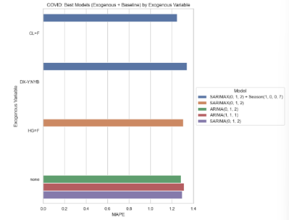
Horizon 1  2025 | 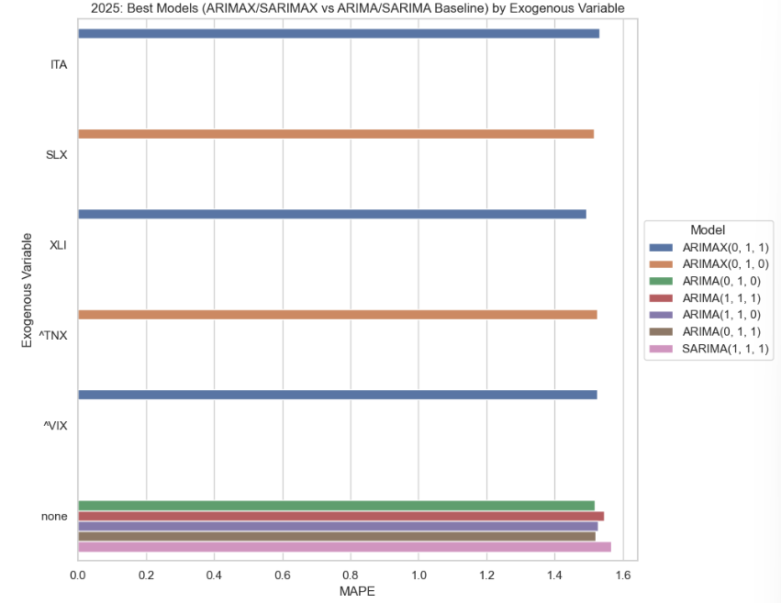 | 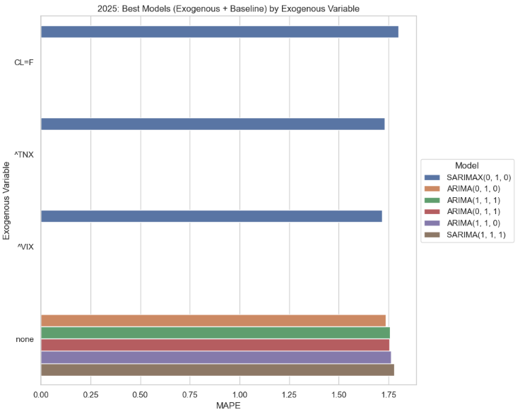
Horizon 3  COVID-19 |  | 
Horizon 3 2025 | 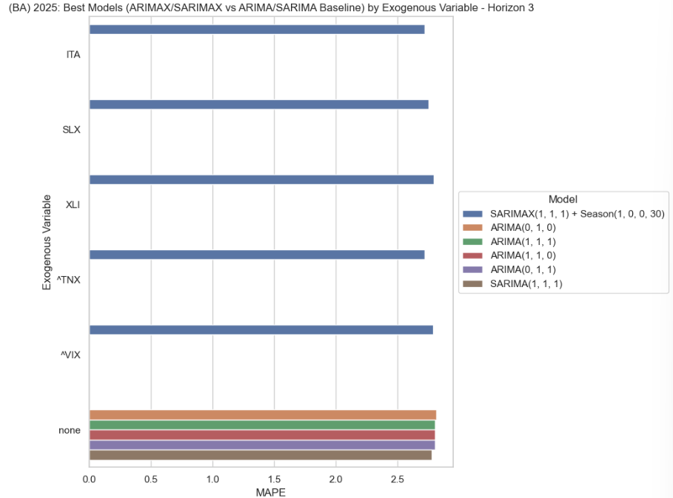 | 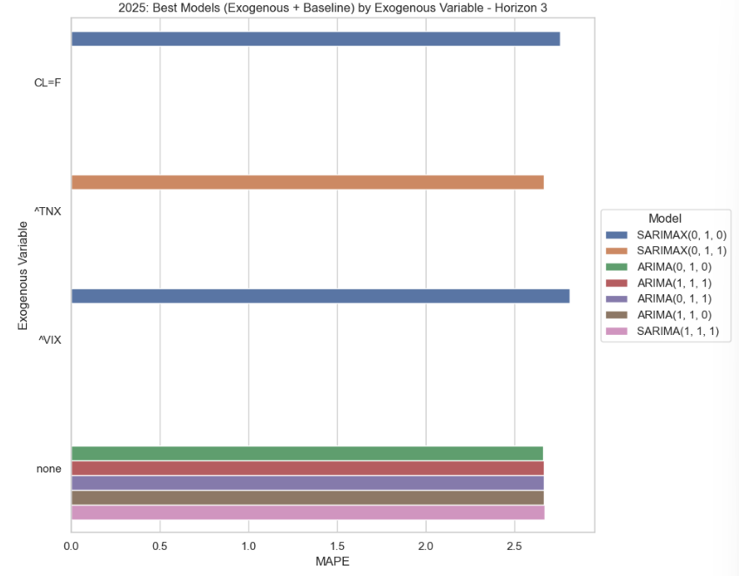
Horizon 7  COVID-19 |  | 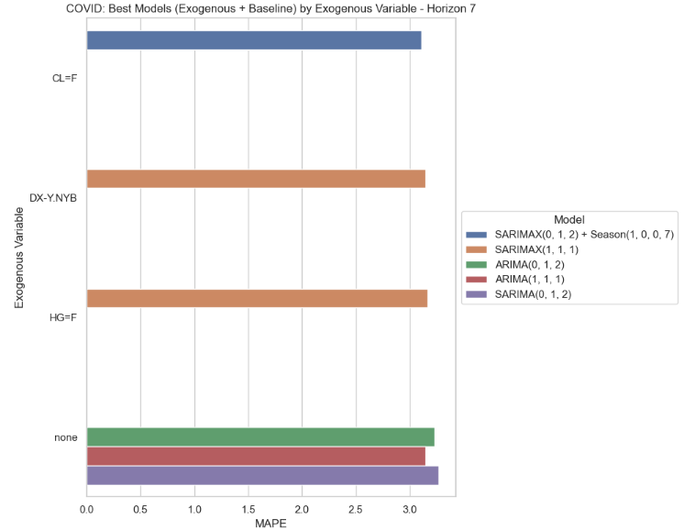
Horizon 7 2025 | 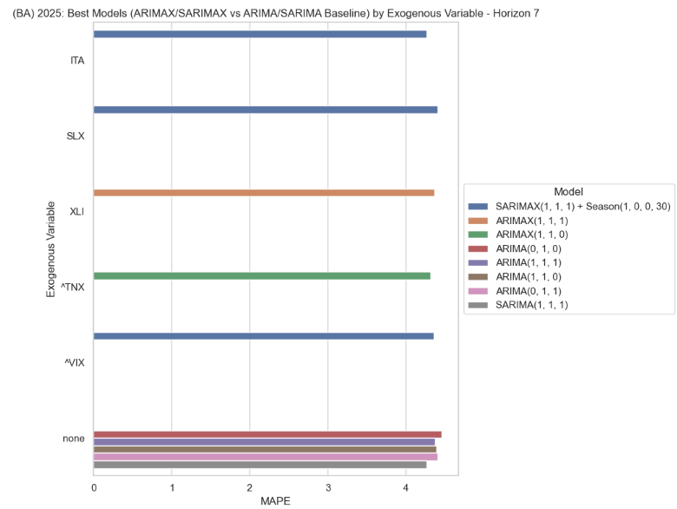 | 

 | Boeing | Dell
Horizon 1 | 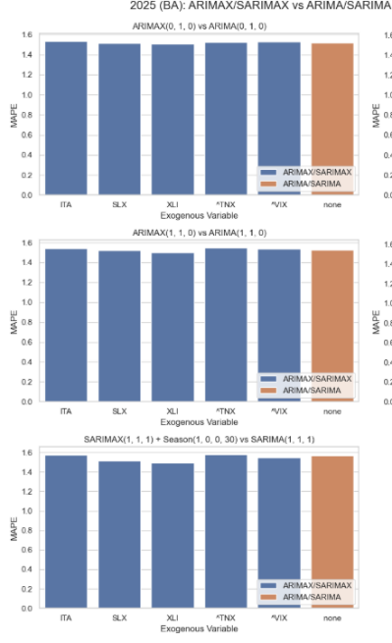  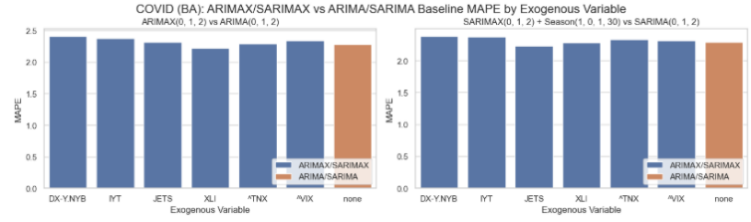 | 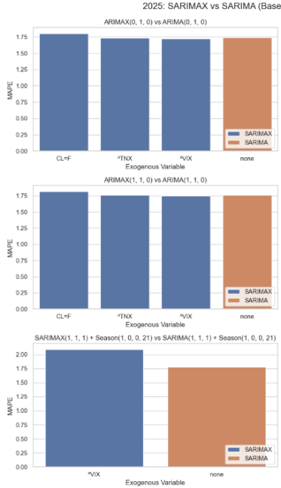  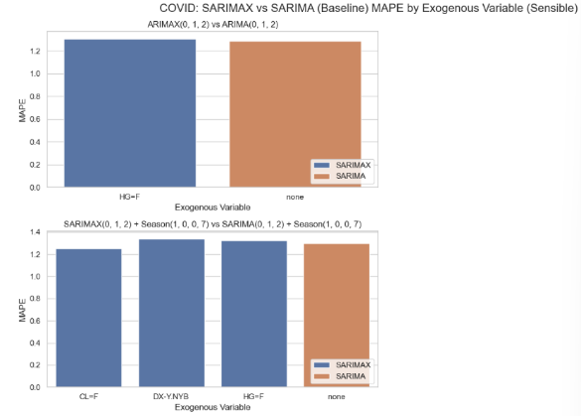
Horizon 3 | 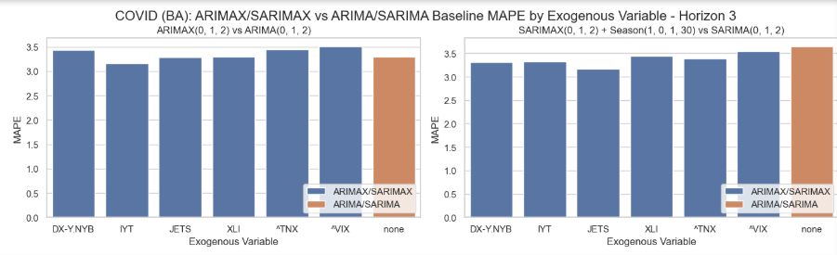 | 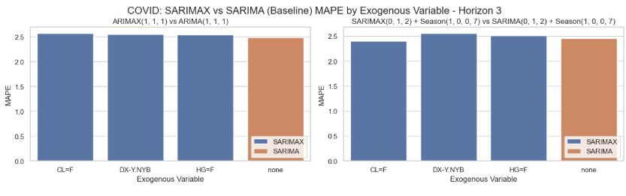  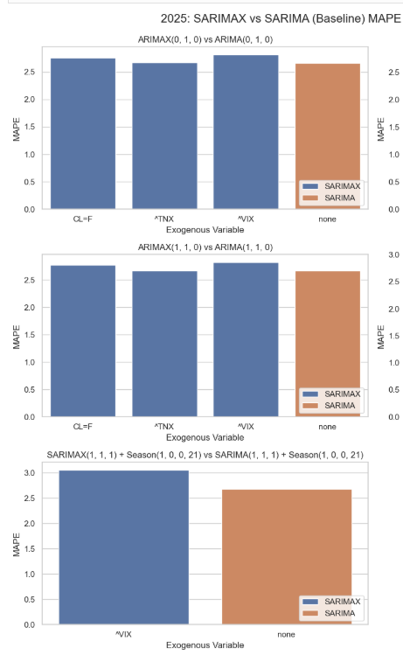
Horizon 7 | 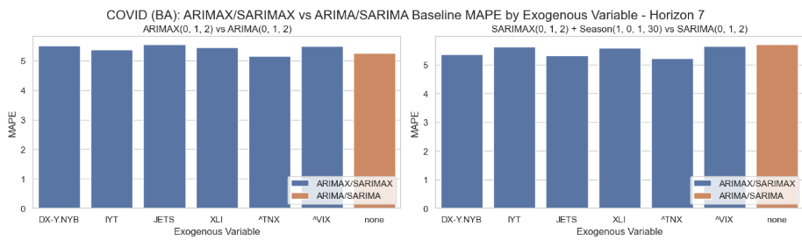  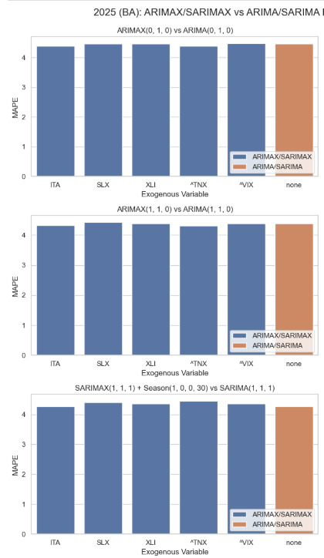 | 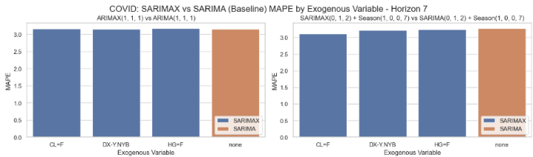  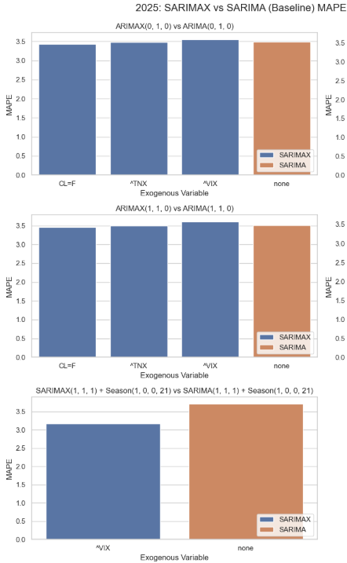

LSTM with and without exo
 | Boeing | Dell
Horizon 1 | 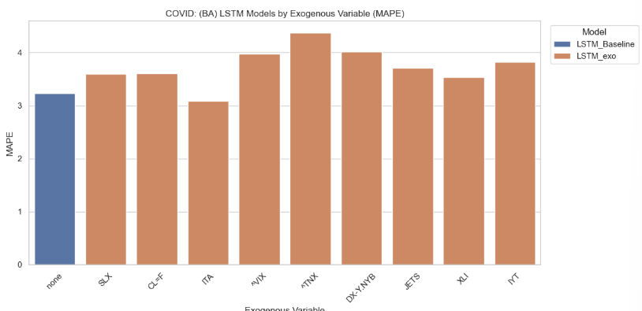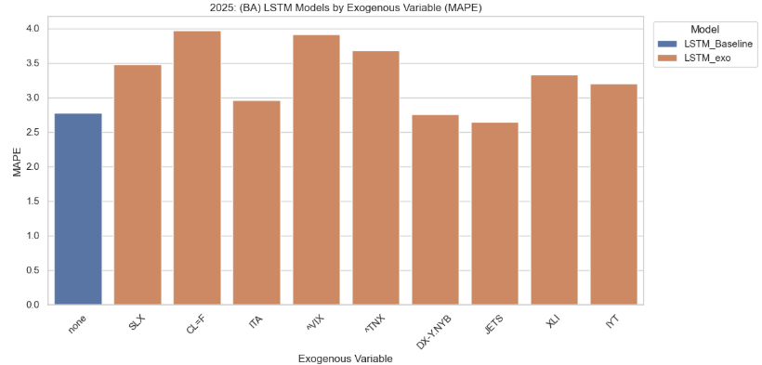  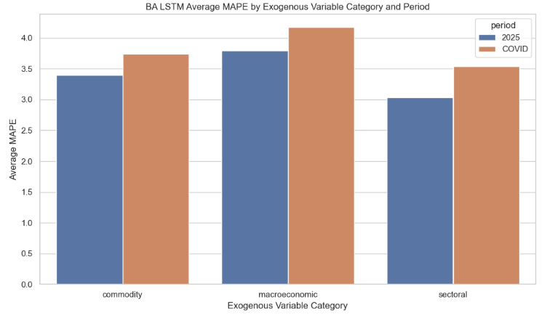 | 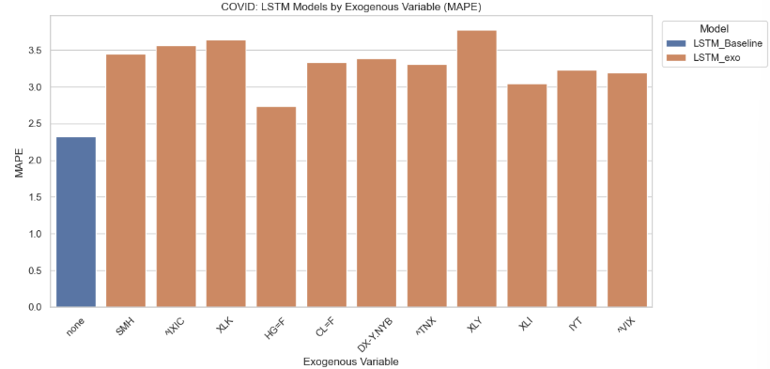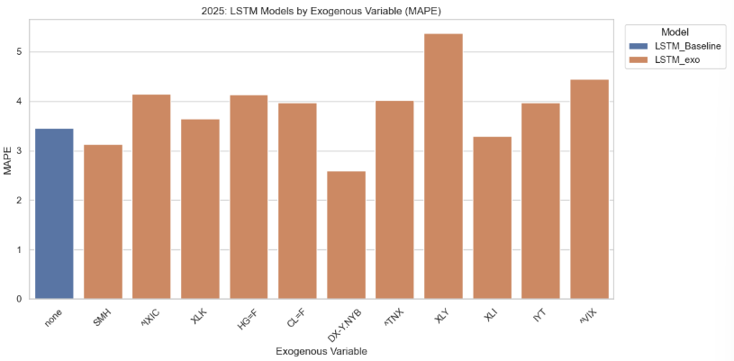  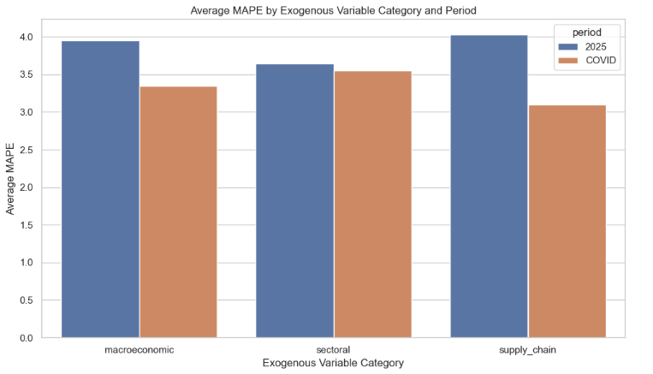
Horizon 3 | 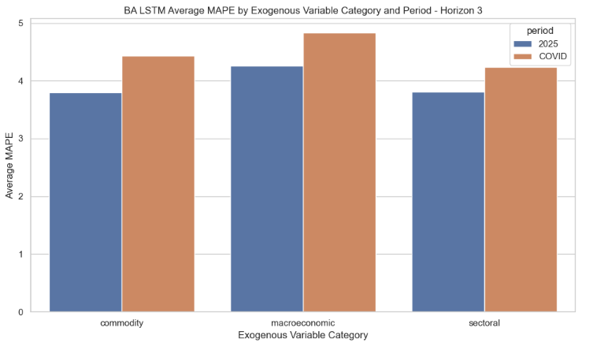 | 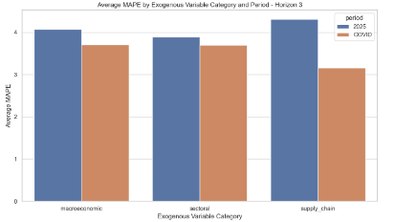
Horizon 7 | 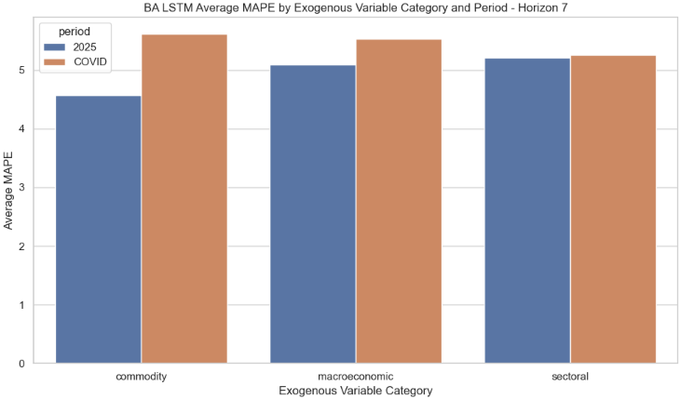 | 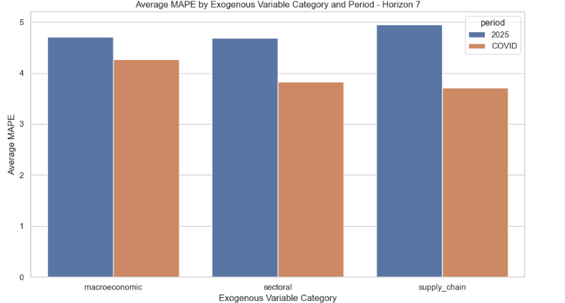

Grouped exogenous strategies for LSTMs
 | Boeing | Dell
Horizon 1 | When the exogenous variables were fed into the model as multi-inputs for each category, sectoral performed the best for covid, but commodity for 2025 (different to average of individual exos per category)  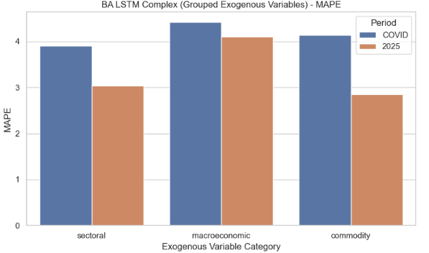  When the best performing exo variable from each of the three categories were fed in together as a multi-input it slightly improved on the baseline for 2025. The only grouped exo variable comparable with the baseline was “best of” for 2025 (commodity close).  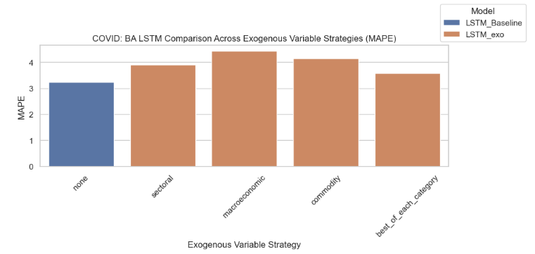  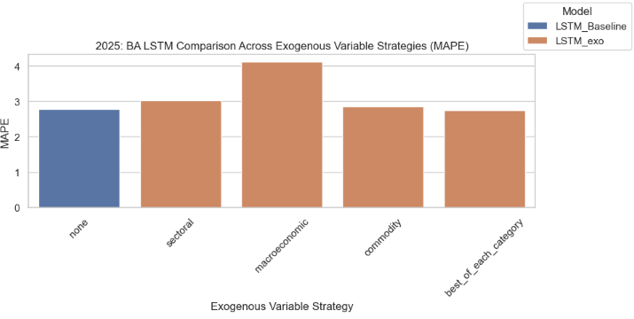  Best LSTM covid: ITA exo model (only one to improve on baselines)  Best LSTM 2025: JETS exo model  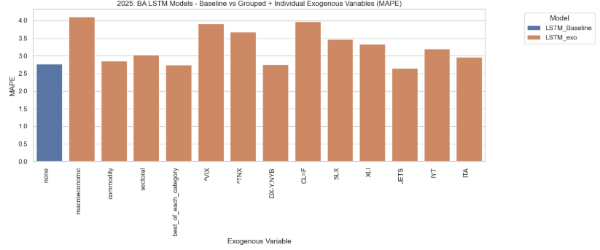  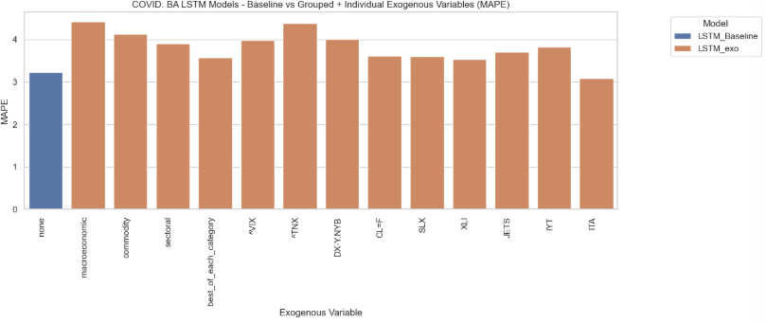 | When the exogenous variables were fed into the model as multi-inputs for each category, supply chain performed the best for covid, but macroeconomic for 2025  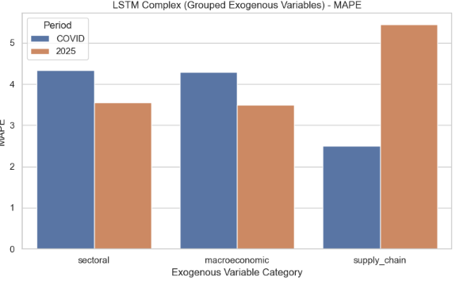  When the best performing exo variable from each of the three categories were fed in together as a multi-input it slightly improved on the baseline for 2025 but did not surpass even the supply chain group for covid. The only grouped exo variable to improve on the baseline was “best of” for 2025.  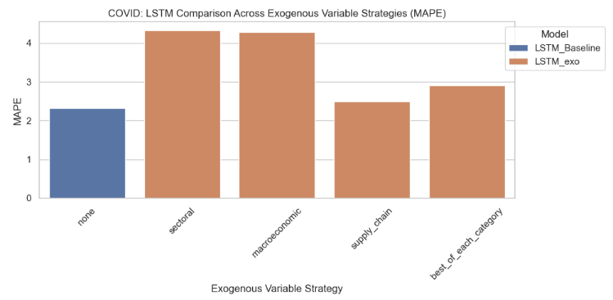  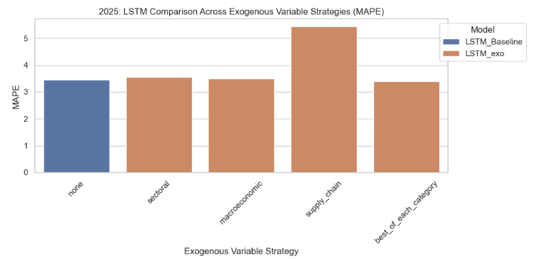  The best overall LSTM was the baseline models (complex) for Covid and the LSTM with DX-Y.NYB for 2025  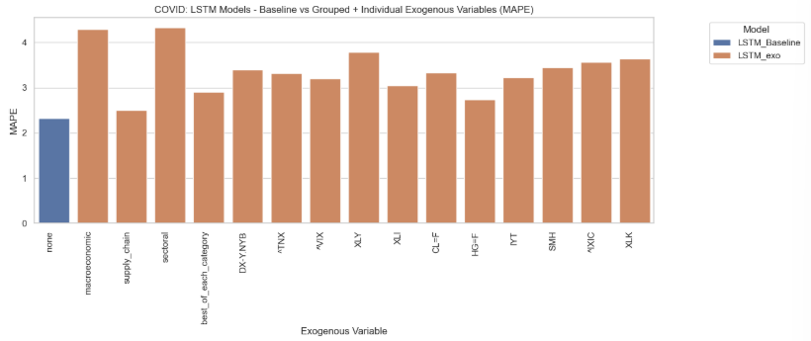  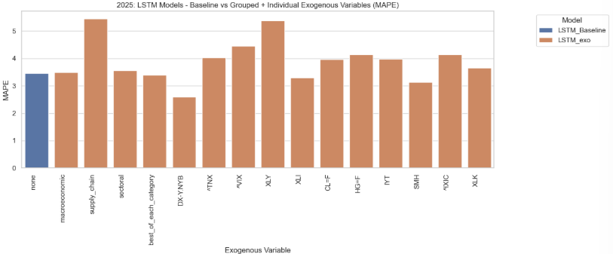
Horizon 3 | When the exogenous variables were fed into the model as multi-inputs for each category, they all performed much the same as each other for COVID, but in 2025 the commodity group of exogenous variables was best.  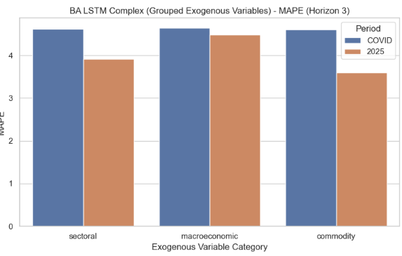  When the best performing exo variable from each of the three categories were fed in together as a multi-input it did not help either periods baseline improves at all. All grouped exogenous variables performed worse than the baseline LSTMs  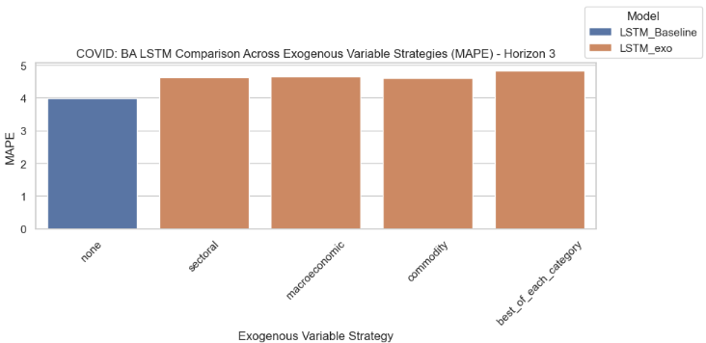  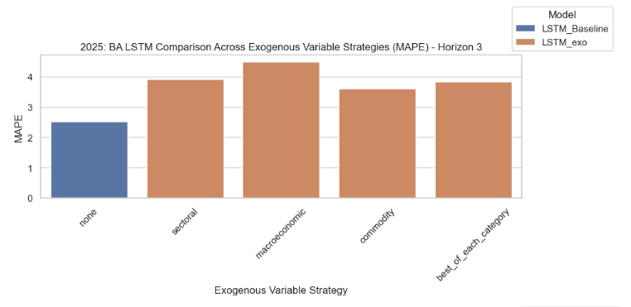  The best overall LSTM was the baseline models (complex) for Covid (with ITA having a similar MAPE value) and also the baseline LSTM for 2025- far better than the exogenous models  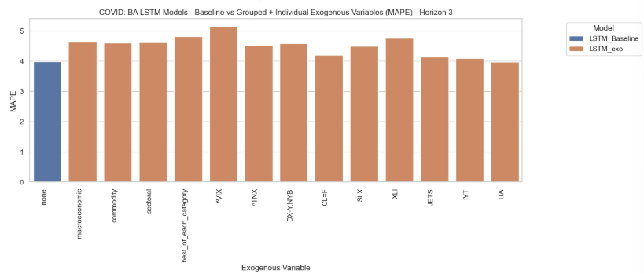   | When the exogenous variables were fed into the model as multi-inputs for each category, supply chain performed the best for covid, even marginally better than the baseline, but worst for 2025, the best for 2025 was macroeconomic  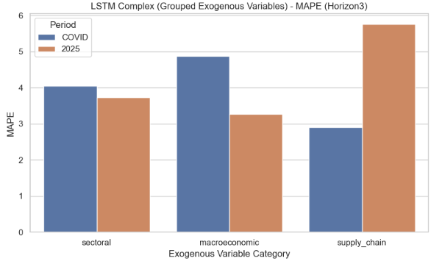  When the best performing exo variable from each of the three categories were fed in together as a multi-input it was slightly better than the baseline for 2025 but worse for covid.  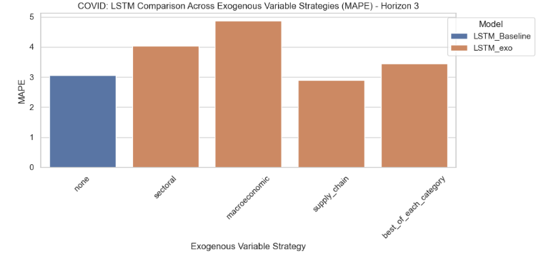  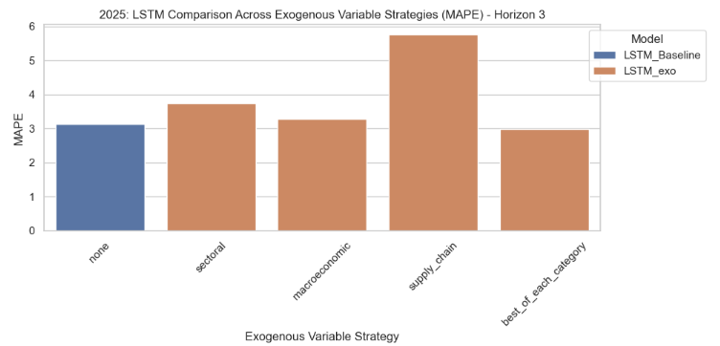  The best overall LSTM was the HG=F model for Covid and the LSTM with best_of_each_category for 2025 (but only marginally better than baseline)  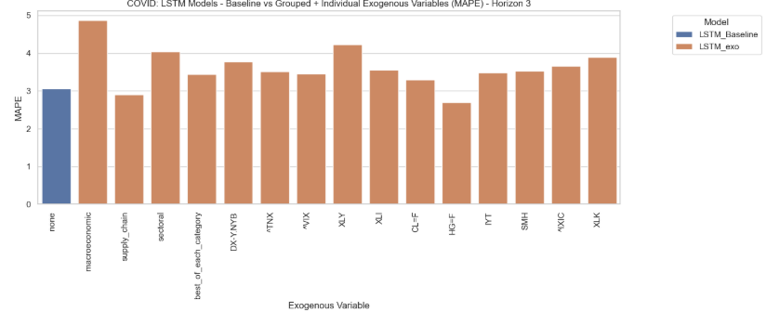  
Horizon 7 | When the exogenous variables were fed into the model as multi-inputs for each category, sectoral performed the best for covid, but commodity for 2025  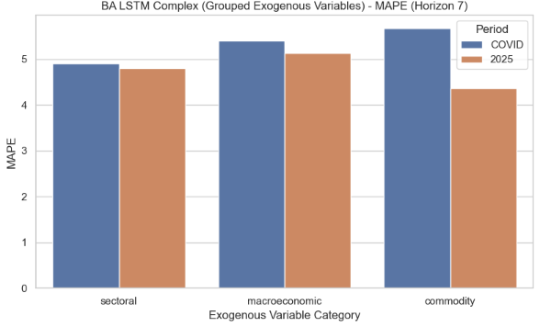  When the best performing exo variable from each of the three categories were fed in together as a multi-input it was comparable with the baseline LSTM (as was sectoral group), during COVID. For 2025 the best_of variable was the only grouped exo variable to improve on the MAPE on the baseline model.  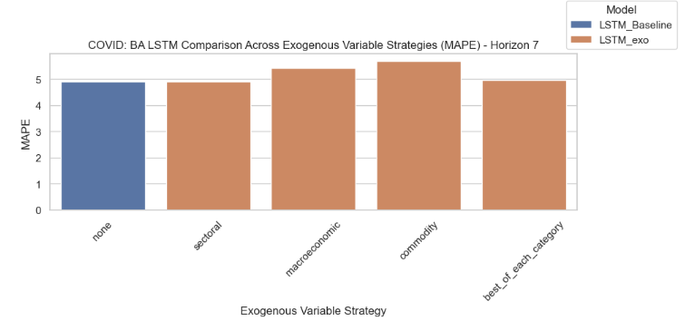  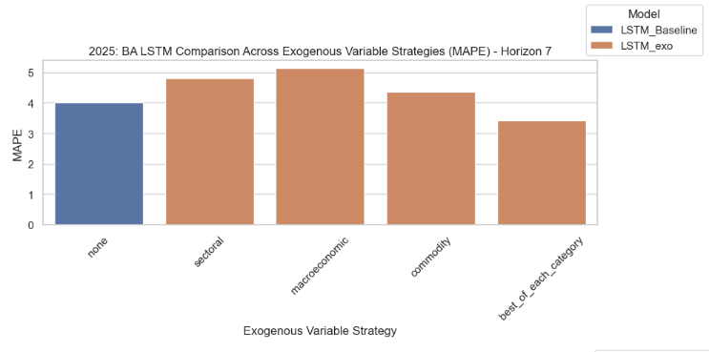  The best overall LSTM was the model with JETS for Covid and the LSTM with best_of_each_category for 2025  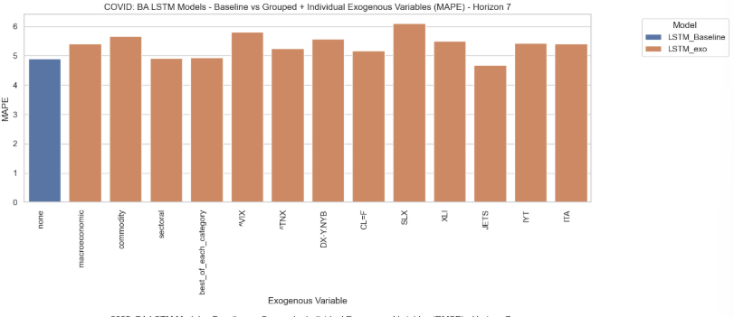   | When the exogenous variables were fed into the model as multi-inputs for each category, supply chain performed the best for covid, but macroeconomic for 2025  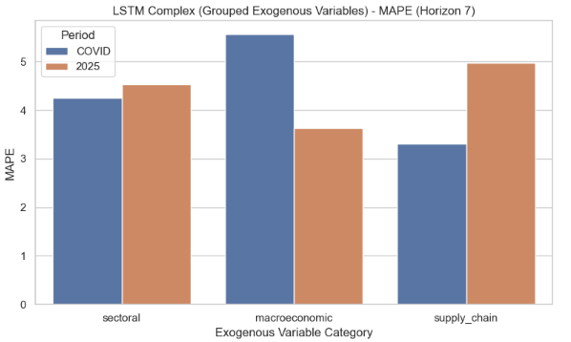  When the best performing exo variable from each of the three categories were fed in together as a multi-input it was no better (slightly worse) than the baseline for 2025. For covid it was similar to the baseline, supply group did better than baseline for this period.  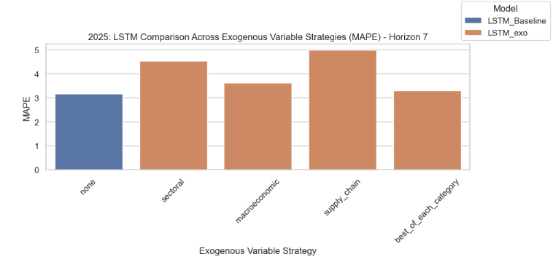    The best overall LSTM was the HG=F model for Covid and the (complex) baseline LSTM for 2025  